

CLIENT FITNESS ASSESSMENT FORM

# Member /Client: Coach: _ Date:

|  |  |  |  |
| --- | --- | --- | --- |
| **Age** | **Weight (kg)** | **Height (cm)** | **Body Fat %** |
|  |  |  |  |

Note: before starting the fitness assessment, be sure to let the client to stretch out and take a few moments to warm up. Ask them to wear comfortable sneakers that offer foot support and comfortable clothing that is easy to move in, but not baggy. To do this test you will need:

* Clear floor space
* Chin up bar for bent arm hangs or pull-ups or Pull Down bar as an alternative
* Mat or towel for crunches
* Stopwatch
* Heart Rate Monitor
* 12-inch step

# Body Measurements: (right side only)

|  |  |  |  |  |  |  |  |
| --- | --- | --- | --- | --- | --- | --- | --- |
| **Forearm** | **Bicep** | **Chest** | **Waist** | **Abdomen** | **Hips** | **Thigh** | **Calf** |
|  |  |  |  |  |  |  |  |



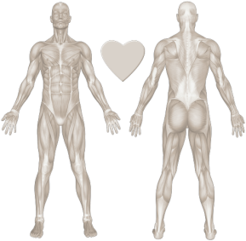**Postural 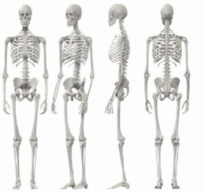Analysis: (Use Arrow to Indicate direction of imbalance)**

**Coach Notes:**

**Flexibility Test (observe the form)**

|  |  |  |  |  |  |
| --- | --- | --- | --- | --- | --- |
| **Test** | **Exercise/Ability** | **Needs Improvement** | **Moderately** | **With Ease** | **Notes** |
| **1** | **Push-ups** |  |  |  |  |
| **2** | **Squats** |  |  |  |  |
| **3** | **Overhead Press** |  |  |  |  |
| **4** | **Pull Down (1/3 BW)** |  |  |  |  |
| **5** | **Rowing** |  |  |  |  |
| **6** | **Crunches** |  |  |  |  |
| **7** | **Broad Jump** |  |  |  |  |



**Strength Test (Please refer to the protocol on the next page)**

|  |  |  |  |  |  |
| --- | --- | --- | --- | --- | --- |
| **Test** | **Exercise/Ability** | **1 to 20** | **21 to 40** | **41 to 60+** | **Notes** |
| **1** | **Push-ups** |  |  |  |  |
| **2** | **Squats** |  |  |  |  |
| **3** | **Pull Ups** |  |  |  |  |
| **4** | **Pull Down (1/3 BW)** |  |  |  |  |
| **5** | **Crunches** |  |  |  |  |
| **6** | **Dead Hang (seconds)** |  |  |  |  |
| **7** | **Bench Step Test** |  |  |  |  |

**Cardiovascular Function: (sub maximal test)**

|  |  |
| --- | --- |
| **Client Heart Rate Zones: % of Max HR** | |
| **Zone 1 : 60-65% (Recovery)** |  |
| **Zone 2 : 65-75% (Endurance)** |  |
| **Zone 3 : 72-82% (Aerobic)** |  |
| **Zone 4 : 82-89% (Anaerobic)** |  |
| **Zone 5 : 90+% (Speed Anaerobic)** |  |

RATHEESH BABU R B (CERTIFIED FITNESS COACH & DIET SUPPORTER)

CONTACT NO:8593013091