2009 NFG Recorder's Report

This year (2009) we submitted 1127 records to the national databases, representing 394 species, compared with 2008 (1661 records - 466 species) and 2007 (1499 records – 463 species). We have to go back to 2004 (1021 records – 407 species) and 2006 (1051 records – 414 species) to find less records submitted, and even then those records represented more species than we found this year. Partly this is down to weather, our 5 autumn forays up to and including 11th October at Walkeringham taking place in very dry conditions. Numbers of fungi found at these 5 forays were unusually low, even a site like Clumber Park producing only 45 species compared with over 60 the year before. Cuckney Hay Wood was an exception in this period with 76 species recorded, but the wood is inclined to be a damp one. Also I believe I received fewer records from individuals throughout this year than in some previous ones. An interesting development this year was an increased number, as we obtain the books and learn the microscopic techniques to do so, of records of microfungi, both from individuals and on the forays. More of us are beginning to look more closely at these growths (rusts, smuts, microscopic ascomycetes, hyphomycetes) on leaves, stems and bark. Such organisms are never going to be everyone’s cup of tea and are evidently not as glamorous as a Fly Agaric or as tasty as a Penny Bun; but viewed under the microscope they can be every bit as fascinating. Moreover they are probably under-recorded everywhere.

This year I have entered all our records, including the current year, onto the ABFG database, CATE, where anyone who is a paid up, registered member can view them online. This system makes recording itself simpler and is highly accurate in keeping up-to-date the ever-changing names of fungi. For Group Recorders it is also well backed up with advice and help. For some recording I still use Mapmate alongside, but will probably do so less and less as it is poorly equipped for fungal recording and its managers seem uninterested. Our records will also continue to be sent to the BMS database (BFRDBI) as previously, so will be present on both national databases.

Below are the summaries of the year’s forays, and tables showing some facts about the fungi we have encountered in 2009.

Haywood Oaks NFG Spring Foray, 9th May 2009
The spring foray is always anticipated with pleasure after the winter break even though large numbers of fungi are rarely involved at this time of year. Something of interest is sure to be found, however, and it is good to find the early-year species. Among the 20 species recorded on this occasion were the springtime species Calocybe gambosa, St George’s Mushroom; Agrocybe praecox, Spring Fieldcap, with its chocolatey smell and floury taste; and Conocybe aporos, though the latter can be found occasionally in the autumn too. Two Fibrecaps were found – Inocybe flocculosa, Fleecy Fibrecap and Inocybe rimosa, Split Fibrecap, the latter on a pine stump. We also re-recorded from here the uncommon Gymnopus (Collybia) acervatus in needle litter around pine stumps. At the end of the foray a good meal was enjoyed at the Fox and Hounds by some of the participants.

Cuckney Hay Wood NFG Foray, 10th September 2009
There was a good turn-out of members and friends on a bright morning for our second visit to this site. In all 76 species were recorded covering a broad range of fungi. 8 members of the Russulaceae were found, the red Russula sylvestris under beech and sweet chestnut attracting a lot of attention. The bright red skin peels completely and the taste is definitely hot. The most interesting find was the tiny white Coprinopsis laanii growing in clusters on an old mossy stump. Michael Bini’s keen eyes picked them out. A small polypore on a stump proved to be Polyporus tuberaster, Tuberous Polypore, a fairly uncommon species also found this year at a site near Worksop. At the end we brought together various people’s finds to display and talk about.

Clumber Park Worksop NFG Foray, 19th September 2009
11 people turned out to this foray, fewer than in previous years. As usual for this venue the foray ended with a picnic. 45 species in all were recorded, among the larger and more significant being Grifola frondosa, Hen of the Woods, at the base of an ancient oak, and Pluteus chrysophaeus, Yellow Shield, on beech. There was also an attractive collection of Russulaceae including Lactarius blennius, Beech Milkcap, with beech and the uncommon or overlooked Russula grisea in leaf litter. The latter usually occurs with oak. Our microfungi enthusiasts were also busy with 7 of these organisms identified on substrates as diverse as oak leaves, leaves of Hedge Woundwort and Mahonia.

Sharphill Wood Notts NFG Foray 27/9/2009
Some members visited this wood last year and found numerous fungi; so the 27 members and guests who came this year were rather disappointed only to find 21 species. The weather was the main culprit, having been unduly dry for several weeks after an early summer of rain. The weather is a normal hazard for mycologists, however, and there is always a risk of drawing a blank. That is not quite true as there is always something of interest to see. Meripilus giganteus is always very impressive by the sheer size of its clusters at the base of trees or stumps. At the other end of the spectrum is the easily missed Beechmast Candlesnuff Xylaria carpophila, a smaller, more delicate version of the common Candlesnuff Fungus which grows on rotten wood. This one grows on old fallen beechmast.

Colliers Wood Notts NFG Foray 3/10/2009
15 enthusiasts turned out for this foray but the weather continued dry, meaning that few of the larger fungi had emerged. This was compounded by the fact that the wood is still in its young stages, so that many of the macro-species have not yet had time to establish. It was generally agreed that it will be a good wood to explore once the trees start to grow more to maturity in several years’ time. Nevertheless, thanks to the efforts and expertise of Di Mears and Craig Levy, we got a more than decent list of micro-fungi and lichens to make up for dearth elsewhere. 17 species in all.

Walkeringham NR Notts, NFG Foray 11/10/2009
Only 8 members ventured this far north for this foray. Just as well perhaps as it was little short of disastrous, thanks to the continuation of the dry spell which bedevilled Sharphill Wood and Colliers Wood. A mere 18 common species were recorded on this small reserve, which has provided many more species in the past, some uncommon to rare. Even so, we did find a small number of Lyophyllum loricatum near the footpath in grass. It puzzled us at the time as it looks rather like its cousin Lyophyllum decastes, Clustered Domecap, which was abundant here, yet not quite like. It is perhaps a bit smaller and is distinguished by the tough, thick cuticle and spherical spores. It is much less common or maybe just overlooked.

Mansfield Cemetery NFG Foray 21st October 2009
Thirteen members turned out for this foray on a damp morning, which happily brightened up later. I was personally disappointed not to find Boletus pulverulentus, plentiful last year; but a good tally of some 55 species were recorded including fairy clubs, some impressive parasols and the club, Cordyceps militaris, Scarlet Caterpillarclub, complete with the unfortunate caterpillar it parasitizes below ground. The Big Smoky Bracket, Bjerkandera fumosa, was a good find, but another bracket on a stump defeated our efforts. Brackets are by no means as easy to identify as their often large size and conspicuous nature might suggest. The tiny white Hemimycena lactea on needles spotted by Arthur Walters was a nice record, as was the small yellow Conocybe rickeniana in grass.

Thoresby Estate NFG Foray, 24th October 2009
A party of 16 visited two adjacent sections of woodland – Old Oaks and The Buck Gates – and recorded a respectable 53 species. Some interesting fungi were found in litter on such fallen items as beech husks (Xylaria carpophila, Beechmast Candlesnuff & Crinipellis scabella, Hairy Parachute), and on a pine cone (Lachnum virgineum, Snowy Disco). The densely tufted Psathyrella multipedata, Clustered Brittlestem, was a good find and fairly uncommon; and on pine wood the pretty golden Calocera viscosa, Yellow Staghorn, always attracts attention. Thoresby, with its dense woodland of mainly oak, beech and birch always proves a productive venue.

Peafield Lane Wood NFG Foray 31st October 2009
This mixed wood was a new venue for the NFG and it proved a highly successful foray with 13 members attending and 64 species recorded. We began and ended at the Redbrick House hotel car park, where some keen eyes spotted fungi in the grass before we had even properly set off. At the latter end of the season, quite a lot of Mycenas (Fairy Bonnets) were predictably in evidence, of which we eventually identified a number. The most interesting ones were Mycena adscendens, Frosty Bonnet; M. capillaris, Beechleaf Bonnet; and some very beautiful M. pura var. rosea, Lilac Bonnet, among beech litter. The uncommon Psathyrella laevissima tufted on fallen oak wood was recorded. It is very similar in many ways to the common P. piluliformis, so specimens were kept and dried against the possibility of misidentification. The brown Pipe Club, Macrotyphula fistulosa, was found by the keen-sighted among the beech litter; and on a piece of rotten pine wood the pale yellow discs of Orbilia xanthostigma, Common Glasscup, were a source of interest. At the end collected specimens were discussed and displayed on one of the tables outside the hotel. After which most of us had a pleasant meal and drink inside.

Sherwood Forest NNR NFG Foray 5th November 2009
We found 77 species at this ever popular venue, which was well attended by 27 members and guests, including children. One of the boys found Collybia cookei for us complete with its yellow below-ground sclerotium, which is so easily broken off and lost. Both of the Ascocoryne jellies were found on wood, and one of the few recognisable dark brown Cortinarius species, told by its earthy, mouldy smell – Cortinarius umbrinolens. There is a lookalike and smellalike but the spores differentiate. The yellowish Inocybe hirtella was collected under oaks – fresh it smells of nothing much, but keep it enclosed for an hour and a smell of bitter almonds or marzipan is given off, a telltale sign for this species. A rarity in Lepiota tomentella was found in soil with oaks, not unlike L. castanea but with duller brown scales and smaller spores. Jerry Clough identified the Birch Rust, Melampsoridium betulinum for us on birch leaves – a formidable name for a very common rust but new to me for all that.

Bestwood CP Nottingham NFG Foray 14th November 2009
This is another popular venue where we can always be guaranteed to find something interesting. Thirteen members including children attended. New for me here was Macrotyphula juncea, Slender Club (a cousin of the larger Macrotyphula fistulosa, Pipe Club, also present), a fungus resembling a very fine ochreish grass stem as much as anything – easily missed in leaf litter but for Craig Levy’s keen eyes. Another new bracket for me which Craig showed us was Lenzites betulinus, Birch Mazegill, on birch stumps. It is a bracket but has gill-like lamellae instead of pores and occurs only on birch. On the Quarry area many interesting fungi were recorded, from the tiny sandy moss cups of Geopora arenosa seen by Janet Fernley to the striking orange-capped bolete, Leccinum versipelle, Orange Birch Bolete, among the birches. Three other good finds here were Lepiota felina, striking with black-brown scales on a pale cap; the short-stemmed grey-brown Melanoleuca brevipes; and Cortinarius alboviolaceous, Pearly Webcap, with its delicate pale and lilac tones. 58 species were recorded.

Gedling House Wood & Meadows Nottingham NFG Foray, 21st November 2009
This site is interesting as it offers two aspects: woods and adjacent pasture fields. The Group has visited this site on a number of occasions now and it usually turns up something of interest. The fields contained some brightly coloured fungi: Bolbitius titubans, Yellow Fieldcap, and white, yellow and orange waxcaps; also the uncommon but duller Stropharia inuncta, Smoky Roundhead, and what we think is the real Melanoleuca melaleuca, a species whose cap and stem flesh remain persistently white – unlike the commoner Melanoleuca polioleuca, Common Cavalier, where the flesh darkens. Not only Lepista nuda, Wood Blewit, but also its less common, and some would say tastier, cousin Lepista saeva, Field Blewit, was found. The woodland produced an earthstar, Geastrum triplex, Collared Earthstar – common as earthstars go but good to find at any time. 38 species were recorded.

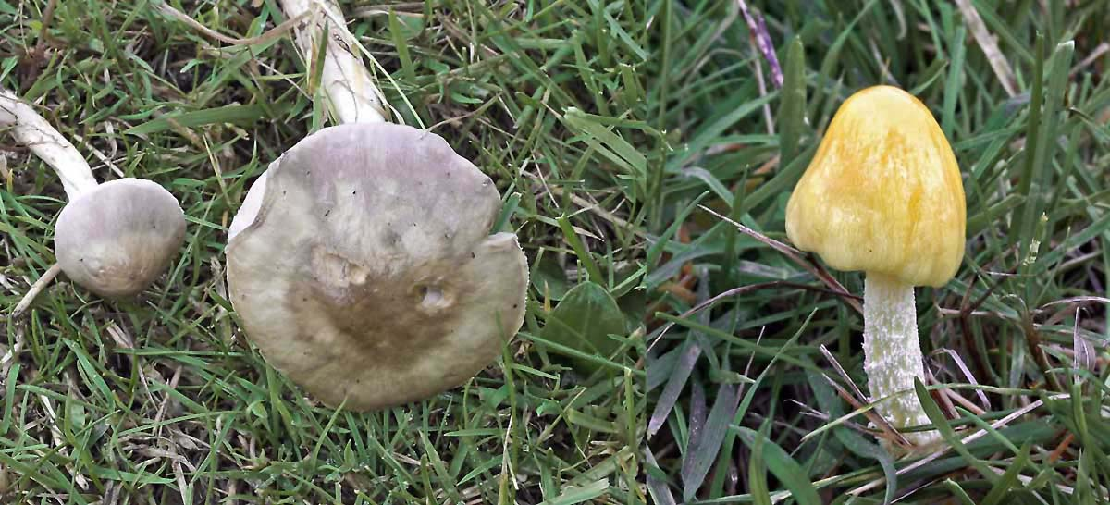
Stropharia inuncta and Bolbitius titubans

Most Frequently Recorded Fungi in Nottinghamshire in 2009
Species | English name | Records
Stereum hirsutum | Hairy Curtain Crust | 22
Trametes versicolor | Turkey Tail | 20
Daedaleopsis confragosa | Blushing Bracket | 17
Xylaria hypoxylon | Candlesnuff | 14
Schizopora paradoxa | Split Porecust | 12
Nectria cinnabarina | Coral Spot | 12
Hypholoma fasciculare | Sulphur Tuft | 12
Diatrypella quercina | Oak Barkspot | 12
Annulohypoxylon multiforme | Birch Woodwart | 11
Bjerkandera adusta | Smoky Bracket | 11
Piptoporus betulinus | Birch Polypore | 11
Rhytisma acerinum | Sycamore Tarspot | 11
Mycena galericulata | Common Bonnet | 11
Scleroderma citrinum | Common Earthball | 11
Fomes fomentarius | Hoof Fungus | 11
Coprinellus micaceus | Glistening Inkcap | 11
Dacrymyces stillatus | Jelly Spot | 9
Laccaria laccata | Deceiver | 9
Xylaria polymorpha | Dead Man’s Fingers | 9
Armillaria mellea | Honey Fungus | 9
Amanita muscaria | Fly Agaric | 9

Most Widespread Nottinghamshire Fungi Recorded 1996-2009
Species | English name | Records per sq km
Stereum hirsutum | Hairy Curtain Crust | 61
Xylaria hypoxylon | Candlesnuff | 61
Trametes versicolor | Turkey Tail | 60
Hypholoma fasciculare | Sulphur Tuft | 59
Auricularia-auricula judae | Jew’s Ear; Jelly Ear | 59
Dacrymyces stillatus | Jelly Spot | 54
Laccaria laccata | Deceiver | 53
Mycena galericulata | Common Bonnet | 52
Rhodocollybia butyracea | Butter Cap | 50
Pluteus cervinus | Deer Shield | 49
Clitocybe nebularis | Clouded Agaric | 49
Coprinellus micaceus | Glistening Inkcap | 48
Lepista nuda | Wood Blewit | 48
Daedaleopsis confragosa | Blushing Bracket | 48
Piptoporus betulinus | Birch Polypore | 48
Bjerkandera adusta | Smoky Bracket | 48
Armillaria mellea | Honey Fungus | 46
Nectria cinnabarina | Coral Spot | 45
Tubaria furfuracea | Scurfy Twiglet | 45
Lepista flaccida | Tawny Funnel | 43
Lycoperdon perlatum | Common Puffball | 43

Some Uncommon Nottinghamshire Fungi (Less than 500 National Records) 2009
Species | English Name | Site | BFRDBI records
Cortinarius saturninus var. bresadolae |  | Haywood Oaks | 4
Lepiota lilacea |  | Carlton-in-Lindrick (garden) | 22
Inocybe oblectabilis |  | Carlton-in-Lindrick, Carlton Wood | 30
Cortinarius incisus |  | Nottingham, Bestwood CP (Quarry) | 34
Hygrophoropsis macrospora |  | Nottingham, Attenborough NR | 44
Peziza domiciliana |  | Hucknall (allotment) | 45
Leucoagaricus carneifolius |  | Carlton-in-Lindrick churchyard | 49
Dennisiella babingtonii (sooty mould) |  | Carlton-in-Lindrick(garden) & churchyard; Haywood Oaks | 52
Corynespora olivacea (a Hyphomycete) |  | Carlton-in-Lindrick churchyard | 54
Coprinopsis laanii |  | Cuckney Hay Wood | 55
Trametes suaveolens (RDL2) |  | Nottingham, Attenborough NR | 56
Rutstroemia petiolorum |  | Sherwood Forest NNR | 67
Lepiota tomentella |  | Sherwood Forest NNR | 69
Arthonia radiata |  | Colliers Wood | 70
Suillus collinitus |  | Nottingham, Bestwood CP (Conservation Area) | 77
Antrodia serialis |  | Haywood Oaks | 80
Conocybe siennophylla |  | Langold CP | 81
Pyronema domestica |  | Hucknall (allotment) | 87
Parasola hemerobia |  | Sherwood Forest NNR; Worksop, Drinking Pit Lane | 89
Inocybe nitidiuscula |  | Haywood Oaks | 97
Hymenochaete tabacina |  | Carlton-in-Lindrick, Carlton Wood | 98
Geopora arenosa |  | Nottingham, Bestwood CP (Quarry) | 101
Arrhenia rickenii |  | Nottingham, Attenborough NR | 105
Helvella leucomelaena |  | Manor Hills Plantation, Worksop | 117
Paxillus rubicundulus |  | Nottingham, Bestwood CP (Conservation Area) | 118
Peniophora polygonia |  | Lound, Chainbridge Lane NR | 119
Agaricus cappellianus (vaporarius) |  | Nottingham, Bestwood Mill Lakes | 126
Lyophyllum loricatum |  | Walkeringham NR | 134
Calcarisporium arbuscula (a Hyphomycete) |  | Carlton-in-Lindrick, Carlton Wood | 140
Arrhenia spathulata |  | Hucknall (garden) | 151
Guepinia helvelloides | Salmon Salad | Costhorpe | 158
Psathyrella laevissima |  | Peafield Lane Wood | 163
Psilocybe crobula |  | Peafield Lane Wood | 166
Tricholoma portentosum |  | Nottingham, Bestwood CP (Conservation Area) | 181
Xenodochus carbonarius (on Great Burnet leaf) |  | Colliers Wood | 190
Gymnopus acervatus |  | Haywood Oaks | 196
Conocybe rickeniana |  | Mansfield Cemetery | 197
Conocybe pubescens |  | Langold CP | 206
Lepiota felina |  | Nottingham Bestwood CP | 207
Inocybe hirtella |  | Sherwood Forest NNR | 208
Otidea bufonia | Toad's Ear | Nottingham, Attenborough NR | 212
Arrhenia retiruga |  | Nottingham, Bestwood CP (Quarry) | 224
Inocybe praetervisa |  | Cuckney Hay Wood | 232
Uncinula adunca var. adunca (on willow leaf) |  | Colliers Wood | 260
Steccherinum ochraceum |  | Nottingham, Bestwood Mill Lakes | 262
Trametes ochracea |  | Carlton-in-Lindrick, Carlton Wood; Hannah Park Wood, Worksop; Sherwood Forest NNR | 273
Tricholoma cingulatum | Girdled Knight | Haywood Oaks | 275
Macrotyphula juncea | Slender Club | Nottingham, Bestwood CP | 289
Inonotus obliquus |  | Sherwood Forest NNR | 292
Tarzette cupularis | Toothed Cup | Nottingham, Bestwood Village (Nursing Home) | 293
Peziza echinospora | Charcoal Cup | Hannah Park Wood, Worksop | 297
Arrhenia acerosa | Moss Oysterling | Nottingham, Bestwood Mill Lakes | 302
Geastrum striatum | Striate Earthstar | Nottingham, Rise Park | 304
Orbilia leucostigma |  | Mansfield-Woodhouse CP | 308
Pleurotus pulmonarius | Pale Oyster | Sherwood Forest NNR | 318
Chaetosphaeria myriocarpa |  | Mansfield-Woodhouse CP | 323
Russula grisea |  | Haywood Oaks; Clumber Park | 324
Cortinarius alboviolaceus | Pearly Webcap | Nottingham, Bestwood CP | 333
Melanotus horizontalis | Wood Oysterling | Drinking Pit Lane, Worksop | 333
Stropharia inuncta | Smoky Roundhead | Nottingham, Attenborough NR; Gedling House Meadows | 345
Coprinopsis acuminata | Humpback Inkcap | Drinking Pit Lane, Worksop | 362
Bjerkandera fumosa | Big Smoky Bracket | Mansfield Cemetery | 374
Skeletocutis amorpha |  | Haywood Oaks; Drinking Pit Lane, Worksop | 383
Marasmius setosus |  | Nottingham, Bestwood CP | 388
Stropharia coronilla | Garland Roundhead | Nottingham, Attenborough NR | 391
Puccinia smyrnii (a rust) |  | Nottingham, Castle Rock | 400
Amylostereum laevigatum |  | Carlton-in-Lindrick, Carlton Wood | 401
Puccinia acetosa (a rust) |  | Colliers Wood | 418
Pholiota flammans | Flaming Scalycap | Cuckney Hay Wood | 419
Clavulinopsis laeticolor | Handsome Club | Haywood Oaks | 463
Inocybe lacera | Torn Fibrecap | Carlton-in-Lindrick churchyard | 478
Puccinia pulverulenta (a rust) |  | Colliers Wood | 487
Schizophyllum commune | Common Porecrust | Nottingham, Attenborough NR; Gedling House Wood | 497

Distribution of Trametes ochracea, hirsuta, versicolor & gibbosa in Notts

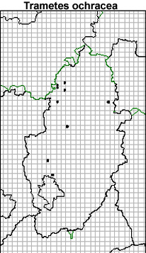 | 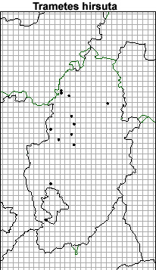
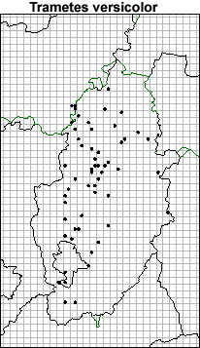 | 