A Wicked Tale of Joy

a dance music narrative video to the music of:

Hendricks, Beatles, Doors, Rolling Stones, Cream

Rock n’ Roll songs of the 60’s and 70’s told brief, poetic, and lyrical tales that spoke from the heart. Some were innocent and naïve, others dark and deeply philosophical: all highly relevant today. A Wicked Tale of Joy illustrates those stories through all forms of movement: musical theater, mime, modern dance, ballet and jazz. Costumes, sets, and lighting effects range from the basic to the spectacular.

Each song stands on its own but collectively create the eternal narrative of the innocence and turbulence of man’s quest for the understanding of good versus evil. The Tale focuses on a madcap Jester (representing you and me) who introduces and orchestrates his creations: The Wicked Couple and a Joyful Couple.

The songs are performed by a mischievous cast of ‘circus and conventional’ style dancers, actors, and mimes. These colorful misfits are quirky, romantic, passionate, humorous, and at times extremely serious. They express joy, pain, anger, and fear, like the songs they perform.

Joyful Couple Jester Wicked Couple

conceived by Tom Stovall
copyright 2017

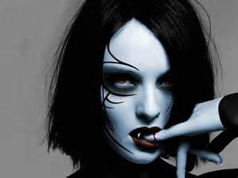
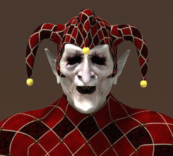
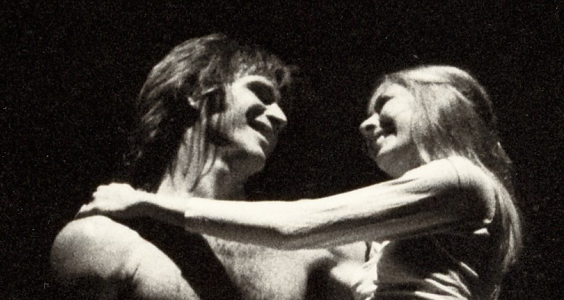

THE PRELUDE

Everybody’s Got Something to Hide Beatles 2:25

(see YouTube below of a Zalouli dancer in sync with Lennon’s song)
Atriohm – Rings of Fairy
https://www.youtube.com/watch?v=XReirWIJ23M

WICKED TALE OF JOY

Hey Joe 3:32

She’s A Rainbow Rolling Stones 4:35

Little Wing Jimi Hendrix 2:28

Strange Brew Cream 2:48

The Crystal Ship Doors 2:32

Riders On The Storm Doors 7:15

The End Doors 6:32
Bold as Love Jimi Hendrix 4:14

Locations:
Castle and Grounds

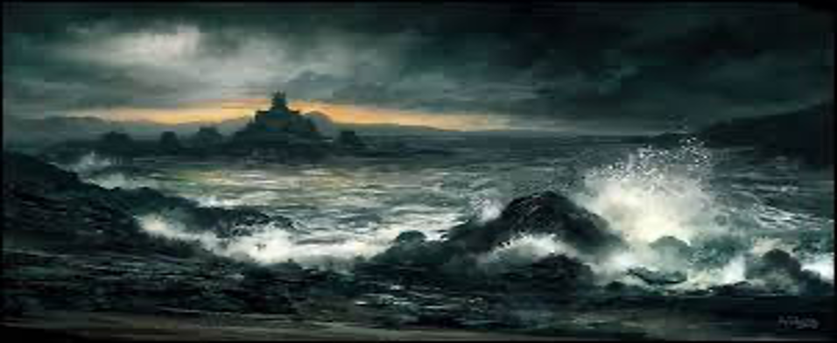

Decaying Ballroom
Prelude, Hey Joe

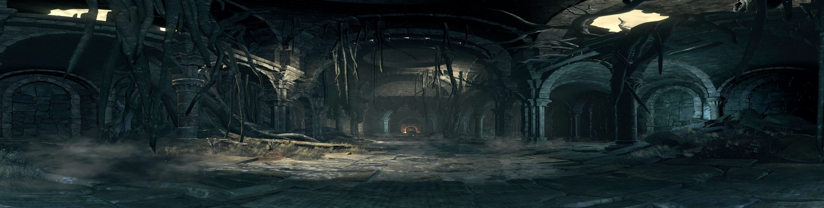

Ballroom
She’s A Rainbow, Little Wing

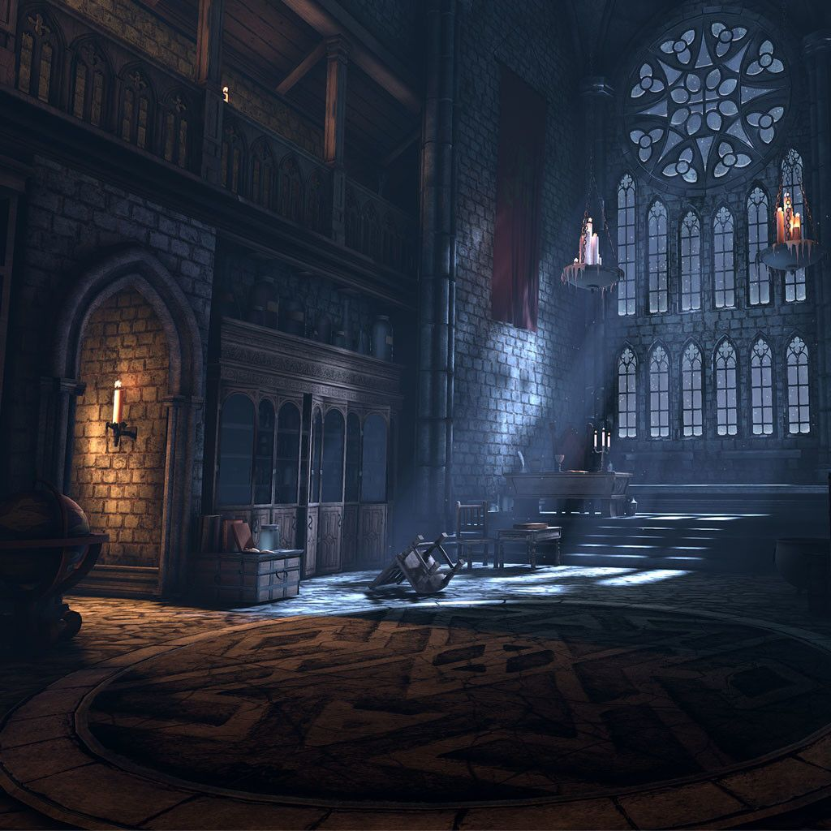

Dungeon
Strange Brew

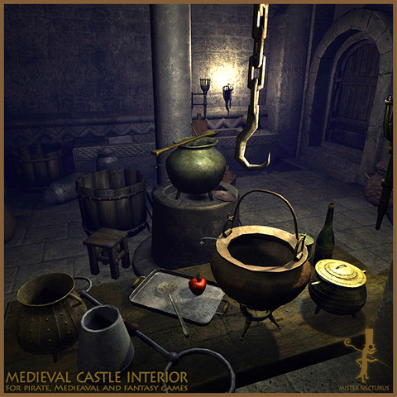

Castle Grounds
Crystal Ship

Castle Grounds
Riders on the Storm

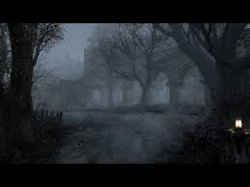

The End

Bold As Love

Joy

THE PRELUDE

EVERYBODY’S GOT SOMETHING TO HIDE Beatles

(please watch YouTube below [Atriohm – Rings of Fairy] as a Zalouli dances in sync with Lennon’s song)
https://www.youtube.com/watch?v=XReirWIJ23M

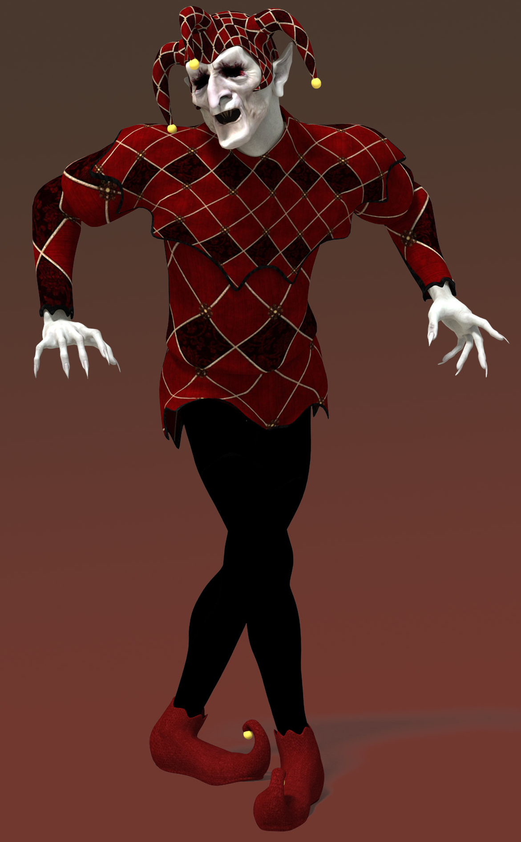

DECAYING BALLROOM

The Jester, the Joyful Couple and the Wicked Couple pose frozen on
stone pillars of assorted heights inside the dark and decaying ballroom
of a mysterious castle. The characters are reminiscent of stone-faced mimes that stand frozen for hours silently begging for bucks.

As the music begins, a Zalouli dancer appears and performs a primordial ceremonial dance in sync to the first two verses to the Lennon’s song.
On the third verse, “your inside is out and your outside is in…”), the
Jester, the Wicked Man and the Joyful Man leap to the ground and
kick some dust up with the Zalouli in an untamed, powerful, African-inspired modern dance. As the song ends, the three characters leap back to their frozen positions, leaving the Zalouli alone as the light fades to black…

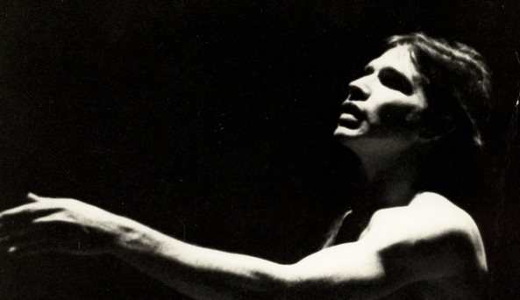
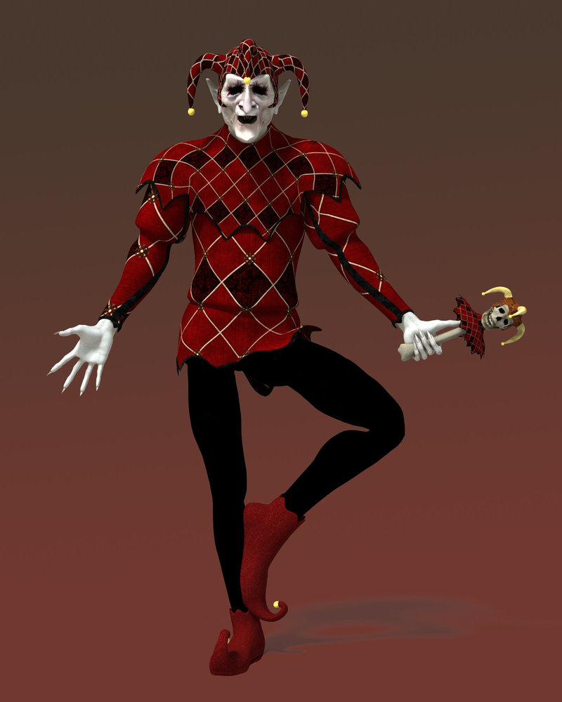
As Hey Joe begins, so does… A WICKED TALE OF JOY

HEY JOE Jimi Hendrix

DECAYING BALLROOM

The characters remain poised on their stone pillars. The Zalouli has vanished.

On the opening guitar riff the fiercelyenraged Wicked Man, Joe, leaps from his pillar frantically barndishing a large black pistol. The sky begins to darken as black clouds close in.

A voice is heard singing, “Hey
Joe, where you goin’ with that
gun in your hand?” The second
time, Joe spins around and searchs for the voice.

He circles the mortified mimes
searching for the mysterious voice. Suddenly, the Jester leaps from his pillar and approaches, ‘Hey Joe, I heard you shot your
woman down”? Joe confronts
the Jester as the frozen
characters on the pillars begin
moving in graceful slow motion
to the sound of the background
chorus voices.

During the solo guitar lead, the Jester and Wicked Man perform a uniform menacing masculine pas de deux.As the guitar solo ends, the Jester grabs the Wicked Woman off her pillar and thrusts her into the arms of the Wicked Man. Heat lightning pierces the blacken sky. She is drawn to his violent nature. The Jester leaps back to his pillar as the Wicked Man and Woman perform an erotic and almost hostile pas de deux before exiting.
SHE’S A RAINBOW Rolling Stones
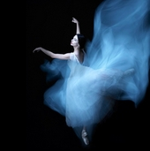

BALLROOM

The Jester descends from his stone pillar and directs a band of gremlins to hoist the beautiful Joyful Woman off her pillar and gently lower her into place in the courtyard. She is dressed in a flowing gown in shades of blue and white. They remove the empty pillars leaving only the Joyful Man poised on his pillar. The Jester coos over his prize.

As the song begins, the Jester commands the Joyful Woman to life. She performs a traditional style classical ballet with a hint of ‘Riverdance' footwork to the fast-moving beat. The exuberant Jester widely encircles the Woman mimicking a Drum Majorette. During the piano and strings break, the Jester joins her in a classical pas de deux. He is overwhelmed with joy.

During the second piano and strings break, the Jester ushers in and positions a chorus of classical dancers on the meadow floor. All join in the fast-moving pace. Near the end, during the lively staccato violin strings, a striking laser show zaps the dancers from all every angle. They playfully dodge the beams, then rebound to the words, “Ou la la, ou la, la, la, la”; fingers snap and hands clap. As the song ends, as the Jester commands the chorus to exit. He is alone with the Joyful Woman.
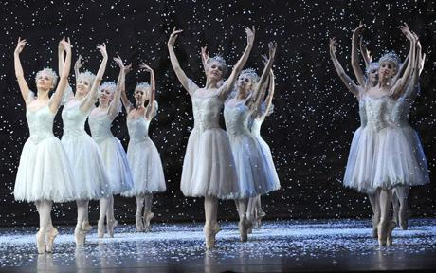
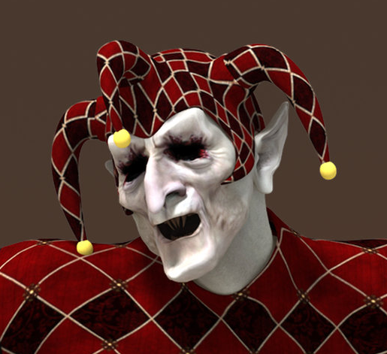

LITTLE WING Jimi Hendricx

BALLROOM

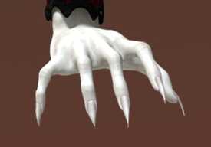

As the guitar solo begins, the gleeful Jester beckons the Joyful Woman to the base
of The Joyful Man’s pillar. The Jester drifts into the darkness as the Woman shyly
performs for the Man. As the drum roll begins, he leaps off his pillar and joins the
her downstage in a pas de deux.
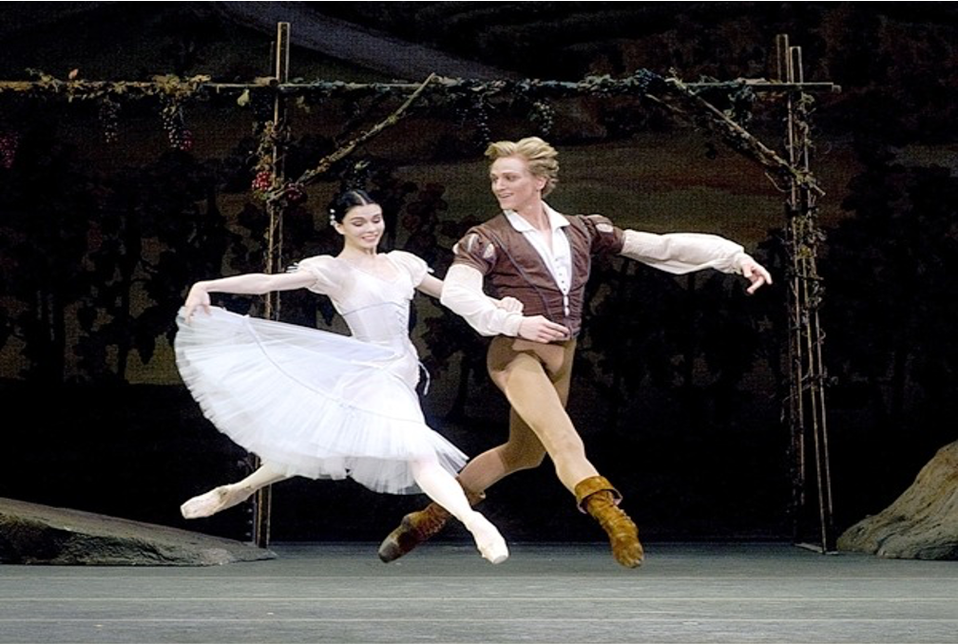

There’s a glow around the Joyful Couple as a deep affection emerges for each other.

It’s an up spirited and exhilarating classical performance. They are in perfect syncopation: same dance, same movements, same love: they are becoming one.

…as the couple exit, the Jester emerges from the darkness with an impish gleam in his eye…

STRNGE BREW Cream

DUNGON… A HEAVY FOG HUGS THE FLOOR
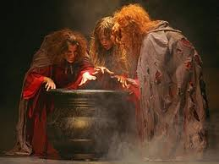

The Jester reveals three decrepit creatures
hovering over a black cauldron stirring a
brew. Thick red and orange vapor gush from
its fiery brew.

The Wicked Woman appears from underneath
the black wings of a band of malevolent
creatures. The Jester retreats. The creatures
surround the caldron and dance hysterically.

During the enigmatic guitar break, the Wicked
Man springs from the fiery cauldron and performs a frightening aerial
dance. As the man descent into the arms of the Woman, the cauldron and
wiccan creatures disappear. Fire engulfs the background. Drawn together like
magnets they perform a dark and decadent dance. Like the Joyful Couple, they are becoming one.
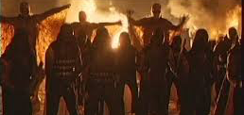

THE CRYSTAL SHIP The Doors
CASTLE GROUNDS
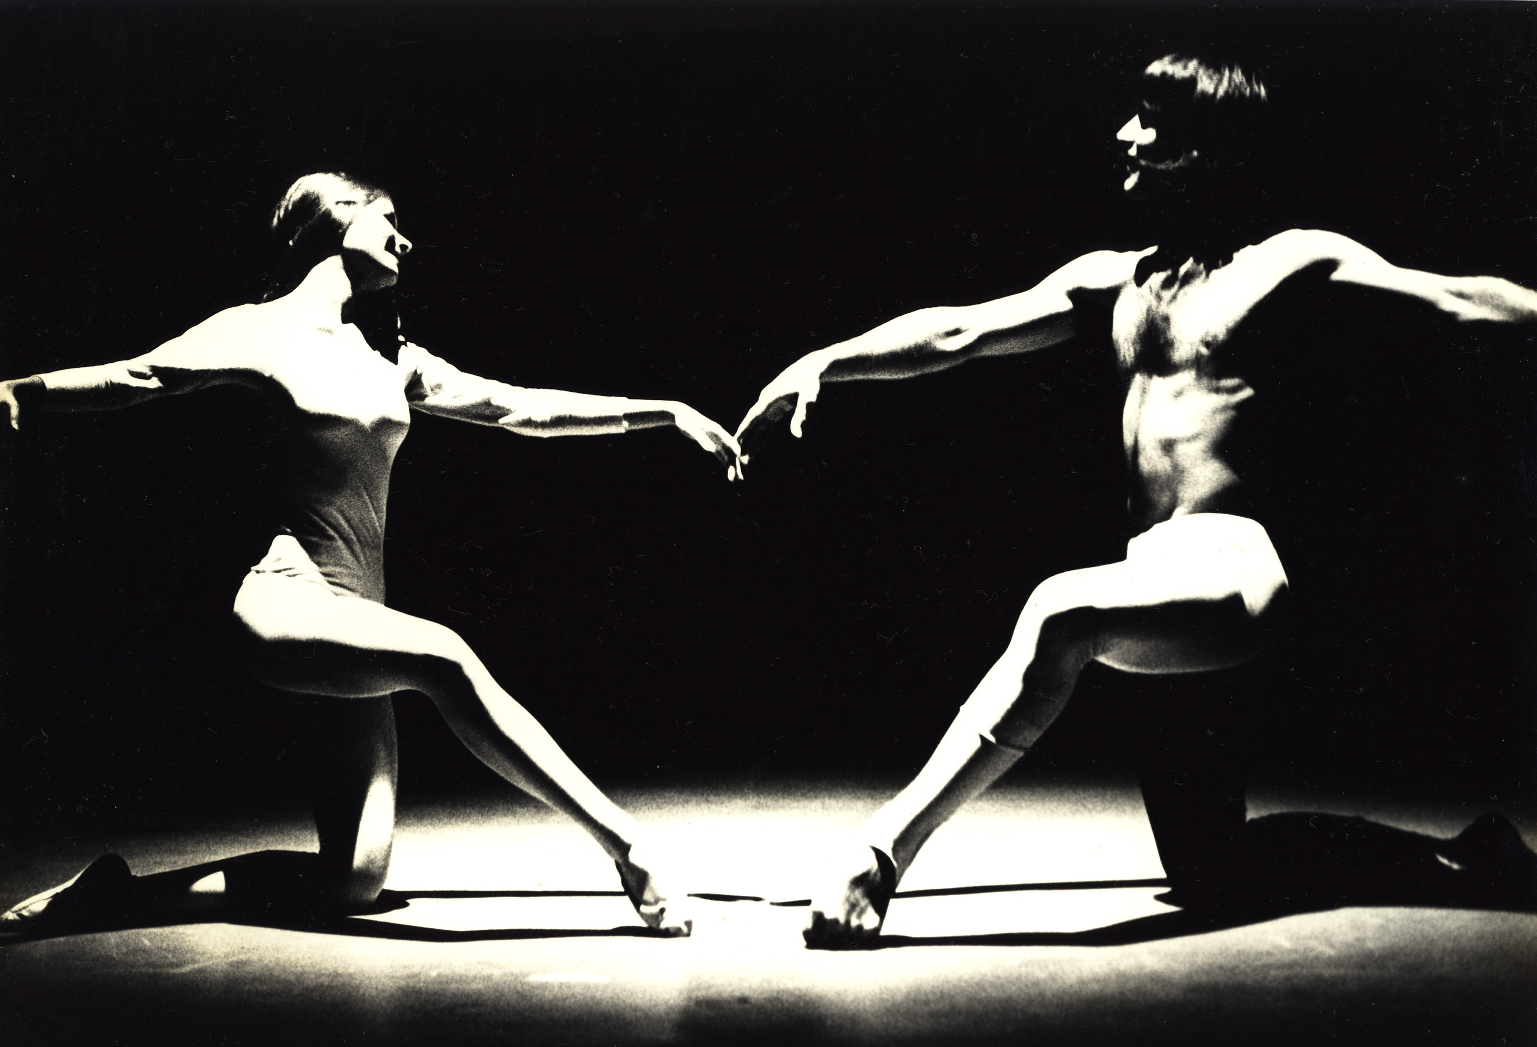

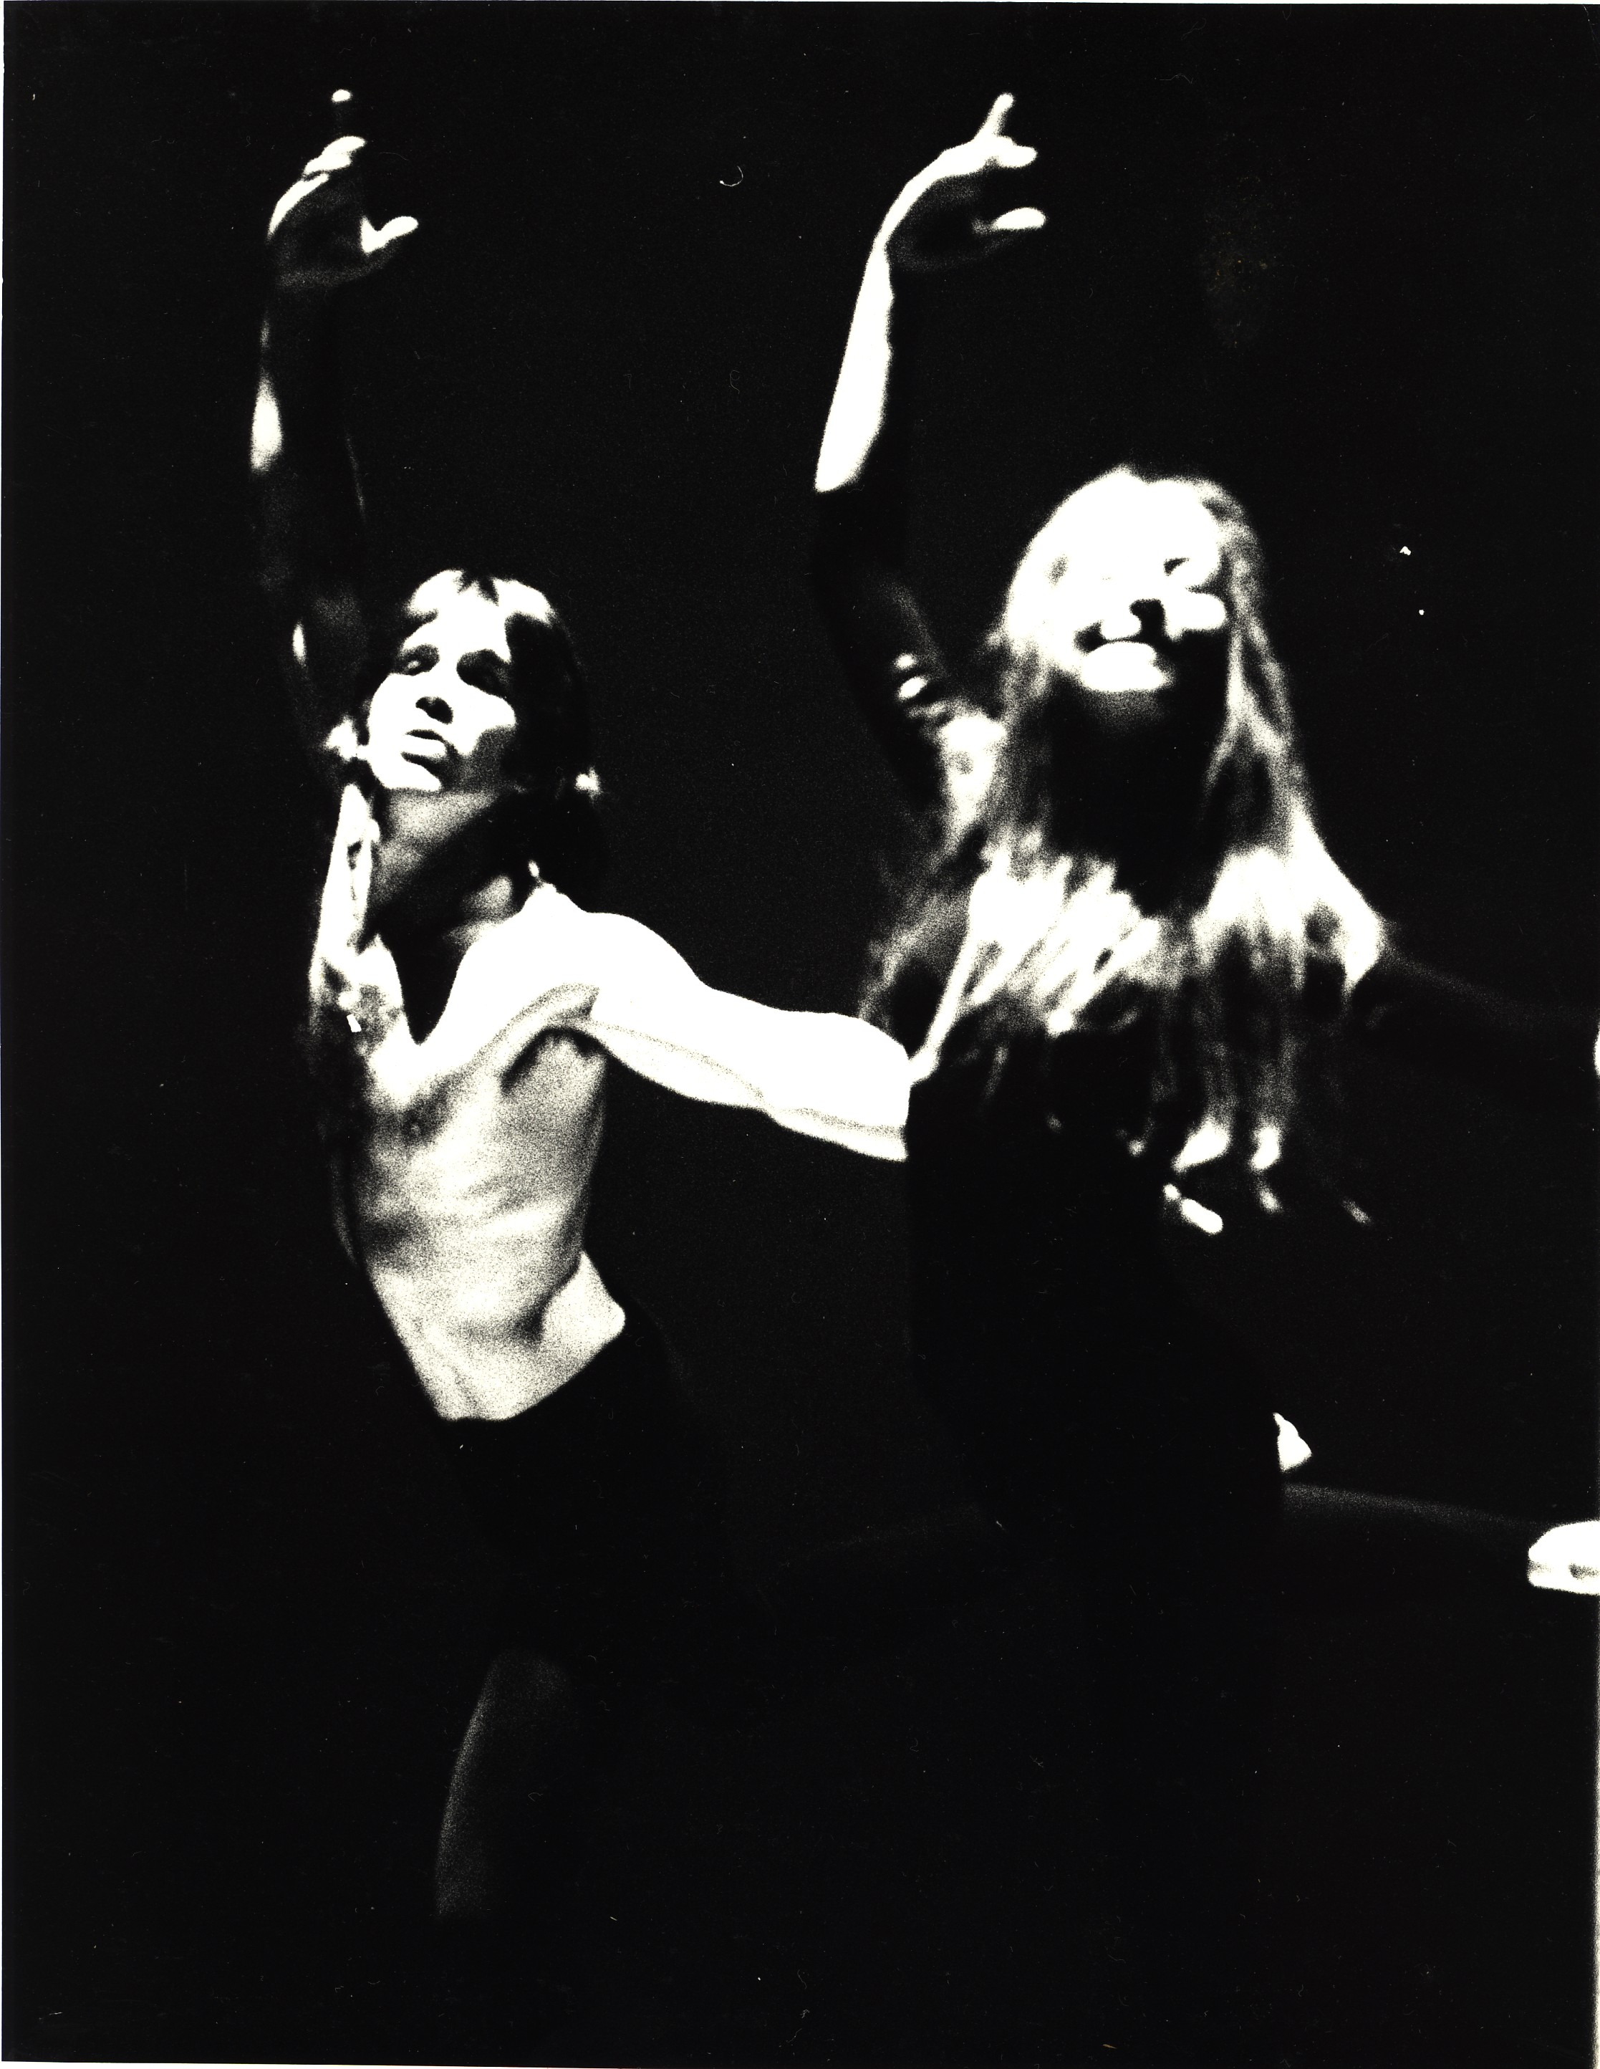

The emotional “Crystal Ship” begins. The passionate classical pas de deux binds the Joyful Couple hearts and minds. The encounter is carnal and highly erotic as flesh presses flesh. They are becoming physically and eternally one.

RIDERS ON THE STORM The Doors

CASTLE GROUNDS: THICK FOG, WAVES CRASH, LIGHTNING FLASHES

The Jester appears with the Zaloui on the edge of darkness. The two perform an abstract sequence of movements to the first verse.

On the lyrics: “there’s a killer on the road…” The Jester lures the Wicked Man in as the Zaloui retreats… a child appears chased by his mother… “take a long holiday, let your children play”, the Wicked Man approaches… the mother grabs her child and quickly exits, “if you give this man a ride, sweet memory will die – killer on the road.” The Wicked Woman appears on the guitar break and joins him in a dark and wicked pas de deux. They slowly vanish into the darkness.

On the lyrics, “girl ya gotta love your man, girl ya gotta love your man… the Joyful Couple cautiously enter. They perform a highly charged romantic pas de deux. “take him by the hand, make him understand… the world on you depends, our life will never end, gotta love your man… yeah”

The Wicked Man returns the Joyful Woman flees. The Wicked and Joyful Men engage in an intense and increasingly sexual male pas de deux. They begin to clash as the Jester breaks the intensity and commands them to separate and escape, leaving the him alone on a dark stage. On the final verse, the couples reappear on the lyrics, “riders on the storm…”. They perform the same dance: same moves, syncopated, separate but melded. Lightning strikes and thunder rolls as the Couples exit and the Jester is once again, alone.

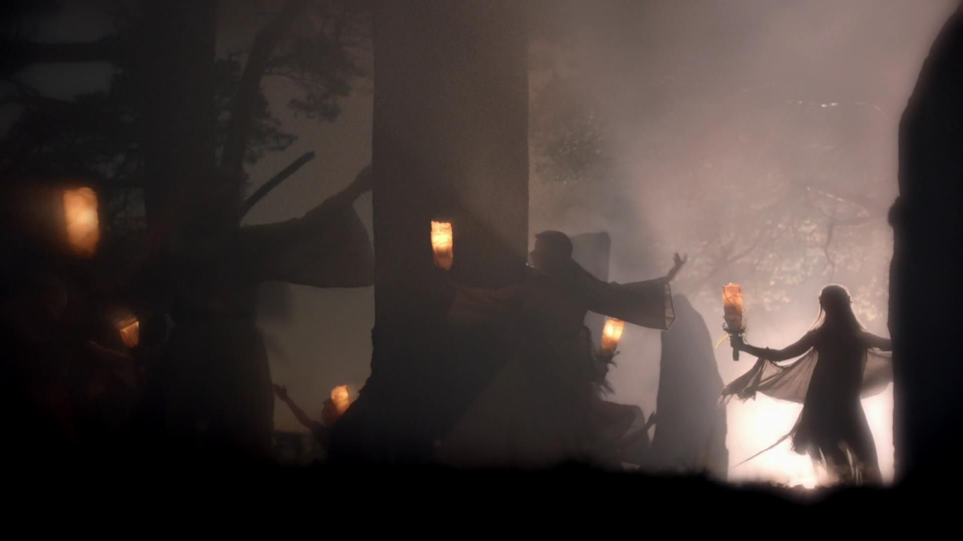

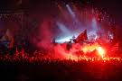

“This is the end, beautiful friend
This is the end, my only friend, the end
THE END The Doors Of our elaborate plans, the end
The end of everything that stands, the end
No safety or surprise, the end
I’ll never look into your eyes again”

Lights flicker to the sound of helicopter blades spinning. The Jester looks to the Heavens. The Wicked Man and Woman slowly descend from a hostile heat lightening laden sky. The Jester retreats. The black winged-creatures envelope the couple as they reach the cobblestone floor below. As the lyrics start, the Couple emerges. Their arms reach out to the audience. “This is the end my only friend, the end.” Heavy fog hugs the floor. It’s the dawn of destruction. The two begin their death dance. On the lyrics, “waiting for the summer rain” the Wicked Couple and the winged creatures scatter into the darkness.

Stillness descends upon the scene. Crickets keep the swamp alive. Fog thickens as eerie shadows of the winged creatures flash across the stage.

The tempo of the music accelerates. Suddenly, the Wicked Couple burst on stage. They perform a withering dance of strained twisted movements. On the lyric, “kill, kill”, the menacing creatures bite and tear at the Couple’s skin. Blood flows down their arms and torsos. The winged creatures drag them down and engulf them as a bloody arm slowly emerges and reaches toward the sky.

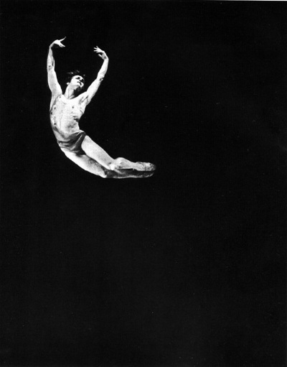
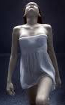

BOLD AS LOVE Jimi Hendricks

Bold As Love thrusts the Joyful Couple to the Heavens as the Wicked Couple is hurled into the depths of Hell. The Jester and Zalouli observe from the edges of darkness.

A thunderous crushing guitar chord shatters the blackened silence as a flash of intense ultra-white light saturates the scene.

The Joyful Man slowly descends slowly to the floor and begin a swirling, leaping, and radiant dance. Light matches the color of the lyrics. As the divine, almost supernatural lead guitar begins, the Joyful Woman appears high above. She performs an aerial dance. On the sound of crashing guitars, she swoops down into the arms of the Man as they perform their final stunning pas de deux. The stage slowly blackens as the music fades.
Tiny plumes of light descend from above accompanying the slow drooping drum roll. The drum roll accelerates. A super loud burst of sound blasts as the Heavens light up. It’s a total theater white out. Brilliant white light flashes from beneath every seat. A thick column of intense white light from a higher source strikes the stage from above. The Joyful Couple move slowly into the column of light and slowly ascend into the Heavens. The cast emerges to witness the event. The Jester and Zaouli attempt to follow but are repelled by a screeching blistering guitar. The Joyful Couple disappear into an inverted dome bursting with colorful light high above. Accompanying the piercing guitars, bright colors blink and rotate inside the dome as spectacular explosions follows. The bloody arm sinks into the fiery depths as the Jester and Zaoluli slither into the darkness…

THE END

