A Wicked Tale of Joy

a dance extravaganza to the music of
Jimi Hendricks, John Lennon, The Doors, The Rolling Stones, Cream

similar to a symphony, a dance performance is traditionally structured in two acts
two short unrelated performances and a single lengthier performance separated by an entr’acte…
A Wicked Tale of Joy serves as the second act

performed under a Cirque du Soleil type tent on an ‘arena stage’

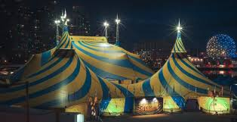

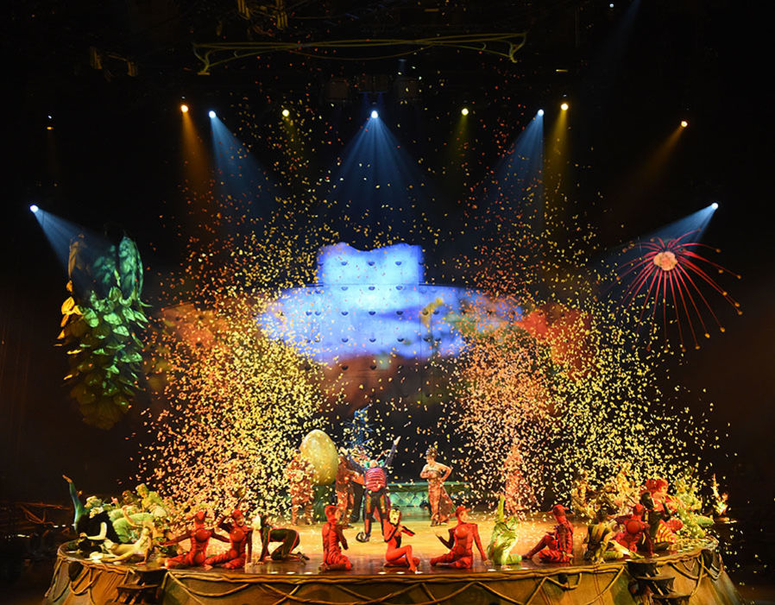

Copyright Tom Stovall

Copyright: Tom Stovall

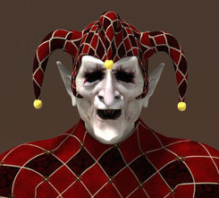
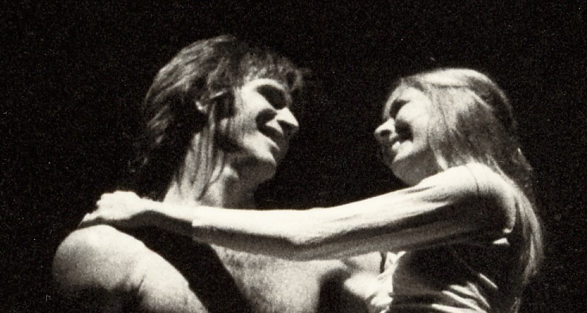
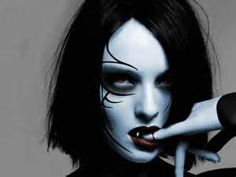

A Wicked Tale of Joy

Rock n’ Roll songs of the 60’s and 70’s told brief, poetic, and lyrical tales that spoke from the heart. Some were innocent and naïve, others dark and deeply philosophical: all highly relevant today. A Wicked Tale of Joy illustrates those stories through all forms of movement: musical theater, mime, modern dance, ballet and jazz. Costumes, sets, and lighting effects range from the basic to the spectacular.

Each song stands on its own but collectively create the eternal narrative of the innocence and turbulence of man’s quest for the understanding of good versus evil. The Tale focuses on a madcap Jester (representing you and me) who introduces and orchestrates his creations: The Wicked and Joyful Couples.

The songs are performed by a mischievous cast of ‘circus and conventional’ style dancers, actors, and mimes. These colorful misfits are quirky, romantic, passionate, humorous, and at times extremely serious. They express joy, pain, anger, and fear, like the songs they perform.

Joyful Couple Jester Wicked Couple

conceived by Tom Stovall
copyright 2017

THE PRELUDE

A Wicked Tale of Joy

THE PRELUDE

Everybody’s Got Something to Hide Beatles 2:25
(see YouTube below of a Zalouli dancer in sync with Lennon’s song)
Atriohm – Rings of Fairy
https://www.youtube.com/watch?v=XReirWIJ23M

WICKED TALE OF JOY

Hey Joe Jimi Hendrix 3:32

She’s A Rainbow Rolling Stones 4:35

Little Wing Jimi Hendrix 2:28

Strange Brew Cream 2:48

The Crystal Ship Doors 2:32

Riders On The Storm Doors 7:15

The End Doors 6:32
Bold as Love Jimi Hendrix 4:14

Joy

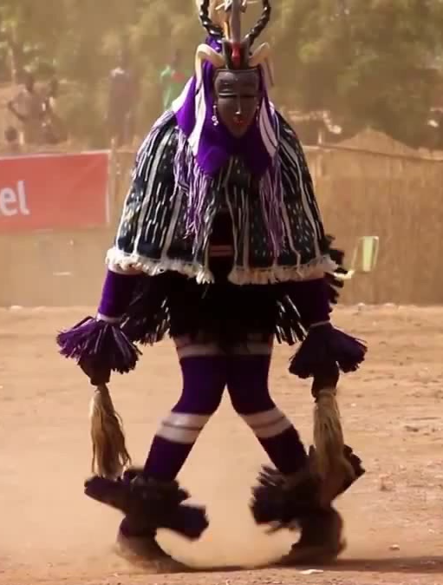

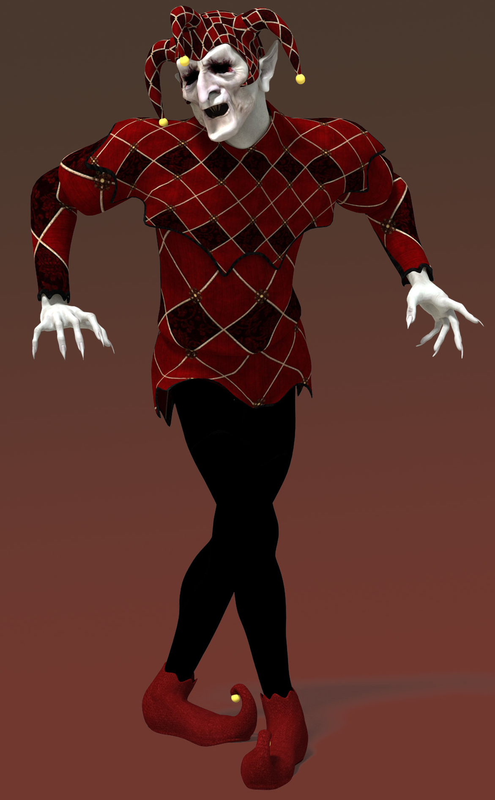
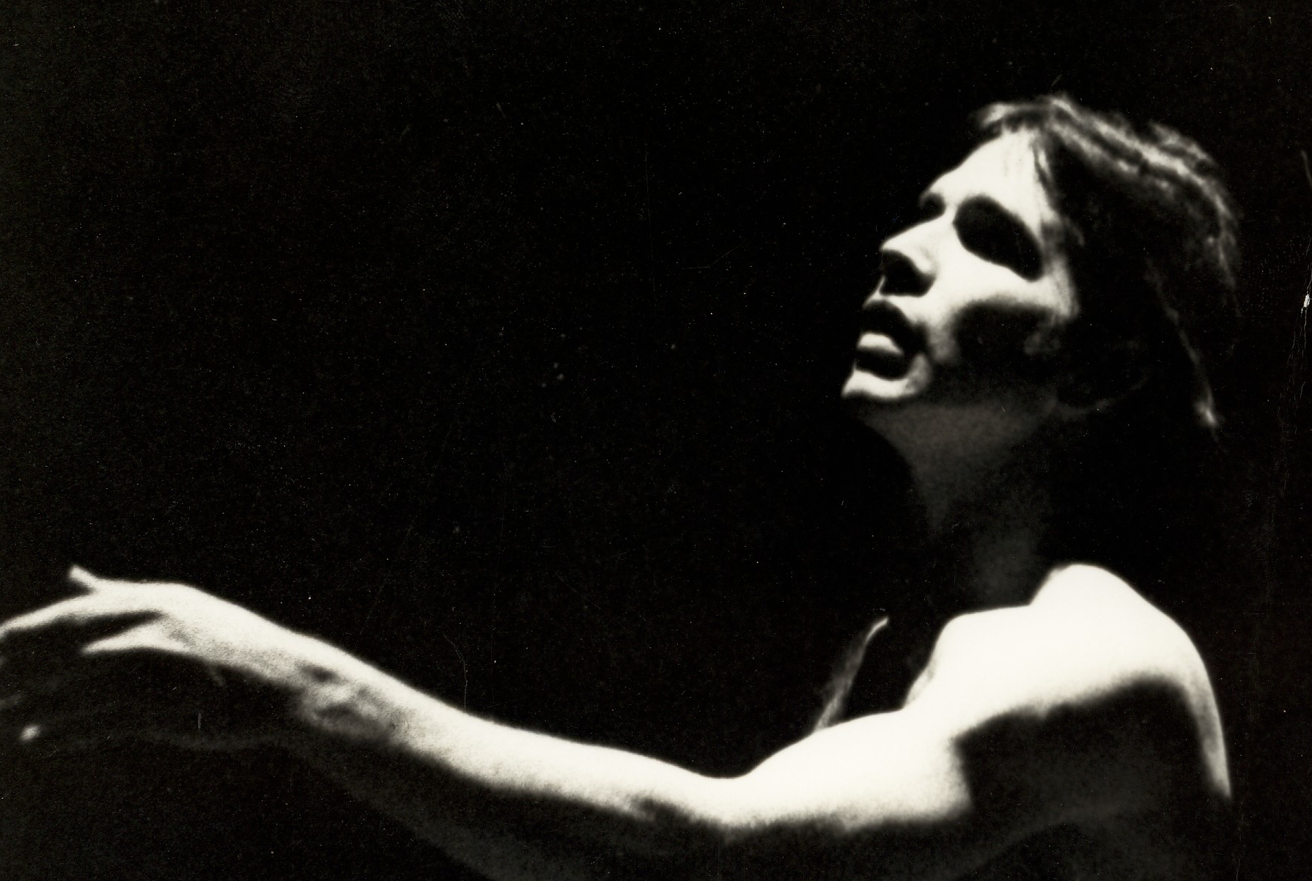
EVERYBODY’S GOT SOMETHING TO HIDE John Lennon

A Zalouli dancer celebrates the origins of man with a primitive ceremonial dance to the beat of John Lennon’s song. Five dimly lit characters, the Jester and the Joyful and Wicked Couples pose frozen on pillars of assorted heights. They are reminiscent of stone-faced mimes that stand frozen for hours silently begging for bucks. The Zalouli performs his ceremonial dance to the first two verses.
On the third verse (“your inside is out and your outside is in…”) the Jester, Wicked and Joyful Men leap to the floor and join the Zalouli in an untamed, powerful, African-inspired modern dance. As the song ends, the three characters leap back to their frozen positions, leaving the Zalouli center stage as the light fades to black…

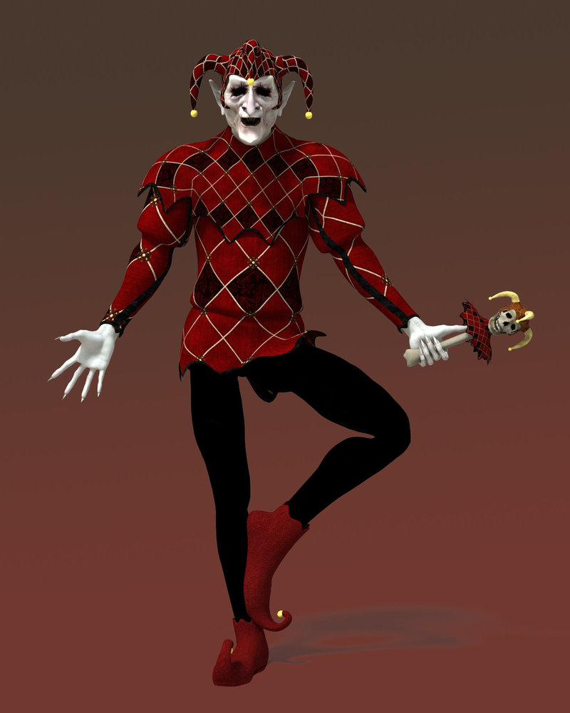
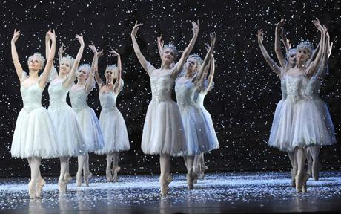
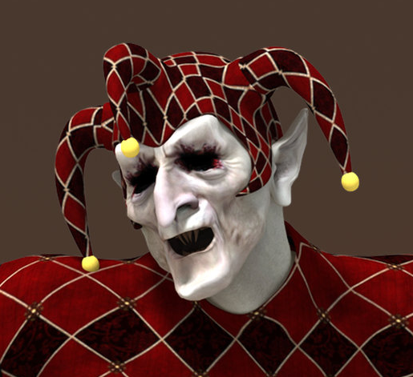
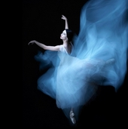
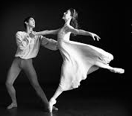
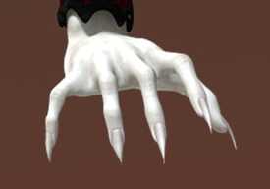
HEY JOE
Jimi Hendrix

The Zalouli has vanished.

As Hey Joe begins, so does
A WICKED TALE OF JOY.

On the opening guitar riff a fiercely
enraged Joe, the Wicked Man,
leaps from his pillar frantically
barndishing a large black pistol.

A voice is heard singing, “Hey
Joe, where you goin’ with that
gun in your hand?” Joe spins
around and glares at the stone
faced figures searching for the voice.

He circles the horrifiied mimes
searching for the mysterious
voice. Suddenly, the Jester leaps
from his pillar and mines, ‘Hey Joe,
I heard you shot your woman
down”?

Joe confronts the Jester as the frozen
characters on the pillars begin
moving in graceful slow motion to
the sound of the background chorus
voices.

During the Hendirx solo guitar lead,
the Jester and Wicked Man perform a
menacing masculine pas de deux
mimicking each other’s moves.

As the guitar solo ends, the Jester
grabs the Wicked Woman off her
pillar and thrusts her into the arms
of the Wicked Man. She is drawn to his violent nature. The Jester leaps back to his pillar as the Wicked Man and Woman perform an erotic and threatening pas de deux before exiting the stage.

SHE’S A RAINBOW The Rolling Stones

Stagehands bark out commands as the Jester descends from his post and directs the stagehands to hoist the beautiful Joyful Woman off her pillar and gently place her center stage. She is dressed in a flowing gown in shades of blue and white. Only the Joyful Man remains on his pillar. The Jester returns to center stage and coos over his prize. As the song begins, the Joyful Woman comes to life performing a traditional style classical ballet with a hint of ‘Riverdance' footwork to the fast-moving beat. The exuberant Jester encircles the Woman mimicking a Drum Majorette. During the piano and strings break, the Jester joins her in a classical pas de deux. He is overwhelmed with joy.

During the second piano and strings break, the Jester ushers in and positions a chorus of classical dancers on stage. All join in the fast-moving pace. Near the end, during the lively staccato violin strings, a striking laser show zaps the dancers from all corners of the theater. They playfully dodge the beams, then rebound to the words, “Ou la la, ou la, la, la, la”; fingers snap and hands clap. As the song ends, as the Jester commands the chorus to exit leaving him alone with the Joyful Woman.

The Joyful Couple express a deep emerging affection for each other.

It’s an up spirited and exhilarating classical performance. They are in perfect syncopation: same dance, same movements, same love: they are becoming one.

…as the couple exit, the Jester emerges from the darkness with an impish gleam in his eye…

As the guitar solo begins, the gleeful Jester beckons the Joyful Woman to the base of the Joyful Man’s pillar. The Jester vanishes into the darkness as the Woman shyly performs for the Man. As the drum roll begins, he leaps off his pillar and joins the her downstage in a pas de deux.

LITTLE WING Jimi Hendrix
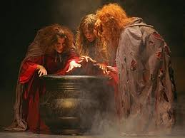
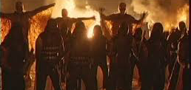
A dense mist hugs the floor as the Jester
ushers in a floating black cauldron. Thick
orange and red vapor gushes from its fiery
bubbling brew. Three decrepit wicca
creatures hover over and stir the brew. The
Jester unveils the Wicked Woman from
underneath the black wings of a band of
malevolent creatures. The Jester disappears
once again. The creatures surround
the caldron and dance hysterically.

During the enigmatic guitar break, the Wicked Man springs from the fiery
cauldron and performs a frightening aerial fabric dance. The cauldron and
wiccan creatures disappear into the blackness as the Man descends into the
arms of the Woman. Drawn together like magnets they perform a dark and decadent dance. Like the Joyful Couple, they are becoming one.
STRANGE BREW Cream
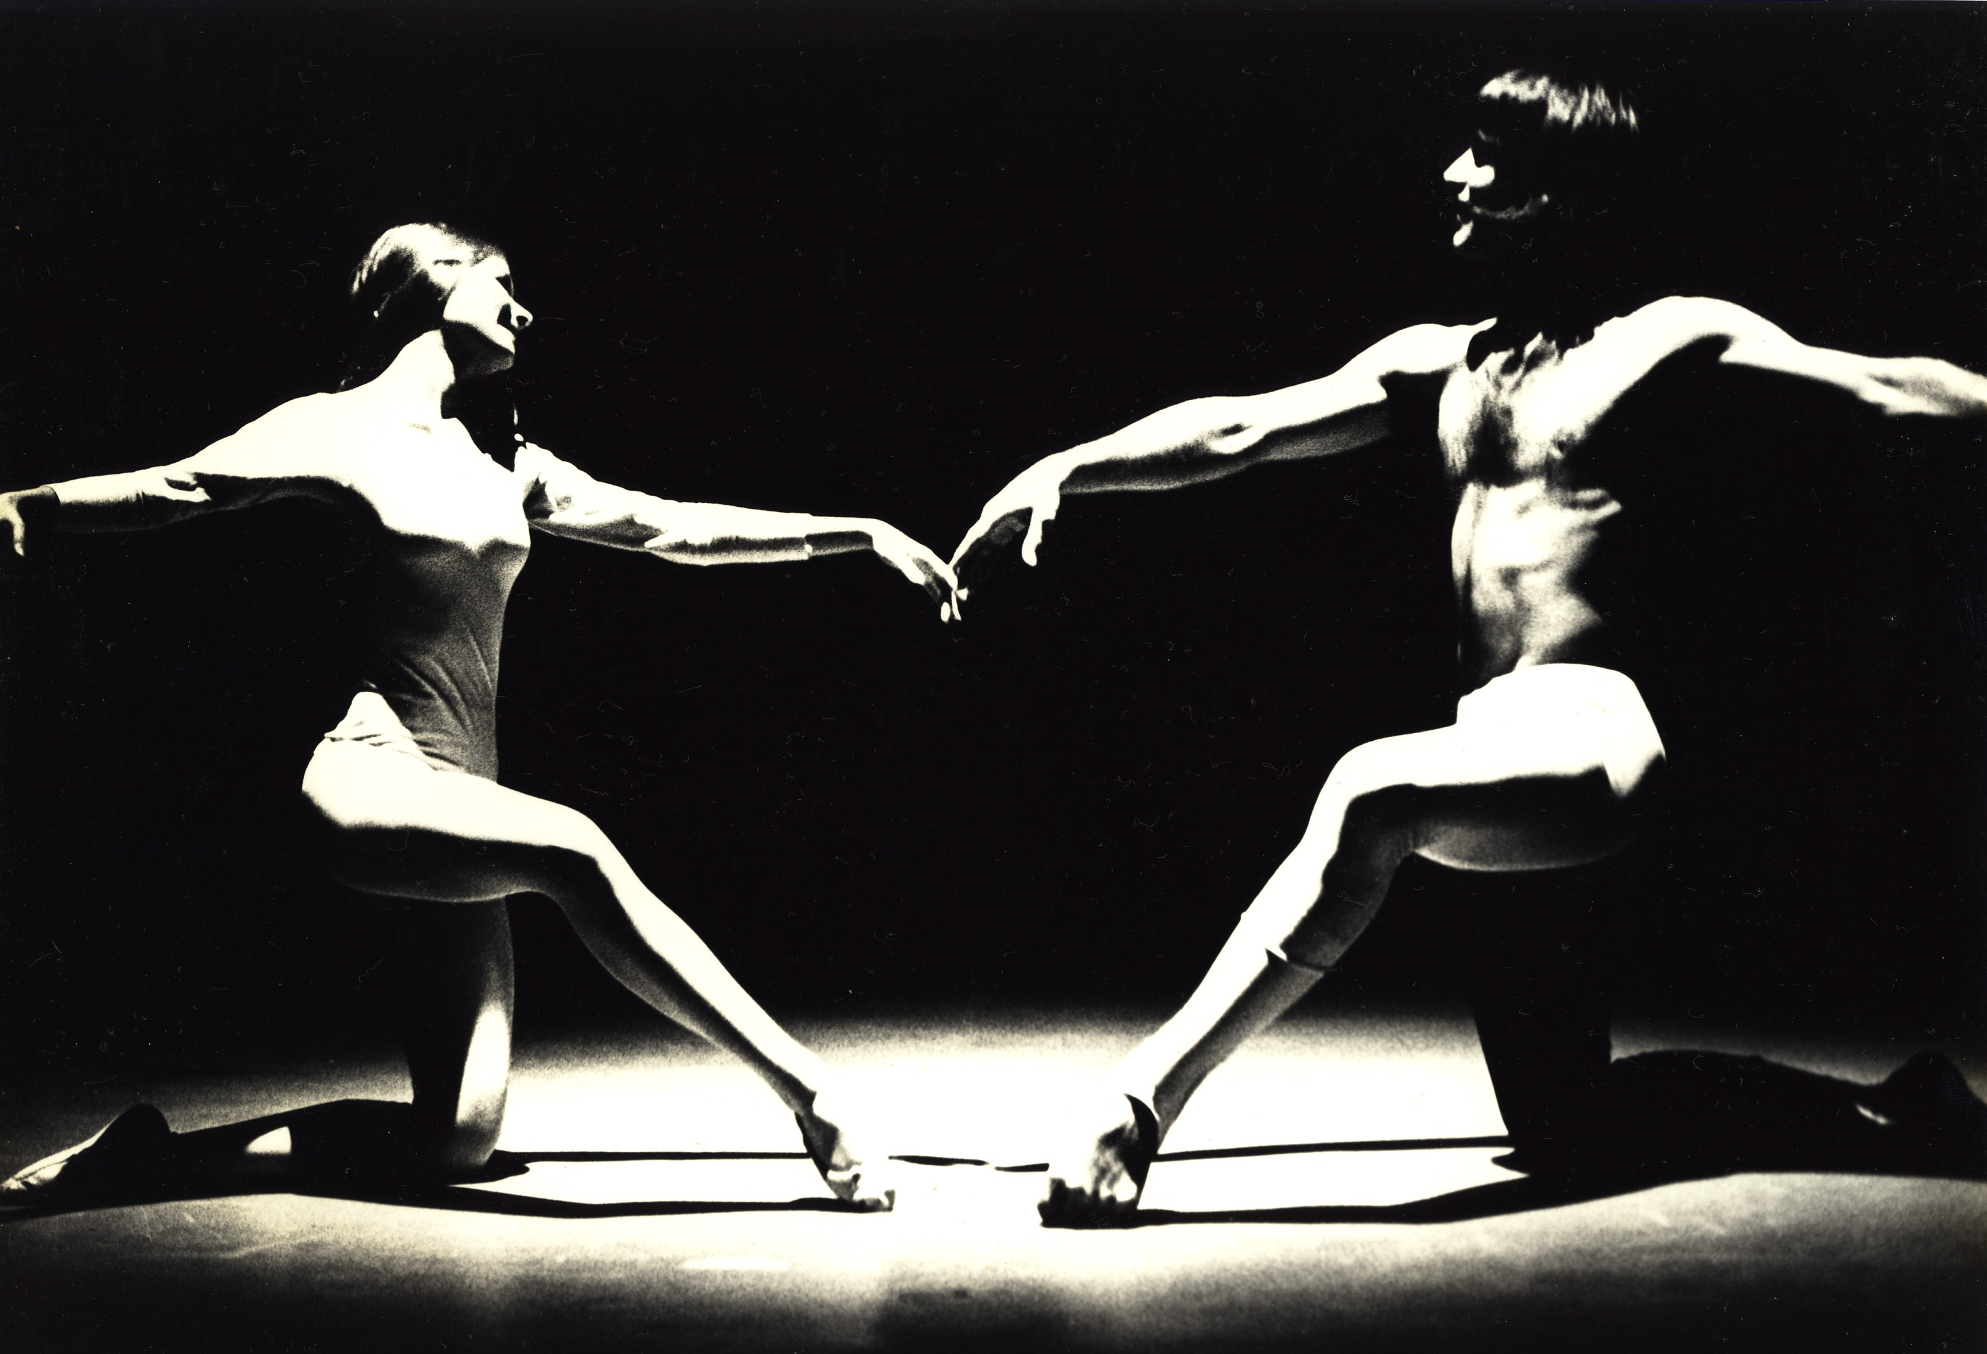

THE CRYSTAL SHIP The Doors

The emotional “Crystal Ship” begins. The passionate classical pas de deux binds the Joyful Couple hearts and minds. The encounter is carnal and highly erotic as flesh presses flesh. They are eternally one.
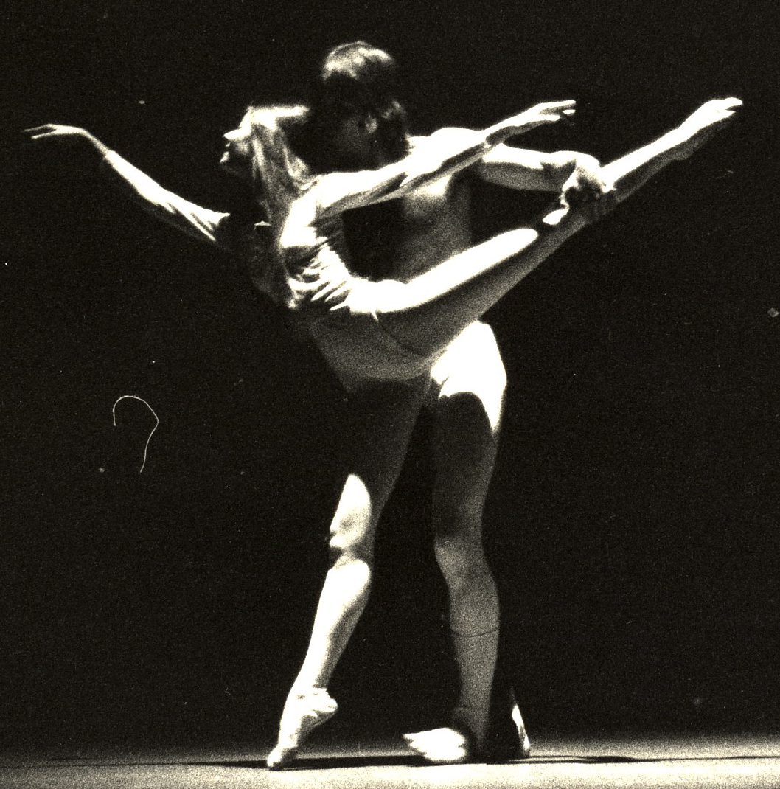
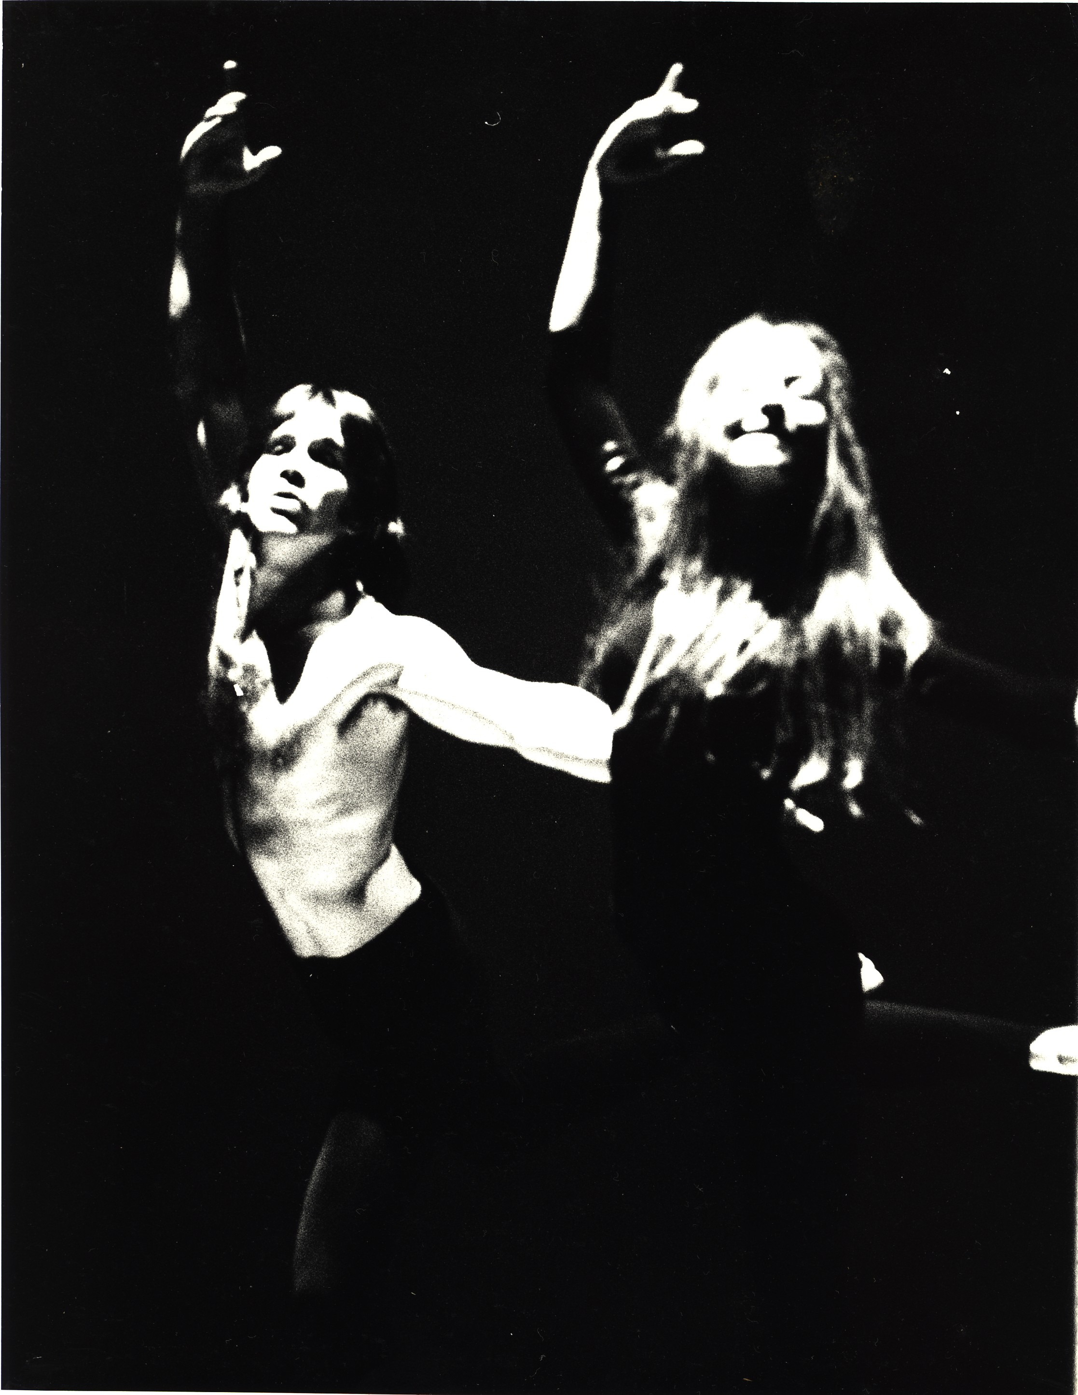
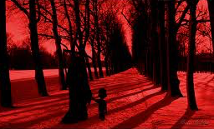
RIDERS ON THE STORM The Doors
Sounds of waves crash. Heavy fog creeps in and hugs the stage floor. The atmosphere turns gloomy and hostile. The Jester appears with the Zaloui on the edge of darkness. The two perform an abstract sequence of movements to the first verse.

On the second verse the Jester lures the Wicked Man on stage then retreats with the Zaloui. The Man performs the second verse. On the lyrics: “there’s a killer on the road…” a child appears chased by his mother… “take a long holiday, let your children play”, the Man approaches… the mother grabs her child and quickly exits, “if you give this man a ride, sweet memory will die – killer on the road.”

The Wicked Woman appears on the guitar break and joins him in a dark and wicked pas de deux. They slowly vanish into the darkness.

The Joyful Couple cautiously enter and counter with a highly charged pas de deux to the lyrics: “girl ya gotta love your man, girl ya gotta love your man… take him by the hand, make him understand… the world on you depends, our life will never end, gotta love your man… yeah”
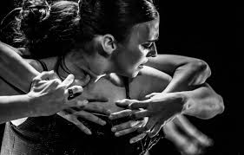
The Wicked Man returns the Joyful Woman flees. The Wicked and Joyful Men engage in an intense and increasingly sexual pas de deux. The Jester breaks the intensity and commands them to exit leaving the him alone on a dark stage. On the final verse, the couples reappear on the lyrics, “riders on the storm…”. They perform the same dance: same moves, syncopated, separate but melded. Lightning strikes and thunder rolls as the Couples exit and the Jester is once again, alone.

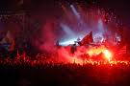
“This is the end, beautiful friend
This is the end, my only friend, the end
Of our elaborate plans, the end
The end of everything that stands, the end
No safety or surprise, the end
I’ll never look into your eyes again”
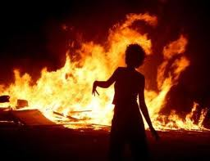
Lights flicker to the sound of helicopter blades spinning. The Jester looks to the Heavens. The Wicked Man slowly descends to the Wicked Woman below as the Jester retreats. The black winged creatures envelope the couple. As the lyrics start, the Couple emerges. Their arms reach out to the audience. “This is the end my only friend, the end.” Heavy fog hugs the floor. It’s an eerie scene. The two begin their final death dance. On the lyrics, “waiting for the summer rain” the Wicked Couple and the winged creatures scatter into the darkness.

Stillness descends upon the scene. Crickets keep the swamp alive. Fog thickens as eerie shadows of the winged creatures flash across the stage. We see faint images of man’s atrocities toward his fellow man projected onto the thick layer of fog. A fiery nuclear mushroom cloud shatters the images.

The tempo of the music accelerates. Suddenly, the Wicked Couple burst on stage. They perform a withering dance of strained twisted movements. On the lyric, “kill, kill”, the menacing creatures bite and tear at the Couple’s skin. Blood flows down their arms and torsos. The winged creatures drag them down and engulf them as a bloody arm slowly emerges and reaches toward the sky.
THE END The Doors

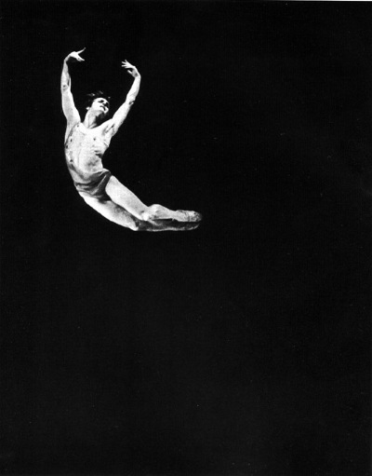
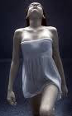

The Joyful Man slowly descends slowly to the floor and begin a swirling, leaping, and radiant dance. Light matches the color of the lyrics. As the divine, almost supernatural lead guitar begins, the Joyful Woman appears high above the audience. She performs an aerial fabric dance. On the sound of crashing guitars, she swoops down into the arms of the Man as they perform their final stunning pas de deux. The stage slowly blackens as the music fades.

Tiny plumes of light descend from above accompanying the slow drooping drum roll. The drum roll accelerates. A super loud burst of sound blasts as the Heavens light up. It’s a total theater white out. Brilliant white light flashes from beneath every seat. A thick column of intense white light from a higher source strikes the stage from above. The Joyful Couple move slowly into the column of light and slowly ascend into the Heavens. The cast emerges to witness the event. The Jester and Zaouli attempt to follow but are repelled by a screeching blistering guitar. The Joyful Couple disappear into an inverted dome bursting with colorful light high above. Accompanying the piercing guitars, bright colors blink and rotate inside the dome as spectacular explosions follows. The bloody arm sinks into the fiery depths as the Jester and Zaoluli slither into the darkness.
THE END
BOLD AS LOVE
Jimi Hendricks

Bold As Love thrusts the Joyful Couple to the Heavens as the Wicked Couple is hurled into the depths of Hell. The Jester and Zalouli watch from the edges of darkness.

A thunderous crushing guitar chord shatters the blackened silence as a flash of intense ultra-white light saturates the blackened theater.

