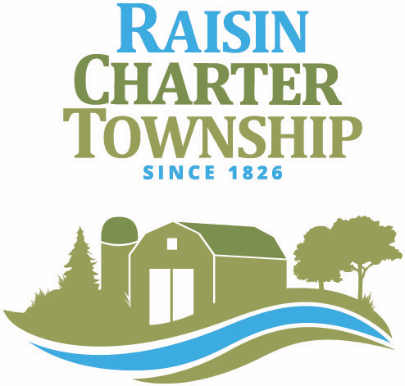

REGULAR MEETING
RAISIN CHARTER TOWNSHIP
BOARD OF TRUSTEES
APRIL 8, 2024 AT 5:30 P.M.

The Township Board met for a pre-meeting session at the Raisin Township Hall at 5:30 pm.
Members present: Palmer, C. Witt, D. Witt, Brousseau, Hawkins, Bunch.
Members absent: Smith

Public Comment: None

The following items were discussed:

- LCRC to repair cracks in Coachlite Subdivision @ N/C to Township
- Creating a Cemetery Board
- TALL walk through to discuss maintenance
- Cemetery Improvements

The Township Board began the regularly scheduled meeting at 6:30 P.M.

1. CALL TO ORDER: Meeting called to order by Supervisor Tom Hawkins.

2. WELCOME, PLEDGE, INVOCATION: Pledge and moment of silence.

3. ROLL CALL
Members Present: Dale Witt, Jim Palmer, Deb Brousseau, Cheryl Witt, Tom Hawkins, Susan Bunch
Members Absent: Kerry Smith

4. COMMUNICATIONS: None

5. PUBLIC COMMENT: Travis Bates

6. CONSENT AGENDA
6.1 Previous Months Minutes
6.2 Reports
6.3 Financial Reports

Motion Palmer, support Brousseau to approve consent agenda M/C all.

APPROVAL OF PAYMENT OF BILLS:

Accounts Payable: $ 475,519.52
Payroll: $ 97,993.23
Total Payables & Payroll: $ 573,512.75

Motion Palmer, support Brousseau to Approve bills. M/C all.

7. APPROVAL OF AGENDA
Motion by Brousseau, support Palmer to approve agenda. M/C all.

8. UNFINISHED BUSINESS:

9. NEW BUSINESS:
9.1 Lenawee County Hazard Mitigation Plan – Resolution #2024-040824
Motion Bunch, support Brousseau to adopt Lenawee County Hazard Mitigation Plan- Roll Call Vote:
Yeas: Brousseau, Bunch, Hawkins, D. Witt, C. Witt, Palmer, Nays: None; Absent: Smith M/C all.

9.2 Land Division: 2677 Sutton Rd - Property Owner: Koebel
Motion by Palmer, support D. Witt to approve split of Parent Parcel# RA0-120-2050-00 into:
RA0-120-2000-00 “Parcel A”
RA0-120-2010-00 “Parcel B”
RA0-120-2020-00 “Parcel C”
RA0-120-2030-00 “Parcel D”
RA0-120-2040-00 “Parcel E”
RA0-120-2060-00 “Parcel F”
RA0-120-2070-00 “Parcel G”’
RA0-120-2080-00 “Parcel H”
RA0-120-2090-00 “Parcel I”
RA0-120-2100-00 “Parcel J” M/C all.

9.3 Land Division: 5806 Centenial Rd - Property Owner: Whitman
Motion by Palmer, Support Brousseau to approve split of Parent Parcel #RA0-102-4970-00 into:
RA0-102-4960-00 “Parcel A”; RA0-102-4950-00 “Parcel B”. M/C all.

10. UPCOMING EVENTS:
KRTA Meeting 4/9 @ 9 AM
Planning Commission 4/9 @ 6:30 PM
MTA Conference April 22-25 Traverse City, MI

11. ADJOURN MEETING: Meeting adjourned at 7:PM

_______________________________________ _______________________________________
Tom Hawkins, Supervisor Susan Bunch, Clerk

