Statement of Intent

At SKAPE, we are committed to providing a caring, friendly and safe environment for all members of our school community where everyone has a right to work and learn in a relaxed and secure atmosphere. Bullying of any kind is unacceptable at our centre. If bullying does occur, everyone should be able to tell and know that incidents will be dealt with promptly and effectively. This means that anyone who knows that bullying is happening is expected to tell a relevant member of staff.

What Is Bullying?
Bullying is the use of aggression with the intention of hurting another person. Bullying
results in pain and distress to the victim.

Bullying can be:
- Emotional : being unfriendly, excluding, tormenting (e.g. hiding belongings, threatening gestures)
- Physical: pushing, kicking, hitting, punching or any use of violence
- Racist: racial taunts, graffiti, gestures
- Sexual: unwanted physical contact or sexually abusive comments
- Homophobic: because of, or focussing on the issue of sexuality
- Verbal: name-calling, sarcasm, spreading rumours, teasing
- Cyber: all areas of internet, such as email & internet chat room misuse
- Mobile threats by text messaging & calls. Misuse of associated technology, i.e. camera & video facilities

Why is it Important to Respond to Bullying?
Bullying hurts. No one deserves to be a victim of bullying. Everybody has the right to be
treated with respect. Pupils who are bullying need to learn different ways of behaving. The SKAPE Centre has a responsibility to respond promptly and effectively to issues of bullying.

Objectives of this Policy
- All staff, volunteers, pupils and parents should have an understanding of what bullying is.
- All staff and volunteers should know what the SKAPE Centre policy is on bullying and follow it when bullying is reported.
- All pupils and parents should know what the SKAPE Centre policy is on bullying, and what they should do if bullying arises.
- As a Centre we take bullying seriously. Pupils, parents and staff should be assured that they will be supported when bullying is reported.
- Bullying will not be tolerated.

Signs and Symptoms
A child may indicate by signs or behaviour that he or she is being bullied. Adults should be
aware of these possible signs and that they should investigate if a child:

- changes their usual routine
- is unwilling to go to school/Centre (school phobic)
- becomes withdrawn anxious, or lacking in confidence
- starts stammering
- attempts or threatens suicide or runs away
- cries themselves to sleep at night or has nightmares
- feels ill in the morning
- has possessions which are damaged or " go missing"
- has unexplained cuts or bruises
- becomes aggressive, disruptive or unreasonable
- is bullying other children or siblings
- stops eating
- is frightened to say what is wrong
- gives improbable excuses for any of the above
- is afraid to use the internet, telephone or mobile phone
- is nervous & jumpy when a cyber message is received

These signs and behaviours could indicate other problems, but bullying should be considered a possibility and should be investigated

Procedures
- If bullying is suspected or reported, the incident will be dealt with immediately by the member of staff who has been approached.
- All incidents should be taken seriously.
- Ensure that the victim feels safe. Reassure them and make sure they are not feeling foolish or inadequate.
- Talk to all who may have been involved.
- Report the incident to the SKAPE Centre Manager/School staff and record the incident appropriately e.g. the SKAPE Centre will record in a file on an incident report form, inform school/parents. If the incident is of a racial nature procedures for recording should be carried out as stated in the racial incidence policy.
- The bullying behaviour or threats of bullying must be investigated and the bullying stopped quickly.
- The Centre staff may choose to talk to the people involved including sharing of feelings and responsibility.
- Identify any trigger factors and take steps to prevent further incidence.
- Make it clear that bullying has consequences that will be dealt with along the guidelines in the behaviour policy and that serious incidents will be considered on an individual basis. All consequences will be explained carefully to both bully/bullies and victim.
- The SKAPE Centre staff will continue to monitor the situation.
- If there are further incidents the SKAPE Centre Manager will inform the head or deputy. In serious cases parents should be informed and will be asked to come in to a meeting to discuss the problem.

Outcomes
- The bully (bullies) may be asked to genuinely apologise.
- If possible, those involved will be reconciled.
- Further incidents will be recorded and rigorously monitored
- The SKAPE Centre Manager will work with the school to develop a Behaviour Support Plan
- All incidents will be taken seriously and investigated and dealt with, each case will be monitored to ensure repeated bullying does not take place.

Prevention
SKAPE Centre places particular emphasis on providing a secure learning, caring environment in which the confidence, physical and social skills of each pupil can be developed. We promote a positive approach to behaviour at the SKAPE Centre. To support this we have the following in place;
- Behaviour Policy
- Centre rules
- No Bullying Policy
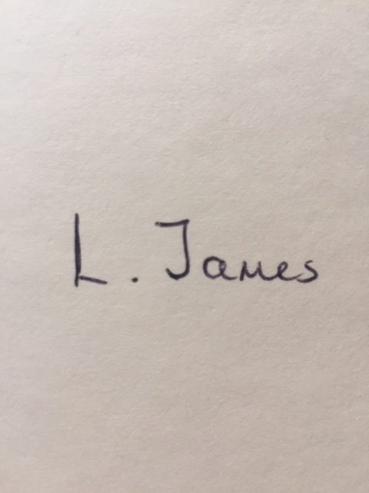

Signed: Date: 12/02/2024

Print Name: L. James
Reviewed: Annually
Review Date: February 2025

Date | Reason for Change | Approved By | Revision Number
31/01/23 | Initial policy | K Watson | 01
12/02/24 | Review | K Watson | 02

