INTRODUCTION
People who work alone without direct or close supervision are lone workers. On call workers’, those working overtime, those who work outside normal hours and those who open and close work premises may, at times, become lone workers. SKAPE employees will generally not be required to lone work, however in the instance that a lone working shift arises, the following policy and accompanying procedure should be adopted.
In many cases the risks to which lone workers are exposed are not significantly different to those of their co-workers. However, in some situations they may be at greater risk because of the nature and location of their work. These additional risks will include:
- The risk of violent attack to a worker opening or closing a premises where the attacker is intent on theft.
- The risk of violent attack because the worker is working with vulnerable people or in an area of social deprivation.
- The inability to summon assistance in the event of sudden illness or an accident.
- Unfamiliarity with the particular risks at a remote worksite.
- Unsafe practices adopted by lone workers free from supervision.
- Involvement in serious road traffic accidents.
- Manual handling of tools or equipment between van or car and workplace.
- Manual handling during the delivery of goods.
- Injury due to the layout of a remote work environment, especially for home-based display screen equipment users.
- Injuries due to previously unknown poor health of the lone worker.
- Lack of help or advice in the event of the unexpected.
The likelihood of injury to lone workers may be increased due to:
- Lack of training or awareness of the risk involved with the work activity and or lone working.
- Failure to establish regular communication with the lone worker.
- Lack of supervision.
- Failure to identify a potentially violent situation and implement effective control measures which include eliminating lone working.
- Failure to provide adequate emergency procedures or first aid arrangements and equipment.

LEGAL DUTIES
SKAPE is required to ensure so far as is reasonably practicable the health, safety and welfare of their employees whilst they are at work. There is no qualification or limitation to this requirement. Therefore, for lone workers, SKAPE will take into account where lone workers may go, what they do when they get there, the risks they face, and take steps to reduce those risks so far as is reasonably practicable.
CONTROL MEASURES
For SKAPE employees who are lone working, identification, and assessment of the risks to which they are exposed in the course of their work will be documented within the lone working risk assessment (appendix 1). Once the risks are identified consideration can be given to the appropriate measures required to reduce the risk to an acceptable level. Completed risk assessments are stored electronically and is accessible to the Centre Manager, the Health and Safety Lead and the employee concerned.
The following procedures have been put in place to monitor lone workers and mitigate the risks association with lone working.
- All staff members will be provided with a mobile phone and back up charging equipment upon employment.
- All lone workers should ensure that their work mobile phones are fully charged and in working order before their lone working shift.
- Mobile phones should have GPS enabled and this should be checked that this is discoverable by the Centre/Duty manager phone prior to the lone working shift.
- All staff should ensure a suitable phone signal, where reasonably practicable in the location where the lone working shift is to be carried out.
- Lone workers will be required to document the details of the shift/visit in the Lone Working Contact Log, held securely on site at the SKAPE Centre.
- If the lone working shift occurs anywhere other than the home of the lone worker, then a SKAPE ID badge should be worn at all times where reasonably practicable.
- All lone workers should follow the signing in and out system:
-Lone workers should use their work mobile phone to ‘sign in’ by sending a text (or another agreed form of communication suitable to the needs of the lone worker (if highlighted in the risk assessment) to the Centre/Duty Manager when arriving at the location.
-A confirmation text should be sent to the lone worker by the Centre/Duty Manager to confirm receipt.
-The same process should be followed for ‘signing out’ when leaving the location.
- Regular contact between supervisors and lone workers should take place by text/phone contact.
- Should a lone worker have immediate concerns about their safety or the safety of others during their shift:
-Emergency services should be used in the first instance.
-If the emergency services cannot be contacted, for example, due to the risk of a situation escalating, a telephone call (or another prior agreed form of communication documented in the risk assessment) should be made to the Centre/Duty Manager along with the phrase ‘Please cancel my 5 o’clock appointment’. In this instance the Centre Manager should contact the emergency services and provide the details held in the Lone Working Contact Log.
- Should a lone worker not arrive back at base (or home) at the estimated time of arrival and a sign out text (or other agreed form of communication) has not been received, the Centre/Duty Manager will attempt contact with the lone worker on 3 separate attempts 5 minutes apart. GPS for that phone should be checked for the employee’s location. If no contact is made then the Centre/Duty Manager should contact the emergency services.
- Medical fitness for lone working will be considered before any person is required to become a lone worker and should be reviewed at subsequent periodic appraisal interviews (minimum 6 monthly), or sooner if required.
- In very remote areas where there is no terrestrial mobile telephone signal or suitable wifi connection, SKAPE will not permit lone working.
Any control measures established will take account of the lone working activities carried out outside normal hours. For example, staff that are ‘on call’ or working overtime should be monitored when they are working outside normal office hours (9.30-14.30).
Staff will be consulted prior to the implementation of any monitoring system or contact arrangement should a lone working shift be deemed necessary. This will raise the awareness of the lone workers and provide information to staff to ensure that they understand why monitoring is necessary.
TRAINING
If lone working is deemed necessary for a SKAPE staff member, they will be required to undergo mandatory training in Lone working Awareness and Safety and Basic First Aid Training, prior to starting the lone working arrangement.
RISK ASSESSMENT
All staff members will be required to complete a lone working risk assessment prior to the start of the lone working arrangement (see appendix 1). The risk assessment should be updated as necessary, and at a minimum on a 6 monthly basis for as long as the lone working shift pattern continue. The Centre/Duty manager may wish to use the Lone Worker Check List (Appendix 2) to accompany the risk assessment in order to determine the suitability of the lone working arrangement.
RESPONSIBILTIES OF THE EMPLOYER
When considering lone working, SKAPE’s Centre/Duty manager will always consider if lone working is appropriate or necessary. In reaching that decision and deciding on the measures that should be taken to protect lone workers, the Centre/Duty Manager will:
- Where reasonably practicable, carry out informal inspections and/or a discussion of the workplace, whether belonging to the SKAPE Centre or another organisation/individual, to make sure the workplace is safe.
- Ensure that all lone working staff are appointed a work mobile phone or other communication device. In the event that equipment is faulty, the manager will organise a suitable replacement and/or repair prior to the lone working shift.
- Ensure all relevant risk assessments of activities are completed prior to any lone working activity.
- Arrange for lone workers to undertake mandatory training and ensure training records are kept up to date for all lone workers.
- Regularly check the lone working contact log to ensure staff compliance.
- Periodically speak to those who work alone informally to find out if they have any concerns that can be dealt with easily.
- Consider what emergency situations could arise during a lone working shift and ensure the correct procedures are in place to cover them.
- Make sure that lone workers are aware of and understand all the procedures and controls that SKAPE has in place for lone working.
- Ensure that all methods of contact for the duty team are in place, and devices are in full working order during the lone workers shift.
- Provide portable first aid equipment to all lone workers prior to the start of the lone working arrangement.
RESPONSIBILTIES OF THE EMPLOYEE
Following an agreement of lone working with the Centre/Duty Manager and completion of a lone working risk assessment, employees should:
- Advise the Centre/Duty Manager of any changes in circumstance/medical fitness/disability which may affect the suitability and/or safety of the lone working arrangement.
- Ensure that mandatory training has been completed prior to the start of the lone working arrangement.
- Plan ahead. Make sure you know where you are going and how to get there.
- Ensure all lone working activities are recorded in the Loan Working Contact Log held on site prior to the shift.
- Ensure GPS is enabled and discoverable.
- Use the ‘signing in and out’ system and check that mobile phones are in full working order prior to the shift.
- Set a reasonable time for travel.
- If you start to feel tired stop for a short break if practicable.
- Make sure you know, and follow, relevant safe working procedures.
- If injury occurs to either yourself or others- stay calm, and if you need assistance call your emergency contact (Centre/Duty Manager), or ring 999 giving clear instructions to them of where you are.
- Ensure any incidents or accidents that occur during a lone working shift are recorded in the Incident Log Book, held on site, within 24 hours. If this is not possible than speak to the Centre/Duty Manager to arrange on your behalf.
- If supporting a student during a lone working shift, be aware of body language, signs of anger, tension, stress, or nervousness, adopting a hostile or aggressive stance. Bear in mind that you may be sending out body language messages.
- Avoid invading other people’s space or touching them unless positive handling (Team Teach approved) is required.
- Keep mobile phones secure and out of sight and ensure the Centre/Duty Manager number is pre-programmed for emergency use.
- If using car parks in busy areas, use ones which are well-lit at night.
- Don’t leave a briefcase, lap top, or valuables visible in the car and lock all doors.
- If you are concerned about your safety, or the safety of others, call the emergency services. In the instance where this may not be possible use the code word contact method to the Centre/Duty Manager
- Ensure portable first aid equipment is accessible during the lone working shift.

Signed:  Date: 01/09/2025
Print Name: D. James

Reviewed: Annually
Review Date: September 2026

Date | Reason for Change | Approved By | Revision Number
02/01/24 | Initial Policy Written | K Watson | Rev 1
28/03/25 | Policy review | K Watson | Rev 2
01/09/25 | Policy Review | K Watson | 03

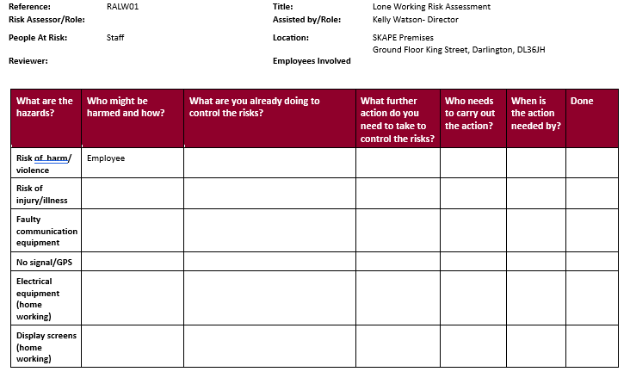
Appendix 1
SKAPE LONE WORKING RISK ASSESSMENT
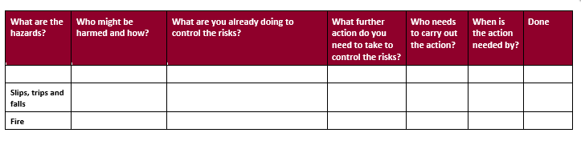
Appendix 2
LONE WORKING CHECKLIST

Name of employee Job Title Date
Question | Y/N
Has the worker received suitable training to carry out the task or activity?
Is the worker medically fit to undertake the task?
Has the worker sufficient information about the job, equipment or substances?
Does the work involve handling dangerous equipment that require supervision?
If cash is being handled, will they be at risk of violence?
Have they been fully trained in strategies for the prevention of violence?
Do they know how to control and defuse potentially violent situations?
Is there adequate provision for first aid?
Does the worker have the appropriate PPE and are they trained in its use?
Are there facilities to be able to contact the worker at all times?
Are there suitable arrangements for the worker in the event of an emergency?
Have plans been made to keep in touch with colleagues?
Is there a means for them to contact line managers, including an alternative?
Are they in possession of emergency contact numbers?
Is the access to, or exit from, the workplace safe and well lit?
Does the workplace present special risks for someone on their own?
Do the arrangements cover out of hours working?
For mobile staff only;
Do they leave an itinerary with another member of staff?
Are personal attack alarms provided where they are appropriate?
Do they carry forms for reporting incidents, including violence or threats of violence?

Comments and further actions required.

Prepared by: Date:
Signature:

