1. AIMS AND OBJECTIVES
- To ensure that children are protected at all times.
- To provide clear, unambiguous guidance to all staff as to their professional roles.
- To ensure good practice throughout the SKAPE Centre which is clearly understood by pupils, parents/carers, school staff, SKAPE Centre staff.
- To foster an ethos of trust, respect and equality within the SKAPE Centre.
- To ensure that SKAPE Centre staff, school staff, parents/carers and pupils are aware of the SKAPE Centre's responsibility on confidentiality.
- To provide consistent messages at the SKAPE Centre about handling information about children once it has been received.
- To encourage children to talk to their parents, carers and school and SKAPE Centre staff.
- To ensure that pupils and parents/carers know that SKAPE Centre staff cannot offer unconditional confidentiality.
- To ensure that if there are child protection concerns, the correct procedures are followed.
- To ensure that parents/carers/school staff have a right of access to any records that the SKAPE Centre might hold on their child but not to any other child for whom they have no caring responsibility.

2. WHERE AND TO WHOM THE POLICY APPLIES
The policy applies to and is made available to:
- All staff employed by the SKAPE Centre and from the school at which the pupil attends.

3. POLICY GUIDANCE
The Centre prides itself on effective communication and close relationships with school staff/parents/carers. SKAPE Centre staff are always available to talk to staff/children/parents/carers about issues causing them concern and may in some cases support children in talking to their parents/carers. Staff should adhere to the following guidance:
- When talking with pupils it is important to be aware of the maintenance of professional boundaries.
- Staff must make it clear to children that they cannot offer unconditional confidentiality when they first begin to talk about something sensitive or an issue concerning their welfare.
- Children should be warned that if there is a child protection issue where they, or others,
are likely to be at risk of significant harm, staff have a duty to inform the SKAPE Centre and school's designated Child Protection Officer, who in turn might need to involve other agencies. This must be done sensitively. It should be made clear that appropriate people who can help will be informed but only those who need to know will be involved.
- Centre staff can only offer confidentiality to pupils on issues that do not involve significant illegal activities, e.g. vandalism, arson etc... If the conversation begins to move to this kind of issue, children must be warned that confidentiality cannot be guaranteed.
- In all cases where it is felt that confidentiality with a child will be broken, the pupil must be informed in the first instance and reassured that their best interests will be maintained.
- All information about individual children should be considered private and should only be shared with those staff who have a need to know.
- All social, medical and personal information held by the SKAPE Centre should be kept secure in a manner that means it cannot be accessed by individuals other than SKAPE Centre/school staff.
- Information collected for one purpose should not be used for another.
- All children have a right to the same level of confidentiality irrespective of gender, race,
religion, medical concerns and special educational needs.
- Pupils should be made aware of the specialist confidential services that may be available in the school community e.g. the public health nurse.

4. CONFIDENTIALITY & INFORMATION ABOUT FAMILIES/CARERS/PARENTS
The SKAPE Centre recognises that sometimes there may be family issues which might affect a pupil and which the family might only disclose if they can be sure the information will be treated confidentiality. SKAPE Centre staff will respect the wishes of the family and where it is necessary to share the information given, this will be discussed with the parent first, unless a pupil is considered to be at an immediate risk and/or there is an overriding child protection concern.

5. INFORMATION ABOUT STAFF
All staff can normally expect that their personal situations and health will remain confidential
unless:
- It impinges on their contract terms.
- It endangers pupils or other members of staff.
- There is a legal obligation to disclose information
- It is necessary for disclosure in legal proceedings
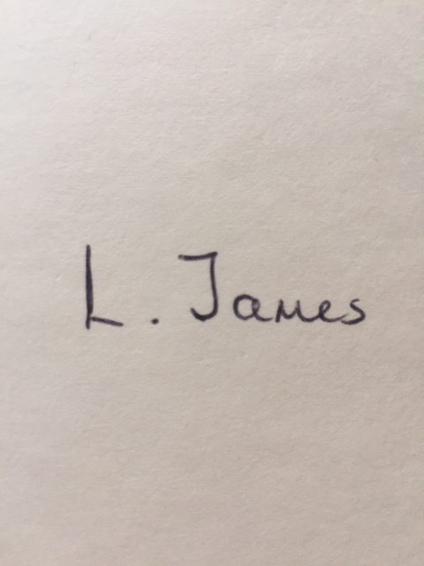
- Despite the duty of confidence and the staff members interest, the wider public interest justifies disclosure.

Signed: Date: 31/03/2024

Print Name: L. James
Reviewed: Annually
Review Date: April 2025

Date | Reason for Change | Approved By | Revision Number
31/03/23 | Initial Policy | K Watson | 01
31/03/24 | Policy Review | K Watson | 02

