INTRODUCTION
This policy sets out what is ‘acceptable’ and ‘unacceptable’ use of mobile phone and handheld devices by the whole SKAPE Centre community (students, staff and visitors) while they are at the Centre or undertaking activities away from the Centre.
This applies to all individuals who have access to personal and/or work-related handheld devices within the broadest context of the setting. It includes children and young people, parents and carers, practitioners, managers, volunteers, students and visitors. This list is not exhaustive.

It is to be recognised that it is the enhanced functions of many handheld devices that will give the most cause for concern; and which should be considered the most susceptible to potential misuse. Examples of misuse include the taking and distribution of indecent images, exploitation, and bullying (please see Safeguarding and No Bullying Policy).

It must be understood that should handheld devices be misused, there will be a negative impact on an individual’s safety, dignity, privacy and right to confidentiality. Such concerns are not to be considered exclusive to children and young people, so the needs and vulnerabilities of all must be respected and protected.

Mobile phones and handheld devices can also cause an unnecessary distraction during the working day and are often to be considered intrusive when used in the company of others.
AIMS
The purpose of this policy is to prevent unacceptable use of mobile phones, camera-phones and other hand-held devices by the SKAPE Centre community, and thereby to protect the Centre’s staff and students from undesirable materials, filming, intimidation or harassment.
GUIDELINES
The following guidelines should be followed:

- The SKAPE Centre learning area will be mobile use free during all learning times.
- Mobile phones brought into school are entirely at the staff member, student’s & parents’ or visitors’ own risk. The Centre accepts no responsibility for the loss, theft or damage of any phone or hand-held device brought onto the premises.
- Student mobile phones which are brought into the Centre must be turned off (not placed on silent) and stored out of sight during lesson times. They must remain turned off and out of sight until the end of the school day when students have left the site. Staff members may use their phones during school break times.
- All visitors are requested to keep their phones on silent, stored safely and out of use whilst on site.
- The recording, taking and sharing of images, video and audio on any device is to be avoided; except where it has been explicitly agreed otherwise by the Centre Manager. Such authorised use is to be monitored and recorded. All mobile phone use is to be open to scrutiny and the Centre Manager/DSL is to be able to withdraw or restrict authorisation for use at any time if it is to be deemed necessary. All videos should be removed from the device as soon as possible and disposed of securely at the end of the period of work.
- The Centre reserves the right to search the content of any mobile or handheld devices on the Centre premises where there is a reasonable suspicion that it may contain undesirable material, including those which promote pornography, violence or bullying. Staff mobiles or handheld devices may be searched at any time as part of routine monitoring.
- Where parents or students need to contact each other during the school day, they should do so only through the Centre’s telephone. Staff may use their phones during break times. If a staff member is expecting a personal call they may leave their phone at the Centre’s Reception, or seek specific permissions to use their phone at other than their break times.
- Mobile phones and personally-owned devices will not be used in any way during lessons or formal school time. They should be switched off or silent at all times.
- Mobile phones and personally-owned mobile devices brought in to the Centre are the responsibility of the device owner. The Centre accepts no responsibility for the loss, theft or damage of personally-owned mobile phones or mobile devices.
- Mobile phones and personally-owned devices are not permitted to be used in certain areas within the Centre site, e.g. toilets.
- Mobile phones will not be used during lessons unless as part of an approved and directed curriculum-based activity with consent from a member of staff.
- The Bluetooth and sharing functions of a device should be switched off at all times and not be used to send images or files to other mobile phones.
- No images or videos should be taken on mobile phones or personally-owned mobile devices without the prior consent of the person or people concerned.

Students’ use of personal devices
- The SKAPE Centre strongly advises that student mobile phones and devices should not be brought onto the premises.
- The SKAPE Centre accepts that there may be particular circumstances in which a parent wishes their child to have a mobile phone for their own safety.
- If a student breaches the Centre policy then the phone or device will be confiscated and will be held in a secure place in the Reception. Mobile phones and devices will be released to parents or carers in accordance with the Centre policy.
- If a student needs to contact his or her parents or carers, they will be allowed to use the Centre’s main phone. Parents are advised not to contact their child via their mobile phone during the school day, but to contact the SKAPE Centre itself.
- Students should protect their phone numbers and communication codes (such as passwords and pins) by only giving them to trusted friends and family members. Students will be instructed in safe and appropriate use of devices and will be made aware of boundaries and consequences.
- Students will be provided with devices to use in specific learning activities under the supervision of a member of staff if required. Such devices will be set up so that only those features required for the activity will be enabled.

Staff’s use of personal devices
- Any permitted images or files taken in the Centre on Staff handheld devices including mobile phones and tablet devices must be downloaded from the device and deleted before the end of the day.
- Staff handheld devices including mobile phones, tablet devices and may be added to the school wireless connection as part of Acceptable Use Agreement.
- Staff are not permitted to use their personal mobile phones or devices for contacting children, young people or their families within or outside of the setting in a professional capacity.
Staff will be issued with a school phone where contact with students, parents or carers is required.
- Staff devices should use encryption and Advanced password where available.
- Staff will be provided with handheld devices if the Centre deems necessary to deliver lessons. Personal devices should not be used as part of teaching and learning.
- Mobile Phones and personally-owned devices will be switched off or switched to ‘silent’ mode during the school day, except during breaktimes when personal use of mobiles is permitted away from the vicinity of the students.
- If members of staff have an educational reason to allow students to use mobile phones or a personally-owned device as part of an educational activity then it will only take place when approved by the Centre Manager.
- Staff should not use personally-owned devices, such as mobile phones or cameras, to take photos or videos of students and will only use work-provided equipment for this purpose.
- If a member of staff breaches the school policy then disciplinary action may be taken.
- Where staff members are required to use a mobile phone for school duties, for instance in case of emergency or during off-site activities, or for contacting students or parents, then a school mobile phone will be provided and used. In an emergency where a staff member doesn’t have access to a school-owned device, they should use their own device and hide (by inputting 141) their own mobile number for confidentiality purposes. A record of staff members numbers will be held at Reception.
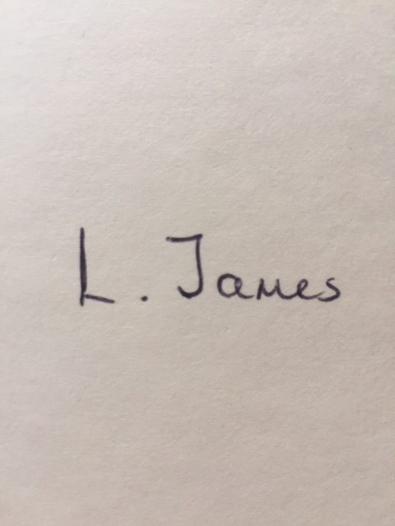
Signed: Date: 31/01/2024

Print Name: L. James
Reviewed: Bi- Annually
Review Date: February 2026

Date | Reason for Change | Approved By | Revision Number
31/01/23 | Initial policy | K Watson | 01
31/01/24 | Policy review- New government guidance to be taken into account should this occur. | K. Watson | 02

