CONTENTS
Introduction and aims
Fire Hazards
Responsibilities
Training
Fire Evacuation
Fire Drills
Risk Assessment
Housekeeping
INTRODUCTION AND AIMS
SKAPE is committed to ensuring the safety of all persons who are in, or in the vicinity of any premises from which we conduct our business activities. This includes safety from fire and its effects. This policy has been developed to ensure staff awareness of safety from fire and its effects, in line with current legislation and government guidelines including:

- The Fire Safety Order (2021); the fire safety legislation in England and Wales which regulates premises and sets out responsibilities for individuals subject to the Fire Safety Order, and places the duty of keeping people safe from fire on the upon the ‘Responsible Person’.
- ‘Fire Safety in the Workplace’ (Gov.UK)
FIRE HAZARDS
A fire hazard is anything that can start a fire, such as ignition sources or combustible materials. Fire hazards include:

- Portable electrical appliances (such as kettles, toasters, hairdryers, heated hair-styling equipment, desk lamps, desk fans, computers, etc)
- Loose or hanging cables, damaged plug sockets and/or light switches
- Smoking or use of other fire-generating items/equipment (candles, fire-lighters, etc) on our premises or in close proximity to it
- Blocked fire escapes / damaged fire exit locks
- Piles of paper, boxes or files around work-spaces, in corridors, cupboards and/or fire exit areas.
- Faulty or poorly managed electrical equipment

RESPONSIBILITIES

Fire hazards can occur in multiple ways, and we expect every SKAPE employee to understand where the dangers lie, how to avoid fire risks arising, and, how to handle a breakout should it occur.

SKAPE employees should:
- Be alert to any fire hazards.
- Immediately report any concerns about hazards and/or fire safety to the nominated fire safety officer or ‘responsible person’.
- Ensure that you are not the cause of any fire hazard by:
- Not leaving permitted electrical appliances plugged in when they are not being used (including kettles, toasters, hairdryers, heated hair-styling equipment, desk lamps, desk fans, etc).
- Turning off your computer, where relevant, when not in use and disconnecting laptops entirely from any plug socket before you leave the building at the end of your working hours each day.
- Not using portable electrical radiators, heaters, fan units or other heat-generating appliances (including kettles, toasters, microwaves, hairdryers, heated hair-styling equipment, etc) without the prior consent in writing from the fire safety officer.
- Smoking, lighting candles or otherwise handling matches, fire lighters or other fire generating items on our within the vicinity of our premises.
- Damaging plugs, cables, wiring, lights and/or lighting equipment.
- Blocking fire escapes, e.g. by piling items in front of these exits.
- Leaving papers, files and other flammable items piled on, in or around your work-space , rather than keeping them in lockable, fire safe containers, (e.g. filing cabinets) or practising a paperless office strategy.
- Handling or storing chemical or flammable goods unless you have the express knowledge and consent of the fire safety officer/responsible person.
- Engaging anyone to carry out maintenance, renovation, refurbishment etc works of any nature on our premises without the express prior consent of the fire safety officer/responsible person
- Tampering with any fire equipment.
- Only using any equipment that you have been permitted by your line manager or the fire safety officer/responsible person to use, and only for the purpose for which it is intended.
- Report:
- Any fire safety equipment, such as extinguishers or fire blankets, that are missing or look damaged o any plug sockets or other electrical interfaces that are not working or look damaged or that have been misused / look as if they have been.
- Comply immediately and responsibly with any fire evacuation orders, whether practice drills or real evacuations.
- Attend fire safety and any other health and safety training sessions that we request. Our fire safety officer/responsible person will inform staff what training is relevant to their role and contracted duties to SKAPE.
- Properly use any fire safety equipment that you have been trained and authorised to use by our fire safety officer.
- Sound the alert, evacuate and call 999 - do not tackle any fire hazard on your own, unless you have been properly trained to do so.

SKAPE is committed to ensuring that there is a responsible person who is in a position to support the implementation and maintenance of this policy, ensuring that they have enough authority to exert influence and be able to communicate effectively to both our staff and senior management. The Responsible Person is a legally created entity, as defined in Article 3 of The Regulatory Reform (Fire Safety) Order 2005. The Responsible Person must carry out an assessment of the fire risks to people on the premises or within its vicinity (these are described as ‘relevant persons’ in the order).
SKAPE’s Responsible Person: Dale James
The nominated person is responsible for the Centre’s overall fire safety compliance. This means that:

- by law, they are called the ‘Responsible Person’ when it comes to fire safety.
- within the SKAPE Centre they take responsibility for ensuring that SKAPE acts at all times to reduce the risk of workplace fire.
- Ensures a safe place of work for all staff and visitors.
- Develop and maintain a robust fire safety plan which accurately reflects and predicts risks and concentrates on life preservation not equipment preservation.
- Has a top-down commitment to fire safety from top management all the way across and throughout the company structure
f) Has clearly established and allocated roles and responsibilities for fire safety
g) Regularly assesses risks of ongoing business and our compliance with our fire safety plan, as well as risks and compliance of any new projects; and monitors and keeps accurate records of the performance of staff and our business against them, including the details of evacuation drills, any incidents and how they were resolved and what staff training has been carried out.
h) Regularly conducts staff training on fire safety and enforces compliance with this policy and our fire safety rules.
i) Engages someone competent to conduct regular fire risk assessments (this might not be the fire safety officer but an expert appointed for this purpose).
j) Ensures that all staff have knowledge of emergency evacuation plans – especially plans and solutions for staff who are disabled, for whom personal emergency evacuation plans must be developed in conjunction with that less able person (and stored in hard copy at their usual workplace).

The Responsible Person will also ensure the following duties are adhered to:

- Ensure each working day that all exits are available and useable.
- Firefighting equipment is in the designated places (weekly).
- All new staff are given induction training.
- Checking and testing the fire alarm (weekly).
- Completion of the Fire Risk Assessment.
- Ensuring the regular servicing of the fire alarm, any emergency lighting and
- Firefighting equipment.
- Ensuring electrical appliances are made subject to PAT testing each year.
- Provision of refresher training for staff once a year.
- Completion of a fire drill every term (or more frequently if the need arises).

TRAINING
Centre staff will be expected to complete and pass mandatory training in Fire Safety Awareness, applicable to their job role, as part of the workplace induction. Training should be completed within the first week of employment and updated on a yearly basis. A training record will be held in the Centre’s HR system and overseen by the Responsible Person.
FIRE EVACUATION
Centre staff should familiarise themselves with the Centre’s Fire Evacuation Procedure (See ‘Fire Evacuation Procedure- Appendix 1). The centre operates a ‘simultaneous’ evacuation procedure, where everyone on the premises will exit the through the escape route in a calm and orderly fashion, obeying any instructions the Responsible Person gives them, and assembling at the designation point.
SKAPE Fire Assembly Point: Queens Street Car Park, Darlington, DL3 6JH
Personal Emergency Evacuation Plan
Under the Health and Safety at Work Act (1974) and the Equality Act (2010), workplaces of all kinds are required by law to provide reasonable adjustments to their workplace if anyone requires it for safety reasons. Personal Emergency Evacuation Plans or ‘PEEPs’ are bespoke and specific fire safety evacuation plans that are designed for specific individuals who may not be able to make use of the normal means of emergency evacuation without assistance. The development of such plans is primarily the responsibility of the Responsible person.
Individuals who may be in need of a PEEP include (but are not limited to):

- Disabled individuals or individuals who have additional needs relating to mobility, sight, cognition or hearing.
- Expectant/nursing mothers.
- Anyone with a good reason to not be familiar with the premises or evacuation procedure eg: part time staff, new employees or visitors.
- Anyone working in an area where a fire alarm is inaudible.
- Those who cannot understand the fire safety information- for example if English is not their first language.
- Those on higher floors, or parts of the building that are more complex to navigate.
- People with temporary injuries.
- Anyone with special care needs

A PEEP should contain information about the specific safety measures to be used in case of a fire for specific people. This could include the following:
- Visual alarms
- Vibrating pagers
- Braille signs, audio alarms/tapes or large print
- Assistance from a designation person- or a ‘buddy’ system
- Special arrangements eg. Ramps, evacuation chairs

FIRE DRILLS
Fire Drills are conducted on a termly basis and organised by the Responsible Person. Following completion of a fire drill the Responsible Person will complete the ‘Emergency and Fire Evacuation Drill Record’ (Appendix 2). All employees are required to comply with fire drills taking instruction from the Responsible Person throughout.

FIRE SAFETY ARRANGEMENTS
The Responsible Person will ensure the Centre is adhering to the following fire safety arrangement:

- A full list of every staff member with the necessary training to fight fires in an emergency.
- The location of all firefighting equipment on the premises.
- Details of all different types of firefighting equipment stored on the premises and what rooms/types of fires it should be used against.
- A plan of how, upon discovering a fire, the fire brigade will be contacted.
- Termly testing and logging of the fire alarm bell.
- Monthly visual inspection and logging of fire extinguishers.
RISK ASSESSMENT
The fire risk assessment helps identify the fire safety precautions the Responsible Person must take to comply with the Fire Safety Order. The risk assessment process involves an inspection of the premises to identify potential fire hazards, to ensure adequate measures to stop fire starting and that adequate fire protection measures are in place to protect everyone in the building. Fire risk assessment should cover the following:

- Identification of the fire hazards.
- Identification of the people at risk.
- Evaluation of the risk (has it been removed or reduced?)
- Record of findings, emergency plans and applicable training.
- Regular review and update of the assessment.

Fire safety risk assessments are completed by the Responsible person on yearly basis, or more frequently when required. See Appendix 3 for a template risk assessment.

A 2 yearly fire safety inspection and accompanying risk assessment is carried out by an appropriately qualified independent fire safety advisor, and any associated actions following this will be overseen by the Responsible Person.
HOUSEKEEPING
Housekeeping is a vital everyday practice when it comes to fire safety. Poor housekeeping is a major risk factor when it comes to fire hazard. All staff should adhere to the duties outlined in this policy to ensure that fire risk due to poor housekeeping is eradicated. Staff are required to adhere to the following control measures:

- Carry out good housekeeping on a regular basis.
- Remove waste/excess carboard boxes used paper, discarded card and other flammable materials from the premises as soon as possible once they are no longer needed.
- Avoid storing flammable waste in places like hallways, near fire exits, or alongside emergency escape routes.
- Make sure all spillages of hazardous materials such as cleaning chemicals, cooking oils, baking substances, industrials fluids, etc are cleaned up and made safe as quickly as possible.
- Store hazardous fuel sources as far away from potential ignition sources as possible.
- Take faulty damaged or otherwise sub-optimal equipment out of regular use as soon as possible.
- In the above instance, the responsible person will arrange for the arrival of repair staff or replacement equipment.
- Always extinguish and dispose of cigarettes properly, and that smoking is NOT PERMITTED anywhere on the premises. Designated smoking areas are the only areas in which smoking is permitted.
- Conduct visual checks on all plug sockets and ensure they are deactivated when not in use.
- Make sure there is no overloading of electrical sockets, and the use of extension leads is kept to a minimum.

Signed: 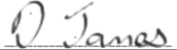 Date: 01/09/2025
Print Name: D. James
Reviewed: Annually
Review Date: September 2026

Date | Reason for Change | Approved By | Revision Number
05/08/23 | Initial Policy Written | K Watson | Rev 1
05/09/24 | Policy Review (D. James) | K Watson | Rev 2
01/09/25 | Policy Review | K Watson | 03

Appendix 1: Fire Evacuation Procedure
All staff are required to follow the steps below upon discovering a fire:
SKAPE fire alarm bell location: Wall behind reception
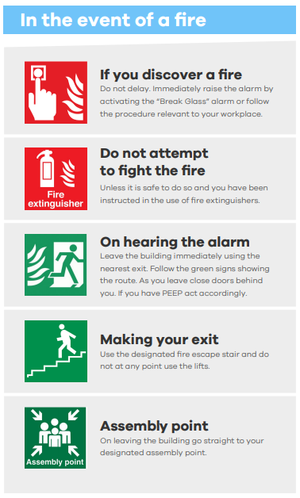

SKAPE Step-by-Step Evacuation Procedure:
a) Upon discovering a fire, a member of staff will raise the fire alarm, located behind reception.
b) A senior member of staff will ensure all students immediately stop what they are doing, and move safely to the main entrance, and be escorted outside to the agreed assembly point. This assembly point will normally be immediately across the car park from the SKAPE building, at a pedestrianised area of Queen Street Car Park.
c) Another member of staff will take a copy of the attendance register for that date to the assembly point and mark off the students to ensure every one is present.
d) The fire warden (to be easily identified by wearing a high vis jacket – normally Dale James, the SKAPE Fire Safety warden) will conduct a sweep of the building to ensure no person, student, staff or visitor, has been left unnoticed in any part of the room, including the toilet, and then will come out lastly to join the assembled group and to inform senior staff that the building is clear.
e) If the above is being conducted as a fire drill, the fire warden may wish to time to the evacuation with the aim of ensuring it has been completed in a timely fashion and if any improvements need to be made whereby a new time target will be set for the next drill. This will then be recorded in the Fire Drill Evaluation and any action points noted.
f) During a fire evacuation all staff and students must:
-Obey the instructions of the Responsible Person.
-Leave any and all personal belongings in the building
-Move in the correct order to the nearest assembly point- Queen Street Car Park
-Inform the Responsible Person of any obstructions or other problems
-Obey the instructions of the firefighting personnel once outside

Appendix 2: Fire Evacuation Drill Evaluation

Use this form to record Emergency Evacuation tests or drills. As a minimum, they should be held at six monthly intervals.
EVACUATION DETAILS | Fire Marshal / Warden Name(s): Dale James
Date of the drill: Time of the drill: Evacuation time: | Roll call conducted  at assembly point Yes / No  All accounted for:  Employees Yes / No  Contractors Yes / No  Visitors Yes / No
Organiser:

Premises or areas involved:

1. Was the alarm sounded promptly? Yes/No

2. Could the alarm be heard throughout the premises? Yes/No

3. Did the person chosen at random to sound the alarm understand the routine? Yes/No

4. Did all staff understand the routine and act effectively? Yes/No

5. Is there a need for further staff training or instruction? Yes/No

6. Was a random activation point chosen? Yes/No

7. Were there any other particular problems in the evacuation? Yes/No
Record further details overleaf and summarise proposed actions in the next column.
8. Were all employees and visitors accounted for? Yes/No

9. Was this evacuation the result of a false alarm? Yes/No
 | State action necessary:
 | Number of Employees involved
 | Dept / Shift | Number of Employees

Person compiling record: ………………………………
Signature: ………………………………………… Date: …………………………

Use this space to record both positive and negative outcomes from the evaluation. Where problems are identified consider and suggest remedial action. Summarise these in the right hand column of the previous page.

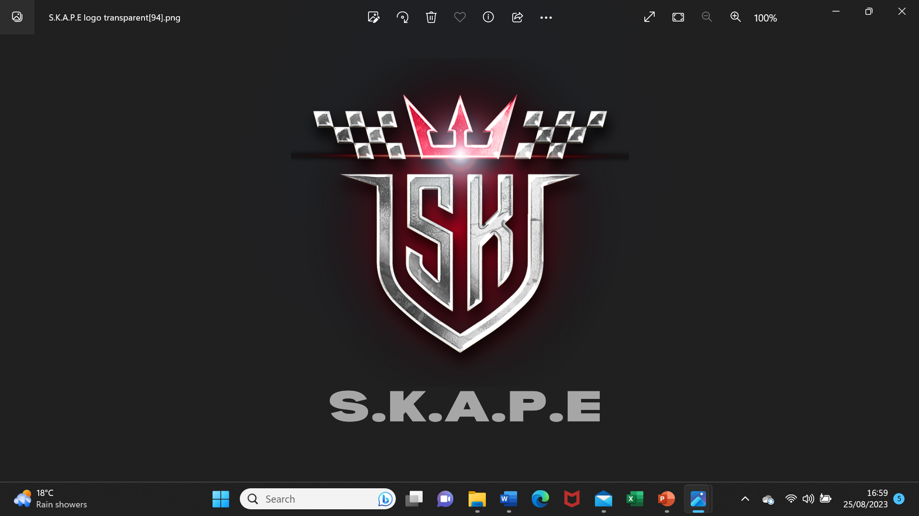
Appendix 3: Fire Safety Risk Assessment
Fire Risk Assessment.pdf

