Background

This policy deals with the policy and practice which informs the SKAPE Centre's use of exclusion. It is underpinned by the shared commitment of all members of the SKAPE Centre's community to achieve two important aims:

1. The first is to ensure the safety and well-being of all members of the SKAPE Centre community, and to maintain an appropriate education environment in which all can learn and succeed;

2. The second is to realise the aim of reducing the need to use exclusion as a sanction.

Introduction

The decision to exclude a pupil will be taken in the following circumstances:

(a) In response to a serious breach of the SKAPE Centre's Behaviour Policy

(b) If allowing the pupil to remain at the SKAPE Centre would seriously harm the education or welfare of other persons or the pupil him/herself/themself at the SKAPE Centre.

Exclusion is an extreme sanction and is only administered by the SKAPE Centre Manager. Exclusion, whether for a fixed term or permanent, may be used for any of the following, all of which constitute examples of unacceptable conduct, and are infringements of the SKAPE Centre's Behaviour Policy:

- Verbal abuse to staff and others
- Verbal abuse to pupils
- Physical abuse to/attack on staff
- Physical abuse to/attack on pupils
- Indecent behaviour
- Damage to property
- Misuse of illegal drugs
- Misuse of other substances
- Theft
- Serious actual or threatened violence against another pupil or a member of staff
- Sexual abuse or assault
- Supplying an illegal drug
- Carrying an offensive weapon
- Arson
- Unacceptable behaviour which has previously been reported and for which SKAPE Centre's sanctions and other interventions have not been successful in modifying the pupil's behaviour.

This is not an exhaustive list and there may be other situations where the SKAPE Centre Manager makes the judgement that exclusion is an appropriate sanction.
At times the SKAPE Centre Manager will decide not to use the extreme sanction of an exclusion but will decide that a Pastoral Support Plan should be drawn up to try to avoid the sanction of an exclusion in the future. This might be accompanied by an internal exclusion.
Exclusion procedure
Most exclusions are of a fixed term nature and are of short duration (usually between one and three days). This will be discussed first with the school and then parents if there is mutual agreement that exclusion is necessary. If a child is excluded on more than one occasion, the SKAPE reserves the right to terminate any contractual agreement with the school for that particular child if the placement is clearly not working. ( See Permanent exclusion below.)

A ‘return to SKAPE Centre’ meeting will be held following the expiry of the fixed term exclusion and this will involve the SKAPE Centre Manger and other staff where appropriate. During this meeting a Pastoral Support Plan will be drawn up, which will include a review date.

Records relating to exclusions will be stored confidentially.

Permanent Exclusion
The decision to exclude a pupil permanently is a serious one.

- The first is a final, formal step in a concerted process for dealing with disciplinary offences following the use of a wide range of other strategies, which have been used without success. It is an acknowledgement that all available strategies have been exhausted and is used as a last resort. This would include persistent and defiant misbehaviour including bullying (which would include racist or homophobic bullying) or repeated possession and/or use of an illegal drug on SKAPE Centre premises.
- The second is where there are exceptional circumstances and it is not appropriate to implement other strategies and where it could be appropriate to permanently exclude a pupil for a first or 'one off' offence. These might include:
- Serious actual or threatened violence against another pupil or a member of staff
- Sexual abuse or assault
- Supplying an illegal drug
- Carrying an Offensive Weapon (Offensive weapons are defined in the Prevention of Crime Act 1993 as "any article made or adapted for causing injury to the person; or intended by the person having it with him for such use by him".
- Arson
- Behaviour which poses a significant risk to the child's own safety.

The Centre will involve the police for any relevant offences. These instances are not exhaustive but
indicate the severity of such offences and the fact that such behaviour seriously affects the discipline and well being of the Centre.

General factors the Centre considers before making a decision to exclude

Exclusion will not be imposed instantly unless there is an immediate threat to the safety of others at the SKAPE Centre or the pupil concerned. Before deciding whether to exclude a pupil either permanently or for a fixed period the Centre Manager/school staff will:

- Ensure appropriate investigations have been carried out
- Consider all the evidence available to support the allegations taking into account the Behaviour Policy, Equal Opportunity and Race Equality Policies
- Allow the pupil to give her/his/their version of events
- Explore the wider context, taking into consideration how much the incident may have been provoked (for example by bullying or by racial or sexual harassment).

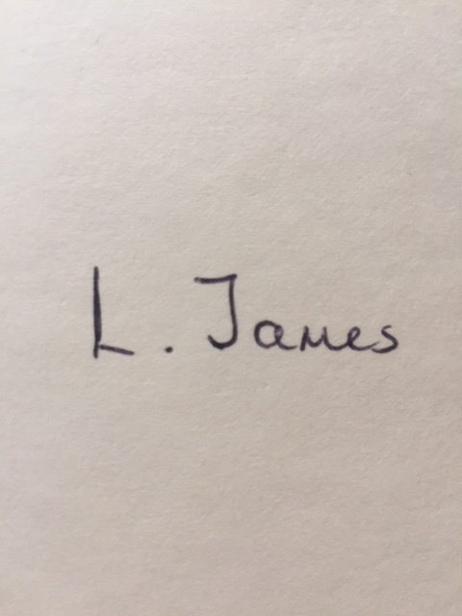
If the SKAPE Centre Manager along with school staff are satisfied that on the balance of probabilities the pupil did what he/she is alleged to have done, then exclusion will be the outcome.
Signed: Date: 31/01/2023

Print Name: L. James

Reviewed: Annually
Review Date: February 2024

Date | Reason for Change | Approved By | Revision Number
31/01/23 | Initial policy | K Watson | 01

