Introduction
This behaviour policy promotes a positive approach with emphasis on praise, reward and encouragement, which will foster a secure, enjoyable and nurturing learning environment. We aim for the highest standards in all aspects of SKAPE life, where each individual is intrinsically valued.

Aims
To create a purposeful and happy atmosphere which will enable visitors to feel secure to develop as individuals we need:

- To acknowledge and value achievements at all levels
- To encourage increasing independence and a sense of personal responsibility
- To consistently reinforce appropriate behaviour thus encouraging positive attitudes in visitors
- To take every opportunity to enhance self esteem
- To encourage tolerance, kindness and respect for others as well as self-respect
- To work in partnership with visitors, parents, school staff and external professionals
- To consistently apply the behaviour policy throughout the SKAPE Centre

Expectations
The way we behave influences everything we do.

Staff are expected to:
- Have a good understanding of all the pupils in their care
- Plan to teach effective, relevant and stimulating sessions/activities which are well differentiated to meet the needs of all the pupils in their care
- Provide pupils with a good role model
- Develop pupils' self-esteem
- Positively reinforce good behaviour
- Deal sensitively with negative behaviour
- Liaise with parents/school about behaviour
- Keep records of behaviour issues
- When appropriate, write a Behaviour Support Plan for individual pupils which are understood by staff, regularly monitored and evaluated

Pupils are expected to:
- Be kind and caring towards one another
- Value diversity in all people, including with regards to sexual orientation, gender preferences and identities, expressed or inferred
- Help those less able than themselves
- Show respect for adults and other pupils
- Show respect for property
- If appropriate, evaluate and modify their own behaviour to the best of their ability

Parents/carers are expected to:
- Be informed and supportive of aspects of their child's behaviour at the Centre
- Be supportive of this Behaviour Policy
- Be supportive of a Behaviour Support Plan which has been developed to support their child's behaviour at the SKAPE Centre

Strategies to encourage positive behaviour
Behaviour management strategies used at the SKAPE Centre will be necessarily diverse to meet the wide age range, cognitive abilities and specific needs of the pupils, but the underlying principles will be the same.

Staff will differentiate between pupils, using strategies appropriate to the individual. Some pupils, whose behavioural needs are greater than others, will have individual Behaviour Support Plans in place, which should be adhered to by all staff who come into contact with those pupils.

It is far better to prevent inappropriate behaviour occurring than to deal with it afterwards. Praise rather than negative feedback is encouraged.

The SKAPE staff have devised and agreed the following Behaviour Support Strategies:
- Be positive and enthusiastic
- Have high expectations of the pupils and expect them to be good
- Be consistent
- Praise the good; 'catch them being good'
- Plan when to give attention and when to ignore
- Stay calm; do not shout
- Never talk about a pupil's behaviour in front of them
- Sanctions must be short, clear and immediate
- Set clear boundaries and establish routines
- Use clear simple language supported by signing and symbols
- Consistently use and evaluate Behaviour Support Plans
- Be selective when choosing which behaviour to work on
- Know that it takes time to change behaviour
- Work as a team - use individual strengths and rotate staff when appropriate
- Do not take things personally
- Take into account each pupil's level of learning as many pupils may be working at the early stages of development.
In addition, a Behaviour Support Plan may be drawn up to try to avoid the outcome of a failed placement at SKAPE in the event of unacceptable conduct. Examples of unacceptable conduct may include the following and could result in a breakdown and/or ultimate failure of the placement:
- Verbal abuse to staff and others
- Verbal abuse to pupils
- Physical abuse to/attack on staff
- Physical abuse to/attack on pupils
- Indecent behaviour
- Damage to property
- Misuse of illegal drugs
- Misuse of other substances
- Theft
- Serious actual or threatened violence against another pupil or a member of staff
- Sexual abuse or assault
- Supplying an illegal drug
- Carrying an offensive weapon
- Arson
- Unacceptable behaviour which has previously been reported and for which SKAPE Centre's sanctions and other interventions have not been successful in modifying the pupil's behaviour.

Recording Incidents
All pupil accidents and incidents MUST be recorded:
- on an 'Incident Report form'
- in the 'Record of Incidents involving the Use of reasonable Force or Injury to pupils or staff'

All pupil injuries MUST also be recorded on a Pupil Accident Form

All staff injuries MUST be recorded on an Accident Report Form

The SKAPE Centre Manager will let you know whether it is necessary for her to complete a RIDDOR Form.

Behaviour Tracking

Criteria for pupils who need a Behaviour Support Plan

A pupil who exhibits:-
- behaviours which prevent him/herself or other pupils from accessing the curriculum
- behaviours which are a danger/risk to him/herself or to other pupils or staff
- behaviours which are socially unacceptable

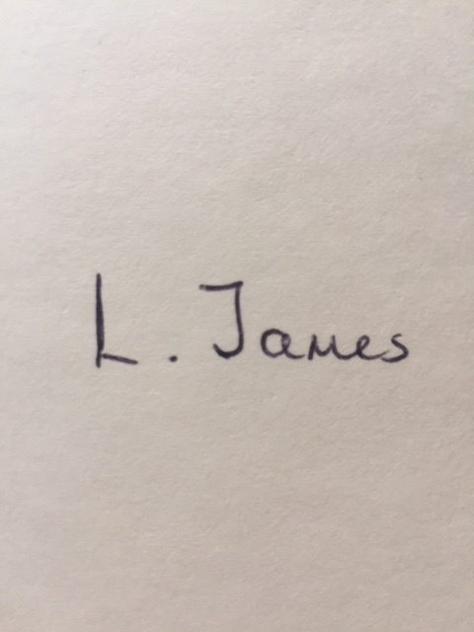
Signed: Date: 02/02/2025

Print Name: L. James
Reviewed: Annually
Review Date: February 2026

Date | Reason for Change | Approved By | Revision Number
31/01/23 | Initial Policy Written | K Watson | 01
20/12/23 | Policy update as requested by DCC Inclusion Lead for DCC AP application | K Watson | 02
31/01/24 | Policy Review | K Watson | 03
02/02/25 | Policy Review | K. Watson | 04

