Upon discovering a fire all staff must follow the steps below:

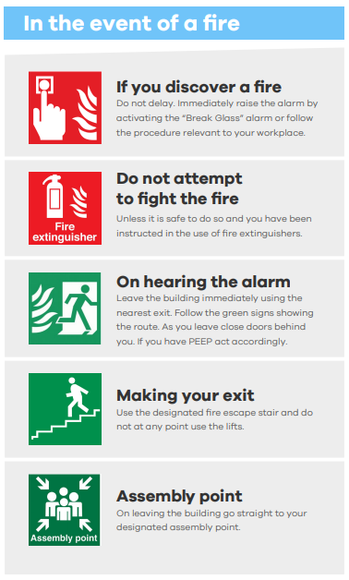

SKAPE Step by Step Evacuation Procedure:
a) Upon discovering a fire a member of staff will raise the fire alarm, located behind reception.
b) A senior member of staff will ensure all students immediately stop what they are doing, and move safely to the main entrance, and be escorted outside to the agreed assembly point.
c) Another member of staff will take a copy of the attendance register for that date to the assembly point and mark off the students to ensure every one is present.
d) The fire warden will conduct a sweep of the building to ensure no person, student or staff, has been left unnoticed in any part of the room, including the toilet, and then will come out lastly to join the assembled group and to inform senior staff that the building is clear.
e) If the above is being conducted as a fire drill, the fire warden may wish to time to the evacuation with the aim of ensuring it has been completed in a timely fashion and if any improvements need to be made whereby a new time target will be set for the next drill. This will then be recorded in the Fire Drill Evaluation and any action points noted.
f) During a fire evacuation all staff and students must:
-Obey the instructions of the Responsible Person.
-Leave any and all personal belongings in the building
-Move in the correct order to the nearest assembly point- Queen Street Car Park
-Inform the Responsible Person of any obstructions or other problems
-Obey the instructions of the firefighting personnel once outside

