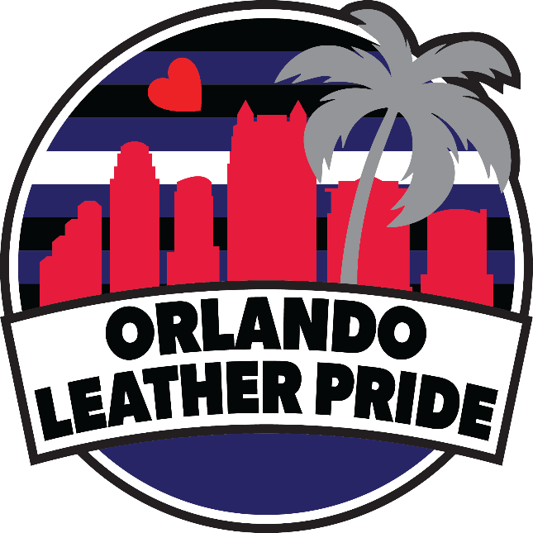
Thank you for reaching out about becoming a contestant for Orlando Leather Pride. Our goal is to have someone that will work for the community, promote Orlando Leather Pride weekend, and have FUN!
In this packet, there are iteMs. for you to review and return to us via email at OrlandoLeatherPride@gmail.com by August 31, 2024.
- Contestant Application
- Photo and Video Waiver
- Contest Schedule
- Contest Format
- Titleholder Expectations
- Contestant Photo and Bio
Again, thank you so much for being part of our contest. We look forward to seeing your participation and wish you the best of luck. As we get closer to the contest, you will be introduced to the Contestant Coordinator. In the meantime, if you have any questions or need anything, please do not hesitate to reach out to us at OrlandoLeatherPride@gmail.com.

With Love,

Martin Phoenix
Producer

CONTESTANT APPLICATION

Legal Name: _______________________________________ Date: _________________________
Address: __________________________________________ Phone: ________________________
_________________________________________________ Pronouns: ______________________
Email: ____________________________________________ Shirt Size: ______________________
Scene Name: ______________________________________

Questions
Which title are you wanting to compete for?
____ Mr.. Orlando Leather Pride 2024 ____ Ms.. Orlando Leather Pride 2024
____ Mx.. Orlando Leather Pride 2024 ____ Orlando Leather Pride Bootblack 2024
____ Orlando Leather Pride Critter 2024

Why do you want to compete for this title? _________________________________________________
_____________________________________________________________________________________
_____________________________________________________________________________________
What do you plan to do with the title? _____________________________________________________
_____________________________________________________________________________________
_____________________________________________________________________________________
What do you know about Orlando Leather Pride? ____________________________________________
_____________________________________________________________________________________
_____________________________________________________________________________________
Is there a non-profit organization that you want to work with and/or help? ________________________
_____________________________________________________________________________________
_____________________________________________________________________________________

CONTESTANT APPLICATION CONTINUED

What does Orlando Leather Pride mean to you? ______________________________________________
_____________________________________________________________________________________
_____________________________________________________________________________________
How do you want to contribute to making Orlando Leather Pride better? _________________________
_____________________________________________________________________________________
_____________________________________________________________________________________
What do you want to be remembered for should you win the title? ______________________________
_____________________________________________________________________________________
_____________________________________________________________________________________
Which event are you looking forward to attending? ___________________________________________
_____________________________________________________________________________________
_____________________________________________________________________________________
What is your favorite kink or fetish? _______________________________________________________
_____________________________________________________________________________________
_____________________________________________________________________________________
Which Disney character is your favorite and why? ____________________________________________
_____________________________________________________________________________________
_____________________________________________________________________________________
What Orlando area bars and/or locations do you gather at with your leather friends and family? ______
_____________________________________________________________________________________
_____________________________________________________________________________________
What advice would you give someone that is new to the leather community? ______________________
_____________________________________________________________________________________
_____________________________________________________________________________________

PHOTO AND VIDEO WAIVER

One of the unique things about this contest is that it is virtual. Some of the categories will be done by submitting photos or videos. Below are some things to consider when submitting them:
- The photos and videos will be shared on Facebook for portions of the contest, so the audience can participate in the virtual contest experience.
- Orlando Leather Pride can reject photos and videos that are not deemed appropriate.
- If you have someone take the photos for you, please list the name of the photographer so that they receive credit.
- Anyone in the photos or videos must be over the age of 18.

By submitting your photos and videos you are giving Orlando Leather Pride permission to post them for the contest purposes.

_________________________________________
Print Name

_________________________________________ ___________________
Signature Date

CONTEST SCHEDULE

Tentatively – Saturday, September 7, 2024 at 5:00 pm EST
- Virtual Contest Show Part 1
  - Introduction Videos – All contestants
Tentatively – Saturday, September 21, 2024 at 5:00 pm EST
- Virtual Contest Show Part 2
  - Leather Pride Presentation – Mr., Ms., Mx. and Bootblack contestants
  - Pride Presentation – Critter contestants
  - Hot Leather Wear – Mr., Ms. and Mx. contestants
  - Bar Wear – Bootblack contestants
  - Mosh Wear – Critter contestants
Tentatively – Saturday, October 5, 2024 at 5:00 pm EST
- Virtual Contest Show Part 3
  - Formal Leather Wear – Mr., Ms., Mx. and Bootblack contestants
  - Best in Show Wear - – Critter contestants
  - Speech Videos – All contestants
Sunday, November 3, 2024
- Winner announced during the Awards Gala.

Photos and videos are due one week prior to the show date.
Interviews will be conducted at an agreed upon time between the judges and contestants but prior to Saturday, October 11, 2024.
Bootblack contestants will have two interviews: personal interview and tech boot interview.

CONTEST FORMAT

Scoring
The scoring for the portions of the Contest are as follows:
Introduction Video 150 points
- Judges 100 points
- Administrative 50 points
Leather Pride or Pride Presentation 150 points
- Judges 100 points
- Administrative 50 points
Interview 300 points
- Judges 300 points
Hot Leather Wear or Mosh Wear 150 points
- Judges 100 points
- Administrative 50 points
Formal Leather Wear or Show Wear 150 points
- Judges 100 points
- Administrative 50 points
Speech Video 150 points
- Judges 100 points
- Administrative 50 points
Total 1050 points

In the event of a tie, the tiebreaker category will be Interview. If that still results in a tie, the tiebreaker category will then go to Speech.

For the Bootblack title, we also have a Tech Boot and Interview category. The max points will be 200 points, making the overall points 1250.

CONTEST FORMAT CONTINUED

Introduction Video
Provide a video no more than three (3) minutes long answering a few predetermined questions.

Leather Pride or Pride Presentation
Show us your best interpretation of leather pride or pride for the Critter contestants. Submit four (4) photos of your look.

Interview
This will be a Zoom interview with the judges. The goal is to get to know you.

Hot Leather Wear or Mosh Wear
Let’s see your interpretation of hot leather wear or mosh wear for the Critter contestants. Submit four (4) photos of your look.

Formal Leather Wear or Show Wear
Give us your interpretation of formal leather wear or show wear for the Critter contestants. Submit four (4) photos of your look.

Speech Video
Submit a video no more than five (5) minutes long on a predetermined topic.

Tech Boot and Interview
For the Bootblack title, you will be provided with a pair of boots. You will only need to repair one (1) of the boots. We will use the other one (1) as a comparison. You will be given 45 minutes to repair the boot. Afterwards, you will have an interview with the Judges on the process and for them to ask you questions about your work. This will all be conducted via Zoom.

TITLEHOLDER EXPECTATIONS

The following is what is expected of the titleholder:

- Titleholder is expected to provide a quarterly report of what they are doing and working on.
- Titleholder should be positive and inspirational when interacting via social media.
- Titleholder should behave appropriately in public.
- Titleholder is required to help promote Orlando Leather Pride.
- Titleholder is not expected to compete at another level.
- Titleholder is expected to do a step down either in person or by video.
- Titleholder will have an opportunity to help plan the next Orlando Leather Pride.

CONTESTANT PHOTO AND BIO
Please email a photo along with a short bio no longer than 500 words to be used for the Orlando Leather Pride website and social media to announce you as a contestant.

