We had >32 attendees (NNN members) at the 11/27/23 North Hampton Neighbors Network (NNN) meeting. We will be holding our General meetings in the lower-level conference room of Buder library on the 4th Monday of each month until further notice. We hope to find a permanent location in the next few months. State Representative (82nd District) Donna Baringer gave a brief update on the upcoming legislative session and Lt. Dan Zarrick (South Patrol District 2) gave a deep dive into safety precautions during the holiday season. Our guest speaker was Jean Corbett, Recycling Specialist from Saint Louis City Recycles. The next general meeting will be held on January 22nd at Buder Library. We will be hosting a holiday happy hour at the Golden Hoosier (3707 S. Kingshighway) on December 4th starting at 4pm. We thank NNN executive board and organization members for a successful 2023. We are better together. Wishing you all a Safe and Happy Holidays and a Happy New Year!!

Please email the NNN admin at admin@northamptonneighbors.com with any questions.

11/27/23 Northampton Neighbors Network meeting:

- Adam Jung opened the meeting at 6pm and reviewed the agenda items:
Donna Baringer
Lt. Dan Zarrick crime report
MSZ Auto Sales
Tilles Park update
Jean Corbett, St. Louis City Recycles

- Donna Baringer, State Representative for the 82nd District.
-2024 legislative session begins on Jan. 7, 2024
-Election year sessions are often filled with controversial legislation and little progress.
- It promises to be a contentious legislative session with bills on budget, taxes, the initiative petition and voting, sports betting, education, and abortion on the agenda.
-She reiterated that this is her last year in office and that Nick Kimble will be running for her office.

- Lt. Dan Zarrick, Commander 2nd District SLMPD South Patrol
-Crime trends and arrests for last month:
Robberies: Bank robbery at People’s National Bank (have suspect in case) and carjacking at QT by armed assailant.
Theft: 3 Porch pirate incident reports – 2 in NoHa and 1 in Clifton Heights. During holiday season statistical trend for higher frequency of street thefts at high crime corridors (within 1 block of main thoroughfares like Chippewa and Hampton)
-Safety tips:
Keep alert when loading/unloading packages during holiday season when thieves will be in store parking lots and in neighborhoods. Don’t sit in car and text/talk on cell phone.
Keep porch lights on at home and help each other (keep an eye on neighbors’ properties).
Unfortunately, do not assume that a child is not armed with a gun.
Consider using FedEx/UPS lockers to receive deliveries (Hampton Walgreens and Schnucks.
After holidays break down boxes that big ticket items are shipped in. Having electronics boxes in front of your house makes you a target.
-Hiring and Staffing updates:
They are using overtime judiciously around holidays to monitor expected uptick in thefts
with much of the patrolling dedicated to these higher crime corridors.
911 staffing is now only 9 positions short (down from 40), and many are in training.
Private security patrols are being increased at businesses targeted for crime or with a high concentration of wanted persons (local gas stations and apartment complexes). Additionally, QT is considering more video surveillance at Kingshighway location.
-For detailed Q/A please see the video recording of the meeting.
- For weekly crime alerts, email request to Gus Karagiannis, community outreach officer/2nd district at gkaragiannis@slmpd.org.

- Rob Meckfessel, Executive Board Member
-Congratulations to Tammi Tryon for hosting successful block party on Lindenwood for National Night Out held on October 3, 2023. We hope to increase participation in the 2024 NNO. See the city website to register your event. (https://www.stlouis-mo.gov/government/departments/public-safety/neighborhood-stabilization-office/national-night-out/nno.cfm)
-Announced cookie drive for 1st responders and passed around sign-up sheet. Contact Tina Wong for details. Cookies to be collected 12/10/23 for 12/11/23 delivery.

- St. Louis Public Library, Buder Branch librarian
- “Countdown to Noon” New Year's Party! Live ragtime, blues and jazz music from T.J. Muller and Ethan Leinwand, and crafts, games and food. This event is for everyone on Dec. 30 from 11am to 1pm., so bring the whole family.
-Work will be ongoing on the Buder building, including HVAC so be alert for construction.
-2024 will bring new programming so sign-up form emails or visit the website to see list of events (https://www.slpl.org/locations/5/)

- Justin Thurman, MSZ Auto Sales
- New resident poll was conducted after the October General meeting. The rankings of 1-5 (1 least support, 5 most support) were collected. The average ranking of support was 1.3.
- The letter sent to the owners of MSZ Auto Sales is posted on the website.

- Tina Wong, Tilles Park update
- Thanks to all the volunteers who have cleared weeds, planted bulbs and spread mulch on the existing beds, the new Naturescaping area, and on saplings around the park. Many people show up on organized planting days as well as on their own to pitch in. All your efforts are appreciated.
- Special thanks to The Garden Shop for donating plants and to volunteers from AB sent from Brightside StL who helped on Oct planting event.

- Jean Corbett, Recycling Program Specialist for STLCity Recycles
- StLCity Recycles is a city agency and part of Brightside St. Louis. Jean educates the community through in-person lectures and social media.
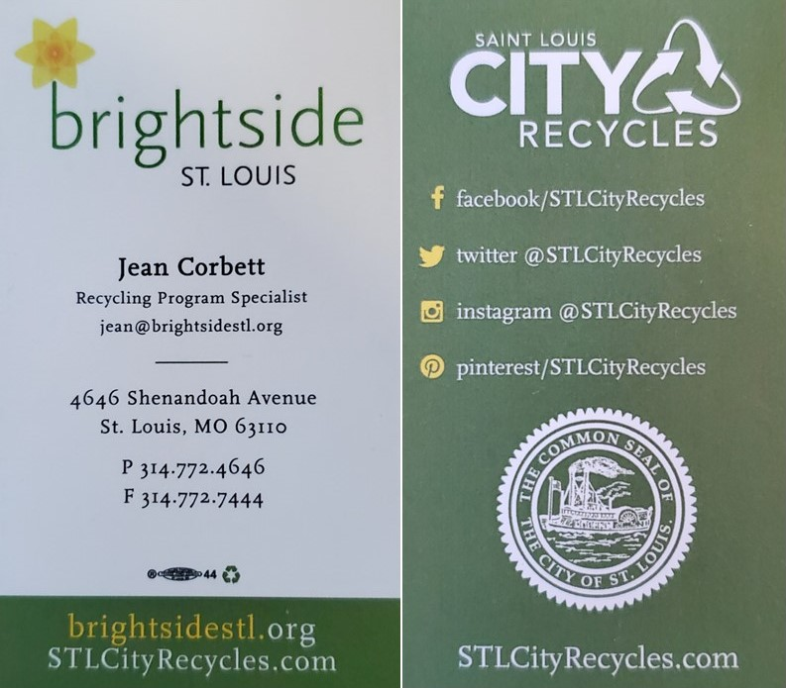
- We had a group quiz, Recycle or Trash and our group was impressively knowledgeable! For details you can visit the website for general lists (right) or watch the video for details.
-All recyclables can be mixed together in the same bin (AKA single stream, mixed recycling) but not every plastic or paper container can go into the mixed recycling stream.
-In general plastics, food (left in containers), Styrofoam (not recyclable) and candy/chip bags (not recyclable) and wax-coated papers (not recyclable) are the biggest sources of contamination in the recycling waste stream.
-Plastics that hold their shape (<5 gal) can be put in the dumpster or roll carts without crushing (scanner can detect). Plastics that stretch with your finger (e.g. plastic shopping bags) should be dropped off at grocery stores for recycling. Plastic utensils are never recyclable.
-Paper cartons that are room temperature or refrigerated can be emptied rinsed and recycled. Coated paper containers, like hot coffee cups and ice cream cartons (any freezer-safe paper product), are not recyclable.
-Recycling disposal contamination rates: best to worst are drop-off sites (best) > roll carts > dumpsters. Repeat offender routes (usually dumpsters) are flagged and they will send regular garbage trucks to those routes to prevent contamination of the larger recycling waste stream. With education these routes can get back on the recycling pick-up route. For list of drop-off sites visit: https://stlcityrecycles.com/dropoff/.
-Confusion points: #s on plastics indicating recycle #, and the mobius symbol and brands selling “recycling bags” are not necessarily accurate indicators that the item is recyclable in our system.
-After pick-up the recycling is brought to the transfer station (Republic Services) where the items are electronically scanned and sorted then manually sorted by workers. The sorted and bailed paper and plastics are then sent on to manufacturers (95% of end material stays in the Midwest) that use them in new products (construction, clothing).
-The sale of the product generated from recycling does not pay for the program. This is an environmental and health priority identified by the citizens and city government. The residents have a recycling line item on their water/refuse bill.
-Jean fielded questions about hazardous waste, LED bulbs, city-wide composting. Details can be found on the video recording of the meeting.

- Sam Kippen, Neighborhood Improvement Specialist Hamilton Heights, North Hampton, Southwest Garden, The Hill. Contact: (314) 657-1377, KippenS@stlouis-mo.gov)
- He helps with quality-of-life issues: potholes, trees, broken lights, abandoned buildings,
abandoned cars. He actively surveys his neighborhoods to identify issues.
-If you have any issues/concerns contact him via cell or email.

- Adam Jung, final announcements
- Holiday Happy Hour to be held (in lieu of December meeting) on Monday, Dec. 4th Golden Hoosier (3707 S. Kingshighway). Party begins at 4pm to take advantage of happy hour food and drink specials.
- Adjourned meeting at 7:30.

To be added to the general meeting agenda, please submit a request though the NNN website: https://northamptonneighbors.com/

