September 11, 2024
Agenda
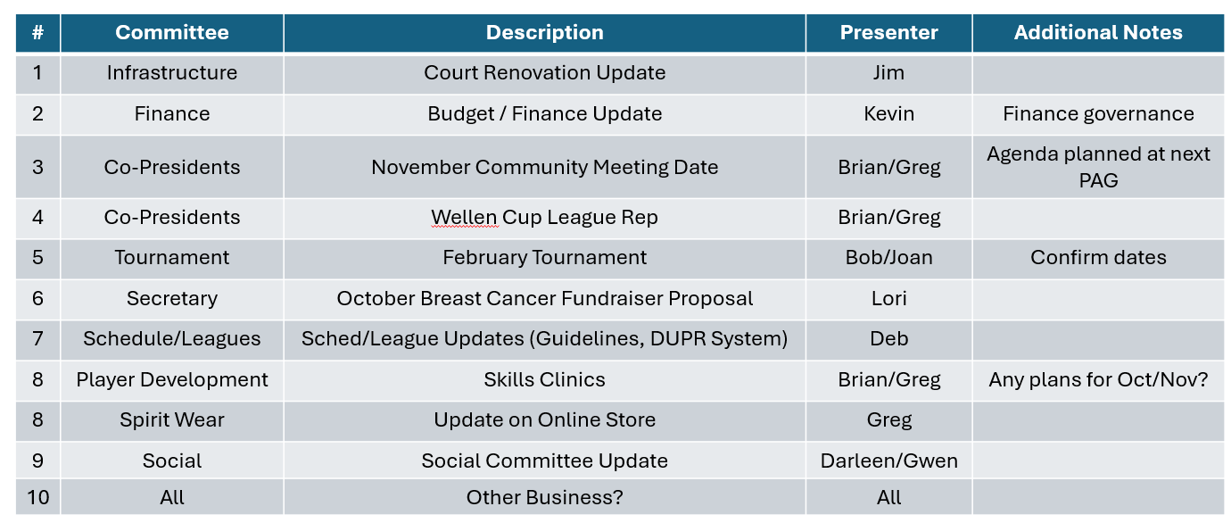

Meeting Notes:
Attendees: Brian, Greg, Jim, Lori, Kevin, Deb
1. Infrastructure Committee (Jim)
- Court renovation work has started. The team is currently digging the holes to install 4 basketball hoops on the temporary pb courts (referred to as courts 6/7). Relocating the basketball courts is a first step and needs to happen before we can do the resurfacing work on courts 5&8.
- They have also started creating a concrete patio area where the shade structure that is currently between courts 5&8 and 6&7 will be relocated to.
- A 10-foot fence will be installed where the shade structure is currently to divide the basketball / temp court area from courts 5&8. This is important because there will be 2 1/2 courts with hoops facing the 10ft fence and 2 hoops facing the back of the club house.
- The temporary courts will continue to have 2 pickleball courts on them and a tennis court. they are not being resurfaced. However, there will be no entrance from courts 5&8. You will need to walk around to a separate entrance to the basketball / temp court area. Basketball will have priority so the temp courts can only be used if there is no one playing basketball. Just as it is today.
- Trees / shubbery is being removed and the fence near courts 5&8 will be squared off. Additional pavement will be added to extend the court surface to allow 4 courts to be painted in the area where courts 5&8 are currently located. These 4 courts (5, 5b, 8, 8b) will run in the same direction and will have permanent nets. As noted previously, there will be a 10ft fence separating this area from the basketball courts. The expectation is we will renumber these courts at some point.
- The budget has already been set for this project and the PAG is not funding any of this project. Thank you Jim!!
- Court closure dates: Jim will continue to communicate court closures via the what’s app and with signs at the courts. We ask everyone to help communicate patience and that is a temporary situation. The situation is subject to change so any dates given are tentative based on the weather and how quickly the work gets done.
- 2025 Budget:
  - Jim put in the resurfacing of existing courts 1,2,3,4
  - Also includes ripping out the shrubbery to prevent roots impacting the courts
  - Removing stones and putting pavers where the bleachers are is also in the budget

2. Finance Committee (Kevin)
- Kevin provided account statements for the PAG account. Kevin and Deb are both on the account. There is $12, 748.93 in the account currently.
- There has not been any reimbursement requests recently.
- Kevin wants to work on creating a budget for next year based on what is known in terms of planned expenses. The BOD asked him to work with his committee (Mark) and bring back a proposed budget to be voted on by the BOD.
- Decision: The BOD agreed that there should be a more formal approval process for expenses over $500. Under $500 will be approved by the Finance Committee (Mark and Kevin should be the approvers). Any questionable expenses should come back to the BOD for review.
- The Finance Committee should work on defining the approval process including how reimbursement requests come to the finance committee. Suggest having a form or email with required fields to provide a paper trail of the request. Need to store these at back up for payments.
- We don’t have any planned expenses currently. We put the purchase of the storage unit and court drying equipment on hold until the court renovations are done. We will revisit at our next meeting.

3. November Community Meeting (Brian/Greg)
- Our fall community wide meeting will be held on November 8th at 6:00 PM.
- We will work on the agenda at our next PAG meeting in October.
- Would like to have a social / happy hour following the meeting.
4. Wellen Cup League (Brian/Greg)
- We need to find folks to be willing to take the lead for GP in the Wellen Cup League.
- Greg, Brian and Deb will set up a separate meeting with Tina to understand the responsibilities. Would be good to see if we can have a team instead of having everything fall onto 1 or 2 people. May need to have 1 person attend the outside WC meetings but, others may be able to help cover the courts, etc.
- We need to revisit at our next meeting in Oct.
- The next WC meeting is likely in November or December. Deb will cover this initial meeting if needed while we sort this out.
5. February Tournament (Bob/Joan)
- Currently, we are still planning for the weekend of 2/15-16 with the rain date of 2/17. With the change in activities director, Bob and Joan will reconfirm the date with GP.
6. October Breast Cancer Fundraiser Proposal (Lori)
- A separate slide was shared to summarize the proposal. The BOD agreed we should move forward but keep as simple as possible for this year.
- Want this to be social and not a huge level of effort to organize. All funds will go to charity. PAG will not make money from this tournament.
- We selected a date of Saturday, 10/26 with a start time of 3 or 4:00PM.
- Since some of the courts will be unavailable, we will use courts 1-4. This will give us a limit of 24 people. It will be first come sign up. Need to be at least an intermediate. Format will be random partners. Lori and Greg have the format from another fundraiser which can be reused.
- The PAG will donate the pink balls and the awards unless they are donated by other members.
- Lori will schedule a follow up meeting to work out the details. Will need the social committee to help with snacks / refreshments.
7. Schedule/Leagues (Deb)
- Continue to discuss the number of leagues and whether we have enough open play slots. Also, whether people are signed up for too many leagues. We agreed to table this until the court renovations are completed. This may be a non-issue when we get the additional courts.
- Same discussion on the open play and paddle process. Some ideas were floated around having set courts for levels, a challenge court, etc. We will revisit at a future meeting.
- Also discussed the DUPR system and the pros/cons. We discussed the challenges with accuracy especially when leagues or games involve players at different levels. The BOD said it will be up to the leagues but recommended not forcing folks to use.
8. Player Development (Brian / Greg)
- We only touched upon this topic. We discussed naming a chair for this committee. One idea was to ask Tim Holt to take on this role. We all agreed that we need someone to organize the schedule and the clinics a bit more.
9. Spirit Wear (Greg)
- We are still investigating setting up an online store for ordering spirit wear.
- We will have more of an update for the next meeting. Lori will also check with Tina on the price sheet and how much the PAG took in on each item. Kevin indicated this is a good income for the PAG so we should get some cut without making the apparel too costly.
10. Social Committee Update (none)
- No events are currently planned. Hope to have the committee help with the Breast Cancer event and the November community wide meeting.
11. New Business (all)
- A topic was raised regarding having signage on the courts to indicate you are playing at your own risk. This is a legal issue that should be raised to GP. Not a PAG issue but could have implications to all of us. We also have players from outside the community playing on the courts during the Wellen Cup or visitors. Not sure who will bring to GP? Will discuss again to be sure someone brings it forward.

