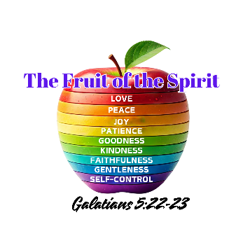
Fill in the Blank Day 1 Recap

- _________ is the foundational fruit. Everything starts with this fruit.

- The ________________ is always in conflict with the Spirit.
- Joy is _________________.
- Happiness is _______________.
- God is _________.
- Cultivating the fruit requires that we _____________________ with the Holy Spirit. (starts with a c)

- The Holy Spirit __________________________ our minds – Romans 12:1-2,
- John 14:27 - __________I leave with you; my ________ I give you.

