PT Market Update – July 2025

Overview: The PT Market update is a monthly report summarizing publicly available M&A activity in the PT market from a practice owner's perspective. Only deals announced via press release or with PTPS&C's permission are included; other undisclosed deals are not reported.
Summary: There were two closings in July 2025, down from seven last year. Year-to-date closings total 34 for 2025 versus 37 in 2024, projecting 58 by year-end (compared to 60 last year). This report is updated to include earlier closings previously not announced.
July marked a decrease in closings compared to last year. However, there have been several late additions included in this report from earlier in the year, so the YTD count is not far behind last year’s pace. The average clinics per transaction is 11.8 YTD 2025, up from 5.9, though this is influenced by several large deals. Closings with 7 or more locations represent 21% of transactions, while those with 3 or fewer make up 68%, compared to 22% and 68% last year. These metrics continue to trend towards last year’s averages.
This report currently reaches over 3,000 readers each month. We are grateful for your continued support. If you would like to receive this report via email or wish to share your feedback, please contact us with the subject line "SIGN UP" at mike@physicaltherapybrokers.com.
If you are considering learning more about your exit strategy, please contact us at mike@physicaltherapybrokers.com to discuss your options, or visit our website at https://physicaltherapybrokers.com/ for further information. Additionally, you may schedule a complimentary introductory call using the following link: https://calendly.com/ptbrokers/45min.

Through July 31, 2025:
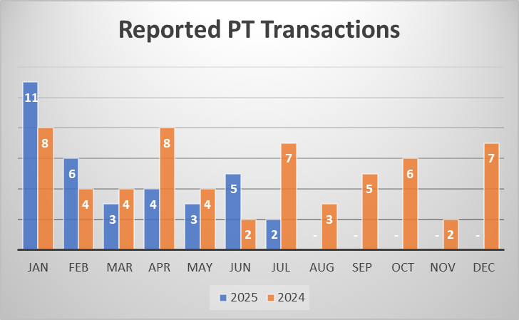

- 21% of transactions consist of 7 or more locations.

- States with the most transactions:

- The following is a list of all publicly released transactions in 2025.

