***AFRICAN VIOLET SHOW***

***AT***

***CHRIST LUTHERAN CHURCH***

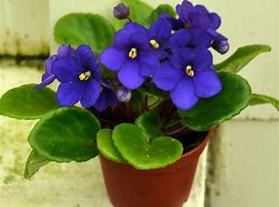***3 9***

*AND STILL GROWING*



2715 LAKELAND HILLS BLVD

LAKELAND, FLORIDA

ACROSS FROM MAIN POST OFFICE

FEB 8, 2019 Sales 9am – 5pm

SHOW 12pm – 5pm

FEB 9, 2019 SALES AND SHOW 9am – 3pm

FIRST LAKELAND AFRICAN VIOLET SOCIETY