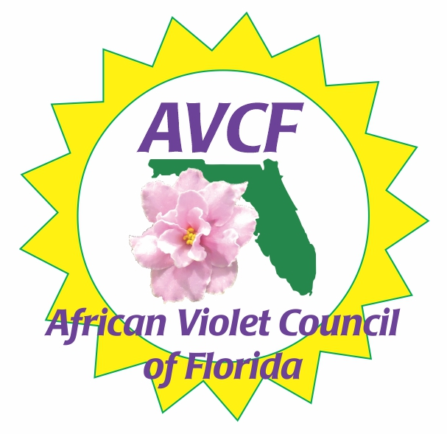
African Violet Council of Florida
Membership Application

Membership payments are due January 1st Delinquent February 1st Expires March 1st
Individual Membership $10.00 ____ Honorary Members (see below) ____ Today’s Date: ____________________
Full Name: _______________________________________ If renewing and none of your information has changed, check here □
Email: _____________________________________________________________________________________________
Cell Phone: _______________________________________ Home Phone: _____________________________________
Street Address: _____________________________________________________________________________________
City: _________________________________________________________ State: _______________________________
Birthday Month/Day: ________________________________ New Membership: ____ Yes ____ No
Local Club: __________________________________________________ in ____________________________________
Please check the following statements that apply to you:
_____ I am a charter member of African Violet Council of Florida (AVCF)
_____ I am an honorary member of the African Violet Council of Florida (AVCF)
_____ I am a member of the African Violet Society of America (AVSA)
_____ I am a Life member of the African Violet Society of America (AVSA)
_____ I am a member of DIXIE African Violet Society (DAVS)
_____ I am a Life member of DIXIE African Violet Society (DAVS)
_____ I am a member of the Gesneriad Society ______ I am an official Gesneriad Judge
_____ I am and AVSA Judge Check Status: __ Student __ Advanced __ Senior __ Master __ Teacher

Affiliated Club Membership $15.00
Name of Organization: ________________________________________________________________________________
Name of Current President: ____________________________________________________________________________
Number of Members: __________ Is your club covered by insurance? ____ Yes ____ No
Club Meeting Time/Days/Dates _________________________________________________________________________
Club Meeting Address: ________________________________________________________________________________
Treasurer: __________________________________________________________________________________________
Vice-President: ______________________________________________________________________________________
Secretary: __________________________________________________________________________________________

Commercial Membership $15.00
Name: _____________________________________________________________________________________________
Address: ___________________________________________________________________________________________

Honorary Membership: Please check appropriate line below
______ AVCF Past President
______ AVCF Charter Member
______ AVCF Show Sweepstakes Winner, one year
______ Affiliate Club Member Novice Blue Ribbon member, one year

Please make your check payable to AVCF (African Violet Council of Florida) and send to:
Angela Newell
8205 Vassar Circle
Tampa, FL 33634.
Rev. 06/26 JF

