Teaching the Congregation of the Redeemed

Pastorick.org  Crosstalking - YouTube |  | 

Matthew 25:31-46

- God is interested in our works but NOT as a means to justification for salvation
- We do not do good work to be saved but we do good work because we ARE saved
- Goods works can be evidence of a redeemed soul
- Works do NOT have anything to become saved!

KJV Majority Text | CJB Minority Text

³¹ When the Son of man shall come in his glory, and all the holy angels with him, then shall he sit upon the throne of his glory: | ³¹ “When the Son of Man comes in his glory, accompanied by all the angels, he will sit on his glorious throne.
- upon the throne of his glory-This is the manifestation of the fact that HE IS GOD (DIVINITY)
- holy (TR only has the proper translation)
  - There are classes of Angels, Elect and Fallen, Operative and Confined
  - There are varying ranks of Angels in both categories (Arc holy h-Angels, Princes)
  - There are varying Assignments of Angels (The Prince of Persia, Iran)
- This is the Kingdom Throne

³² And before him shall be gathered all nations: and he shall separate them one from another, as a shepherd divideth his sheep from the goats: | ³² All the nations will be assembled before him, and he will separate people one from another as a shepherd separates sheep from goats.
- This is the Second Advent not the Rapture.
  - Because here He brings JUDGMENT. (All matters of Judgment have been given to the Son)
- There are only two categories (There are only two places people will live with consciousness)
- Shepards had to separate, sheep need warmth and goats need a higher elevation

³³ And he shall set the sheep on his right hand, but the goats on the left. | ³³ The ‘sheep’ he will place at his right hand and the ‘goats’ at his left.
- Holy and Unholy

³⁴ Then shall the King say unto them on his right hand, Come, ye blessed of my Father, inherit the kingdom prepared for you from the foundation of the world: | ³⁴ “Then the King will say to those on his right, ‘Come, you whom my Father has blessed, take your inheritance, the Kingdom prepared for you from the founding of the world.
- the King- King Messiah, the anointed one
- blessed
  - Perfect tense meaning He has been building a good work in the redeemed in the past, present and future.
  - Passive-Meaning G-D is the instrument of the blessing NOT the person
- foundation of the world:-Redemption was created for you personally before time existed!

³⁵ For I was an hungred, and ye gave me meat: I was thirsty, and ye gave me drink: I was a stranger, and ye took me in:³⁶ Naked, and ye clothed me: I was sick, and ye visited me: I was in prison, and ye came unto me. | ³⁵ For I was hungry and you gave me food, I was thirsty and you gave me something to drink, I was a stranger and you made me your guest, ³⁶ I needed clothes and you provided them, I was sick and you took care of me, I was in prison and you visited me. ’
- Speaking to the Sheep, those on the right

³⁷ Then shall the righteous answer him, saying, Lord, when saw we thee an hungred, and fed thee? or thirsty, and gave thee drink? ³⁸ When saw we thee a stranger, and took thee in? or naked, and clothed thee? ³⁹ Or when saw we thee sick, or in prison, and came unto thee? ⁴⁰ And the King shall answer and say unto them, Verily I say unto you, Inasmuch as ye have done it unto one of the least of these my brethren, ye have done it unto me. | ³⁷ Then the people who have done what God wants will reply, ‘Lord, when did we see you hungry and feed you, or thirsty and give you something to drink? ³⁸ When did we see you a stranger and make you our guest, or needing clothes and provide them? ³⁹ When did we see you sick or in prison, and visit you?’ ⁴⁰ The King will say to them, ‘Yes! I tell you that whenever you did these things for one of the least important of these brothers of mine, you did them for me!’
- Righteous-Not for their good works. Through faith you have the righteousness of Messiah -Romans 3:5
- King-Judge
- done it unto one of the least of these my brethren-Bless and give to those that are in need of physical needs

⁴¹ Then shall he say also unto them on the left hand, Depart from me, ye cursed, into everlasting fire, prepared for the devil and his angels: | ⁴¹ “Then he will also speak to those on his left, saying, ‘Get away from me, you who are cursed! Go off into the fire prepared for the Adversary and his angels!
- Those cursed will depart (cursed) for eternity, those blessed will be that way for eternity
- everlasting fire-Few deal with passages like this from the pulpit

⁴² For I was an hungred, and ye gave me no meat: I was thirsty, and ye gave me no drink: ⁴³ I was a stranger, and ye took me not in: naked, and ye clothed me not: sick, and in prison, and ye visited me not. ⁴⁴ Then shall they also answer him, saying, Lord, when saw we thee an hungred, or athirst, or a stranger, or naked, or sick, or in prison, and did not minister unto thee? | ⁴² For I was hungry and you gave me no food, thirsty and you gave me nothing to drink, ⁴³ a stranger and you did not welcome me, needing clothes and you did not give them to me, sick and in prison and you did not visit me. ’ ⁴⁴ Then they too will reply, ‘Lord, when did we see you hungry, thirsty, a stranger, needing clothes, sick or in prison, and not take care of you?
- Actions the confirmed their heart
- Lord-their reply is correct but their heart is not. False believers

⁴⁵ Then shall he answer them, saying, Verily I say unto you, Inasmuch as ye did it not to one of the least of these, ye did it not to me. ⁴⁶ And these shall go away into everlasting punishment: but the righteous into life eternal. | ’ ⁴⁵ And he will answer them, ‘Yes! I tell you that whenever you refused to do it for the least important of these people, you refused to do it for me!’ ⁴⁶ They will go off to eternal punishment, but those who have done what God wants will go to eternal life.”
- Eternal- Not more judgments
- Our Human intellect cannot understand G-D who is outside the natural laws

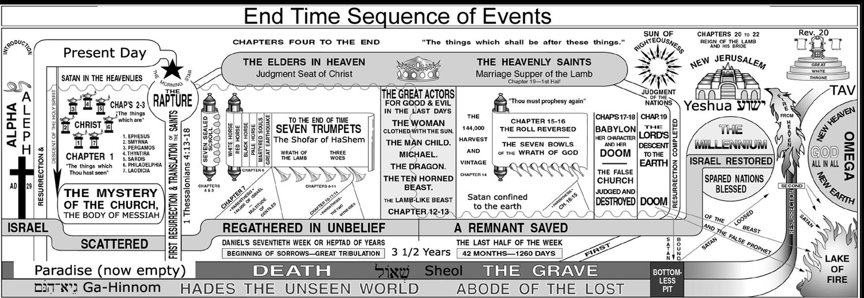

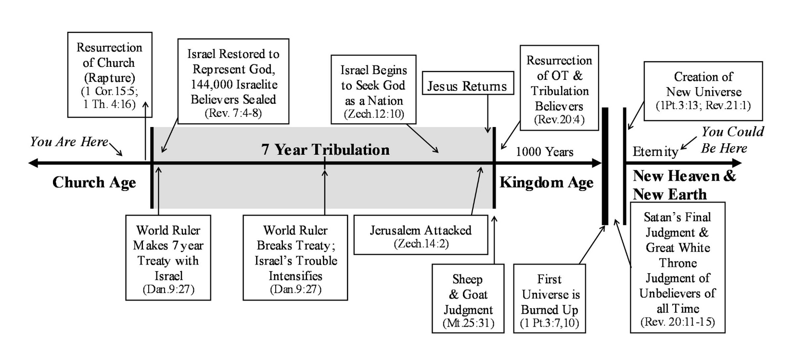

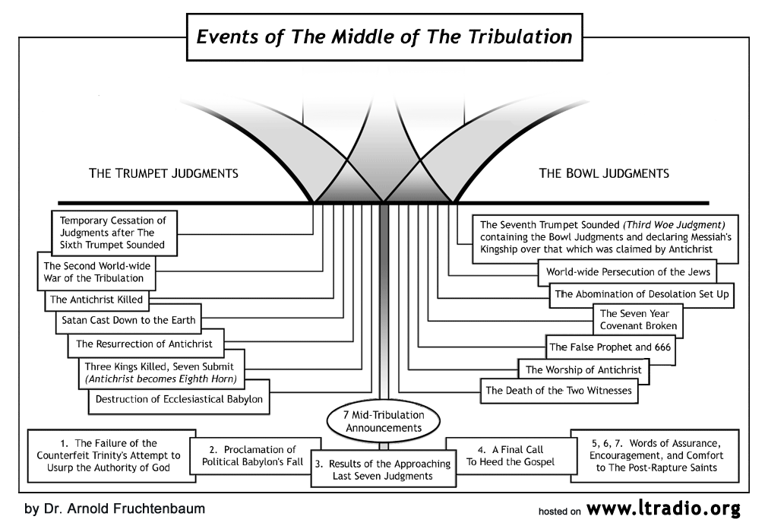

 | ²⁵ For I would not, brethren, that ye should be ignorant of this mystery, lest ye should be wise in your own conceits; that blindness in part is happened to Israel, until the fulness of the Gentiles be come in. -KJV Romans 11:25  Each time we meet as a group this promise is ushered into being.

AD SUNDAY AM 11:00  OLSEN CLASS  SINGLES AND COUPLES TOGETHER  AE205 | LEARNING TOOLS USED  I do not understand the word in the Middle English.  G4536 - salpigx - Strong's Greek Lexicon (kjv) (blueletterbible.org)  https://loveisrael.org/  House of David Ministries  https://floydnolenjonesministries.com/



