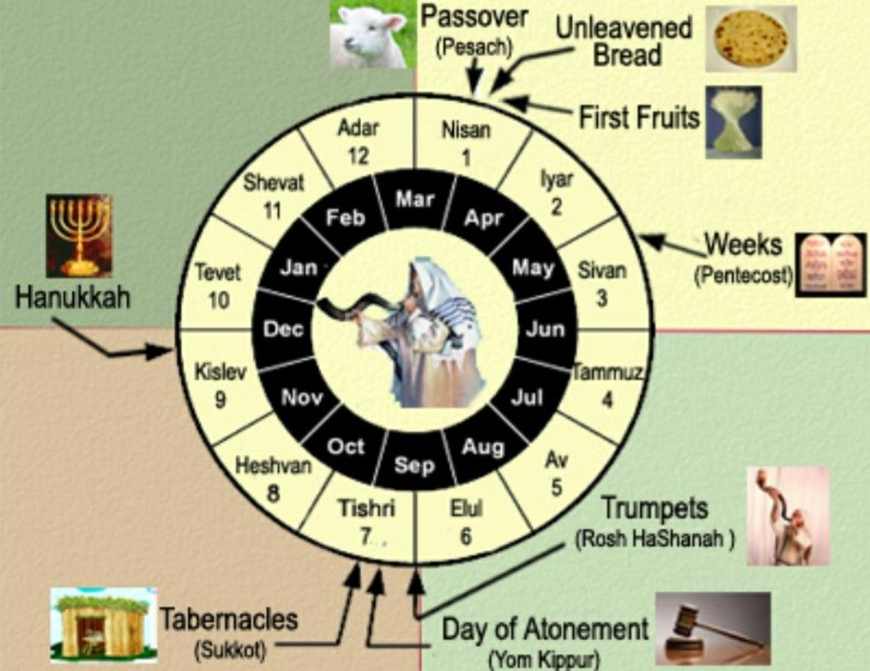

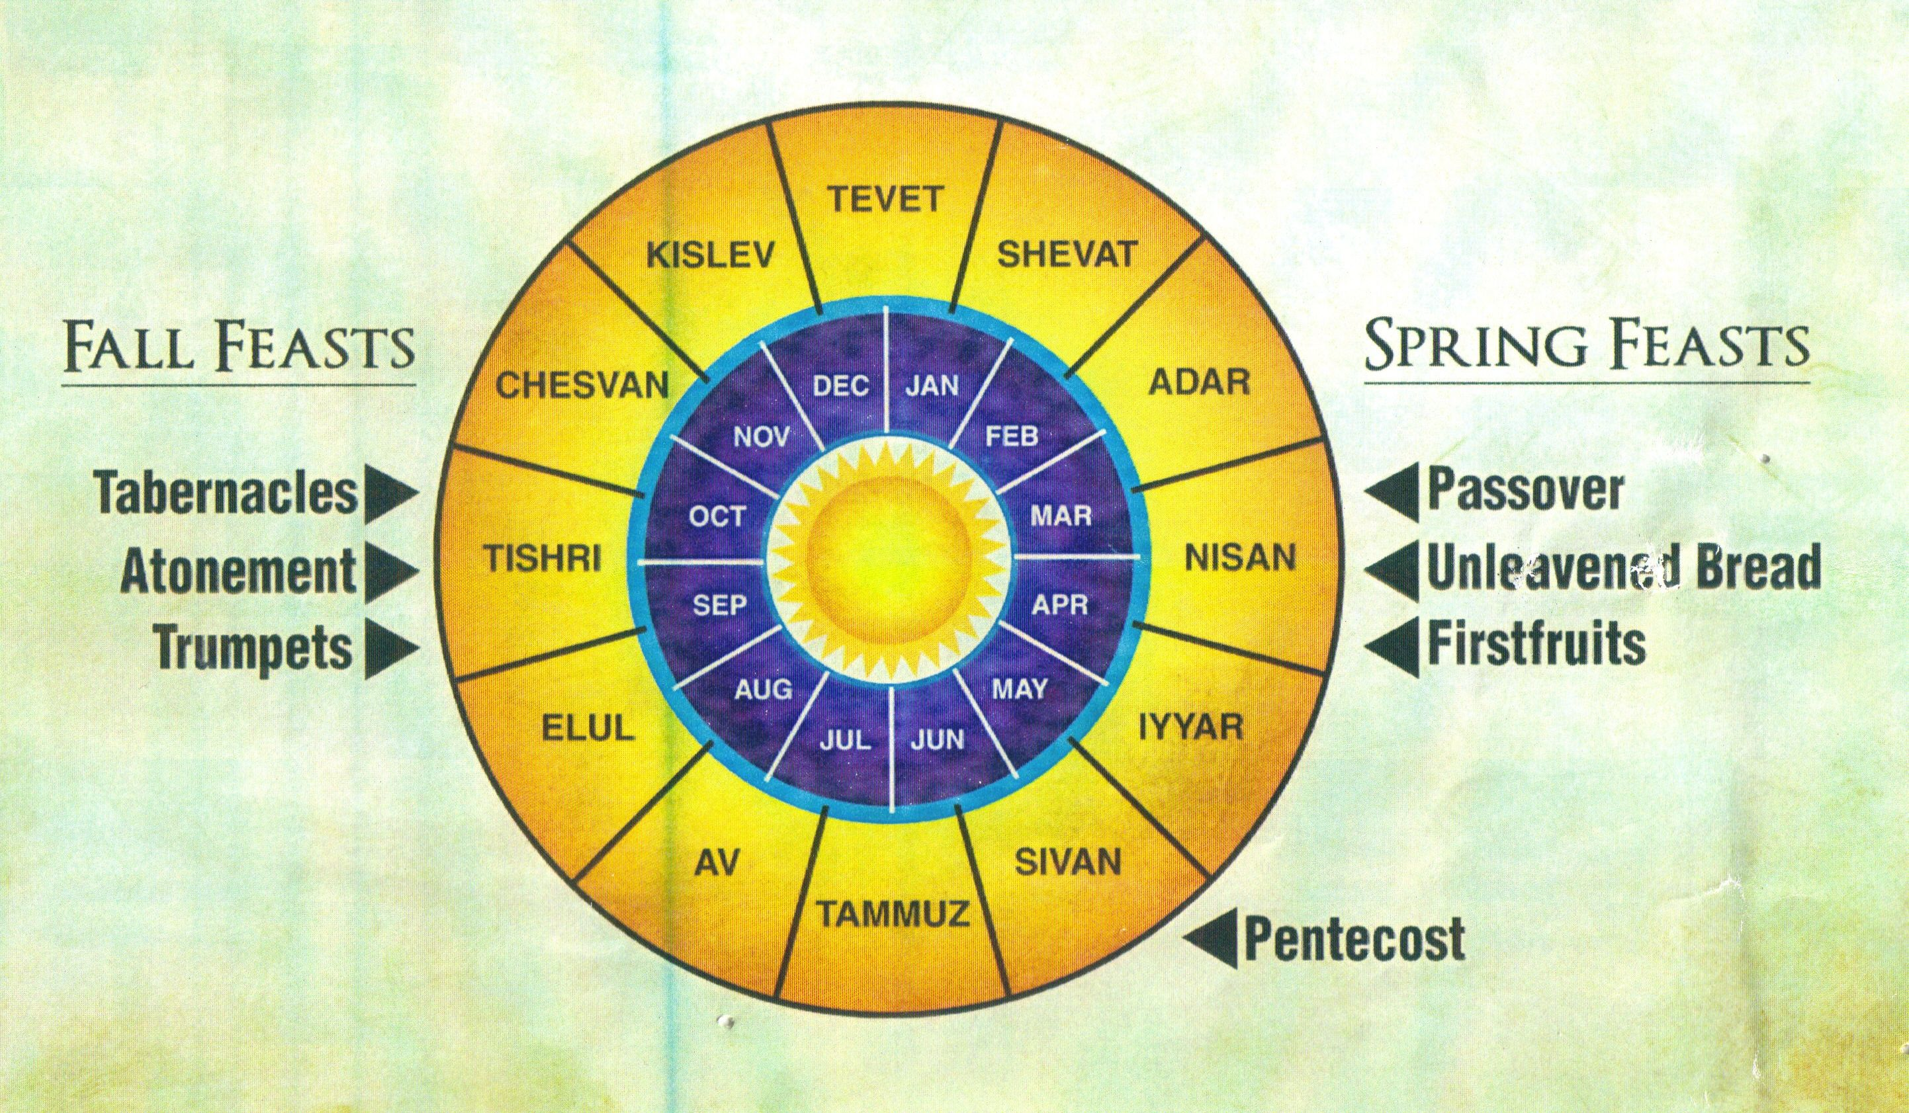

This is from a Jewish Website <https://blog.w9-taxform.com/>

However: *For I would not, brethren, that ye should be ignorant of this mystery, lest ye should be wise in your own conceits; that blindness in part is happened to Israel, until the fulness of the Gentiles be come in.* -Romans 11:25

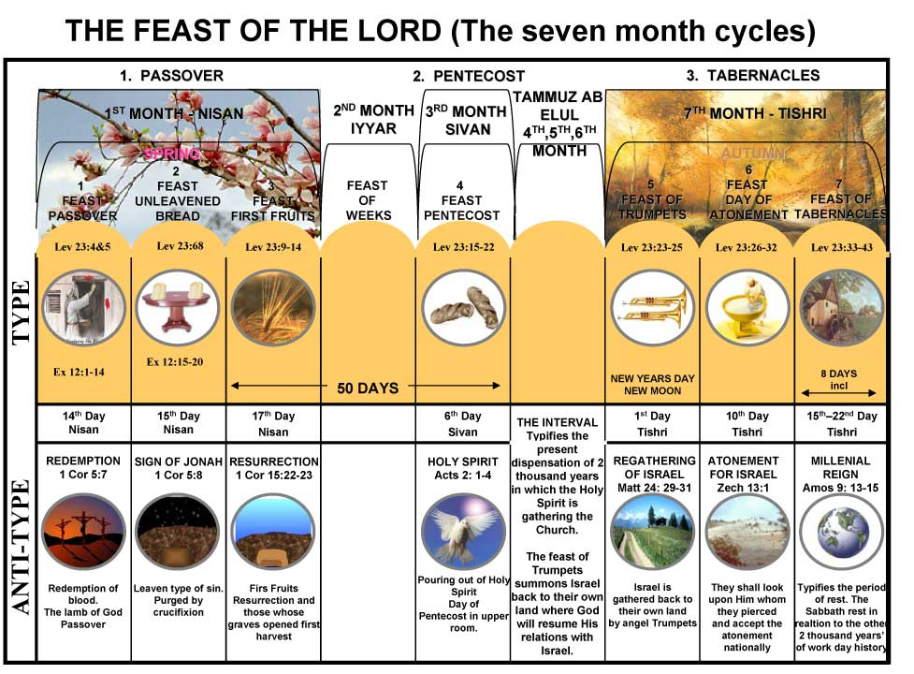

Notice the Anti-Type listed