November 16, 2025

Pastorick.org  Crosstalking @rickandbill5000 |  | Teaching the Congregation of the Redeemed

Excerpt/Notes
and
Teaching Points
from the
Rick Olsen Bible Study

LEARNING TOOLS USED

I do not understand the word in the Middle English.
G4536 - salpigx - Strong's Greek Lexicon (kjv) (blueletterbible.org)
https://loveisrael.org/
House of David Ministries
https://floydnolenjonesministries.com/
Ripped Out of the Bible, Floyd Nolen Jones, Th.D., Ph.D. Published: 2007, 11th Edition. URL: https://floydnolenjonesministries.com/files/130680834.pd



BACKSTORY
- The book of Acts (30-63 B.C.E) and the great misunderstanding of the Holy Spirit
  - Completion of the Perfect -I Cor. 13:10
    - But when that which is perfect is come, then that which is in part shall be done away -
ACTS 18:23–21:14
King James Version | Complete Jewish Bible
²² And when he had landed at Caesarea, and gone up, and saluted the church, he went down to Antioch.  ²³ And after he had spent some time there, he departed, and went over all the country of Galatia and Phrygia in order, strengthening all the disciples. | ²² After landing at Caesarea, he went up to Yerushalayim and greeted the Messianic community. Then he came down to Antioch,  ²³ spent some time there, and afterwards set out and passed systematically through the region of Galatia and Phrygia, strengthening all the* talmidim.

- Messianic Community
- * see below

²⁴ And a certain Jew named Apollos, born at Alexandria, an eloquent man, and mighty in the scriptures, came to Ephesus. | ²⁴ Meanwhile, a Jewish man named Apollos, a native of Alexandria, came to Ephesus. He was an eloquent speaker with a thorough knowledge of the Tanakh.

- TaNaKh
- CORRECTION: P.58
“Apollos Apollos was a Jew from Alexandria, a city on the coast of the Mediterranean in Egypt, northern Africa. At the time, Alexandria was Egypt’s capital and its cultural, intellectual, and research center. Alexandria had a massive library and was a hub for scholars from various cultures. This where they first translated the Hebrew Bible into Greek (the Septuagint or LXX) because so many of the Hellenistic Jews could no longer read Hebrew.”
  - The Septuagint (70)
  - The Septuagint: Acritical Analysis by Floyd Nolen Jones
  - The corrupted path of the Minority Text
    - Example: ACT 8:29
And when he had said these words, the Jews departed, and had great reasoning among themselves
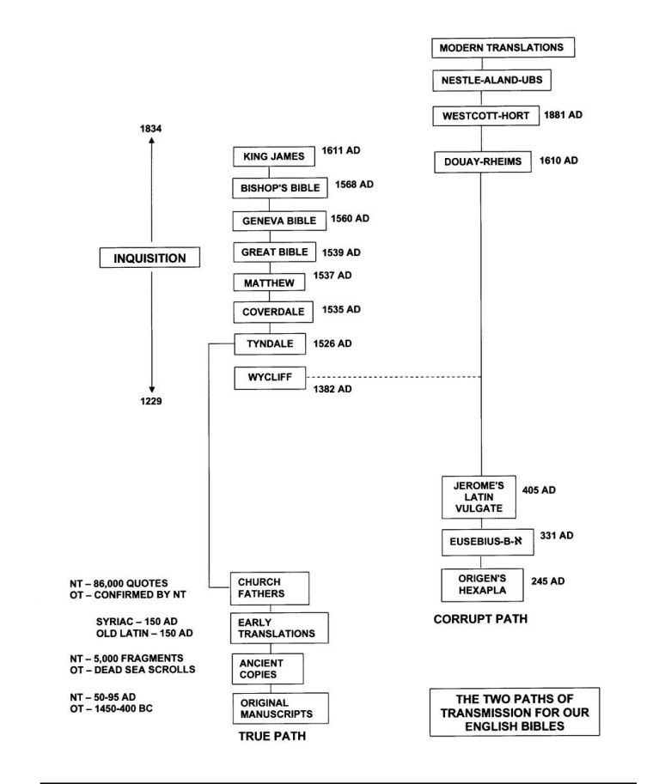
²⁵ This man was instructed in the way of the Lord; and being fervent in the spirit, he spake and taught diligently the things of the Lord, knowing only the baptism of John.  ²⁶ And he began to speak boldly in the synagogue: whom when Aquila and Priscilla had heard, they took him unto them, and expounded unto him the way of God more perfectly. | ²⁵ This man had been informed about the Way of the Lord, and with great spiritual fervor he spoke and taught accurately the facts about Yeshua, but he knew only the immersion of Yochanan.  ²⁶ He began to speak out boldly in the synagogue; but when Priscilla and Aquila heard him, they took him aside and explained to him the Way of God in fuller detail.

- Messiah (SALVATION)
- Immersion
- Aside

²⁷ And when he was disposed to pass into Achaia, the brethren wrote, exhorting the disciples to receive him: who, when he was come, helped them much which had believed through grace:  ²⁸ For he mightily convinced the Jews, and that publicly, shewing by the scriptures that Jesus was Christ. | ²⁷ When he made plans to cross over into Achaia, the brothers encouraged him and wrote the* talmidim there to welcome him. On arrival, he greatly helped those who through grace had come to trust;  ²⁸ for he powerfully and conclusively refuted the unbelieving Jews in public, demonstrating by the Tanakh that Yeshua is the Messiah.

- What scripture did Apollos use?

19 And it came to pass, that, while Apollos was at Corinth, Paul having passed through the upper coasts came to Ephesus: and finding certain disciples,
2 He said unto them, Have ye received the Holy Ghost since ye believed? And they said unto him, We have not so much as heard whether there be any Holy Ghost.
3 And he said unto them, Unto what then were ye baptized? And they said, Unto John's baptism.
4 Then said Paul, John verily baptized with the baptism of repentance, saying unto the people, that they should believe on him which should come after him, that is, on Christ Jesus.
5 When they heard this, they were baptized in the name of the Lord Jesus.
6 And when Paul had laid his hands upon them, the Holy Ghost came on them; and they spake with tongues, and prophesied.
7 And all the men were about twelve.

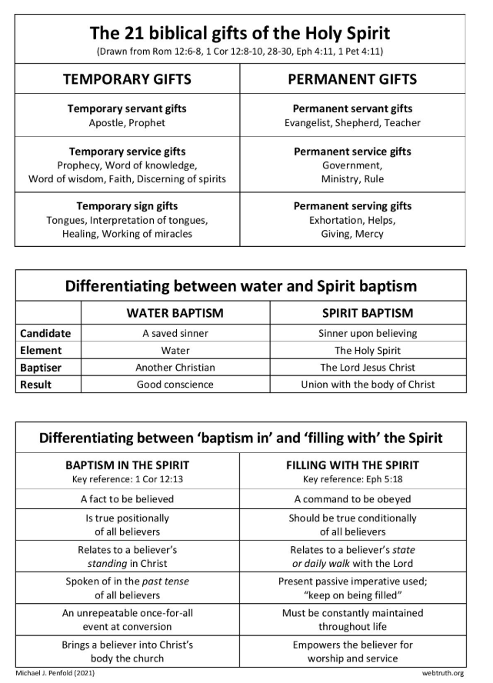
8 And he went into the synagogue, and spake boldly for the space of three months, disputing and persuading the things concerning the kingdom of God.
9 But when divers were hardened, and believed not, but spake evil of that way before the multitude, he departed from them, and separated the disciples, disputing daily in the school of one Tyrannus.
10 And this continued by the space of two years; so that all they which dwelt in Asia heard the word of the Lord Jesus, both Jews and Greeks.
11 And God wrought special miracles by the hands of Paul:
12 So that from his body were brought unto the sick handkerchiefs or aprons, and the diseases departed from them, and the evil spirits went out of them.
13 Then certain of the vagabond Jews, exorcists, took upon them to call over them which had evil spirits the name of the Lord Jesus, saying, We adjure you by Jesus whom Paul preacheth.
14 And there were seven sons of one Sceva, a Jew, and chief of the priests, which did so.
15 And the evil spirit answered and said, Jesus I know, and Paul I know; but who are ye?
16 And the man in whom the evil spirit was leaped on them, and overcame them, and prevailed against them, so that they fled out of that house naked and wounded.
17 And this was known to all the Jews and Greeks also dwelling at Ephesus; and fear fell on them all, and the name of the Lord Jesus was magnified.
18 And many that believed came, and confessed, and shewed their deeds.
19 Many of them also which used curious arts brought their books together, and burned them before all men: and they counted the price of them, and found it fifty thousand pieces of silver.
20 So mightily grew the word of God and prevailed.
21 After these things were ended, Paul purposed in the spirit, when he had passed through Macedonia and Achaia, to go to Jerusalem, saying, After I have been there, I must also see Rome.
22 So he sent into Macedonia two of them that ministered unto him, Timotheus and Erastus; but he himself stayed in Asia for a season.
23 And the same time there arose no small stir about that way.
24 For a certain man named Demetrius, a silversmith, which made silver shrines for Diana, brought no small gain unto the craftsmen;
25 Whom he called together with the workmen of like occupation, and said, Sirs, ye know that by this craft we have our wealth.
26 Moreover ye see and hear, that not alone at Ephesus, but almost throughout all Asia, this Paul hath persuaded and turned away much people, saying that they be no gods, which are made with hands:
27 So that not only this our craft is in danger to be set at nought; but also that the temple of the great goddess Diana should be despised, and her magnificence should be destroyed, whom all Asia and the world worshippeth.
28 And when they heard these sayings, they were full of wrath, and cried out, saying, Great is Diana of the Ephesians.
29 And the whole city was filled with confusion: and having caught Gaius and Aristarchus, men of Macedonia, Paul's companions in travel, they rushed with one accord into the theatre.
30 And when Paul would have entered in unto the people, the disciples suffered him not.
31 And certain of the chief of Asia, which were his friends, sent unto him, desiring him that he would not adventure himself into the theatre.
32 Some therefore cried one thing, and some another: for the assembly was confused: and the more part knew not wherefore they were come together.
33 And they drew Alexander out of the multitude, the Jews putting him forward. And Alexander beckoned with the hand, and would have made his defence unto the people.
34 But when they knew that he was a Jew, all with one voice about the space of two hours cried out, Great is Diana of the Ephesians.
35 And when the townclerk had appeased the people, he said, Ye men of Ephesus, what man is there that knoweth not how that the city of the Ephesians is a worshipper of the great goddess Diana, and of the image which fell down from Jupiter?
36 Seeing then that these things cannot be spoken against, ye ought to be quiet, and to do nothing rashly.
37 For ye have brought hither these men, which are neither robbers of churches, nor yet blasphemers of your goddess.
38 Wherefore if Demetrius, and the craftsmen which are with him, have a matter against any man, the law is open, and there are deputies: let them implead one another.
39 But if ye enquire any thing concerning other matters, it shall be determined in a lawful assembly.
40 For we are in danger to be called in question for this day's uproar, there being no cause whereby we may give an account of this concourse.
41 And when he had thus spoken, he dismissed the assembly.

20 And after the uproar was ceased, Paul called unto him the disciples, and embraced them, and departed for to go into Macedonia.
² And when he had gone over those parts, and had given them much exhortation, he came into Greece,
³ And there abode three months. And when the Jews laid wait for him, as he was about to sail into Syria, he purposed to return through Macedonia.
⁴ And there accompanied him into Asia Sopater of Berea; and of the Thessalonians, Aristarchus and Secundus; and Gaius of Derbe, and Timotheus; and of Asia, Tychicus and Trophimus.
⁵ These going before tarried for us at Troas.
⁶ And we sailed away from Philippi after the days of unleavened bread, and came unto them to Troas in five days; where we abode seven days.
⁷ And upon the first day of the week, when the disciples came together to break bread, Paul preached unto them, ready to depart on the morrow; and continued his speech until midnight.
⁸ And there were many lights in the upper chamber, where they were gathered together.
⁹ And there sat in a window a certain young man named Eutychus, being fallen into a deep sleep: and as Paul was long preaching, he sunk down with sleep, and fell down from the third loft, and was taken up dead.
¹⁰ And Paul went down, and fell on him, and embracing him said, Trouble not yourselves; for his life is in him.
¹¹ When he therefore was come up again, and had broken bread, and eaten, and talked a long while, even till break of day, so he departed.
¹² And they brought the young man alive, and were not a little comforted.
¹³ And we went before to ship, and sailed unto Assos, there intending to take in Paul: for so had he appointed, minding himself to go afoot.
¹⁴ And when he met with us at Assos, we took him in, and came to Mitylene.
¹⁵ And we sailed thence, and came the next day over against Chios; and the next day we arrived at Samos, and tarried at Trogyllium; and the next day we came to Miletus.
¹⁶ For Paul had determined to sail by Ephesus, because he would not spend the time in Asia: for he hasted, if it were possible for him, to be at Jerusalem the day of Pentecost.
¹⁷ And from Miletus he sent to Ephesus, and called the elders of the church.
¹⁸ And when they were come to him, he said unto them, Ye know, from the first day that I came into Asia, after what manner I have been with you at all seasons,
¹⁹ Serving the Lord with all humility of mind, and with many tears, and temptations, which befell me by the lying in wait of the Jews:
²⁰ And how I kept back nothing that was profitable unto you, but have shewed you, and have taught you publicly, and from house to house,
²¹ Testifying both to the Jews, and also to the Greeks, repentance toward God, and faith toward our Lord Jesus Christ.
²² And now, behold, I go bound in the spirit unto Jerusalem, not knowing the things that shall befall me there:
²³ Save that the Holy Ghost witnesseth in every city, saying that bonds and afflictions abide me.
²⁴ But none of these things move me, neither count I my life dear unto myself, so that I might finish my course with joy, and the ministry, which I have received of the Lord Jesus, to testify the gospel of the grace of God.
²⁵ And now, behold, I know that ye all, among whom I have gone preaching the kingdom of God, shall see my face no more.
²⁶ Wherefore I take you to record this day, that I am pure from the blood of all men.
²⁷ For I have not shunned to declare unto you all the counsel of God.
²⁸ Take heed therefore unto yourselves, and to all the flock, over the which the Holy Ghost hath made you overseers, to feed the church of God, which he hath purchased with his own blood.
²⁹ For I know this, that after my departing shall grievous wolves enter in among you, not sparing the flock.
³⁰ Also of your own selves shall men arise, speaking perverse things, to draw away disciples after them.
³¹ Therefore watch, and remember, that by the space of three years I ceased not to warn every one night and day with tears.
³² And now, brethren, I commend you to God, and to the word of his grace, which is able to build you up, and to give you an inheritance among all them which are sanctified.
³³ I have coveted no man's silver, or gold, or apparel.
³⁴ Yea, ye yourselves know, that these hands have ministered unto my necessities, and to them that were with me.
³⁵ I have shewed you all things, how that so labouring ye ought to support the weak, and to remember the words of the Lord Jesus, how he said, It is more blessed to give than to receive.
³⁶ And when he had thus spoken, he kneeled down, and prayed with them all.
³⁷ And they all wept sore, and fell on Paul's neck, and kissed him,
³⁸ Sorrowing most of all for the words which he spake, that they should see his face no more. And they accompanied him unto the ship.

21 And it came to pass, that after we were gotten from them, and had launched, we came with a straight course unto Coos, and the day following unto Rhodes, and from thence unto Patara:
2 And finding a ship sailing over unto Phenicia, we went aboard, and set forth.
3 Now when we had discovered Cyprus, we left it on the left hand, and sailed into Syria, and landed at Tyre: for there the ship was to unlade her burden.
4 And finding disciples, we tarried there seven days: who said to Paul through the Spirit, that he should not go up to Jerusalem.
5 And when we had accomplished those days, we departed and went our way; and they all brought us on our way, with wives and children, till we were out of the city: and we kneeled down on the shore, and prayed.
6 And when we had taken our leave one of another, we took ship; and they returned home again.
7 And when we had finished our course from Tyre, we came to Ptolemais, and saluted the brethren, and abode with them one day.
8 And the next day we that were of Paul's company departed, and came unto Caesarea: and we entered into the house of Philip the evangelist, which was one of the seven; and abode with him.
9 And the same man had four daughters, virgins, which did prophesy.
10 And as we tarried there many days, there came down from Judaea a certain prophet, named Agabus.
11 And when he was come unto us, he took Paul's girdle, and bound his own hands and feet, and said, Thus saith the Holy Ghost, So shall the Jews at Jerusalem bind the man that owneth this girdle, and shall deliver him into the hands of the Gentiles.
12 And when we heard these things, both we, and they of that place, besought him not to go up to Jerusalem.
13 Then Paul answered, What mean ye to weep and to break mine heart? for I am ready not to be bound only, but also to die at Jerusalem for the name of the Lord Jesus.
14 And when he would not be persuaded, we ceased, saying, The will of the Lord be done.

GO BACKER
King James Version | Complete Jewish Bible
²³ And when they had appointed him a day, there came many to him into his lodging; to whom he expounded and testified the kingdom of God, persuading them concerning Jesus, both out of the law of Moses, and out of the prophets, from morning till evening.  ²⁴ And some believed the things which were spoken, and some believed not.  ²⁵ And when they agreed not among themselves, they departed, after that Paul had spoken one word, Well spake the Holy Ghost by Esaias the prophet unto our fathers, | ²³ So they arranged a day with him and came to his quarters in large numbers. From morning until evening he explained the matter to them, giving a thorough witness about the Kingdom of God and making use of both the Torah of Moshe and the Prophets to persuade them about Yeshua.  ²⁴ Some were convinced by what he said,  ²⁵ while others refused to believe.  So they left, disagreeing among themselves, after Sha’ul had made one final statement: “The Ruach HaKodesh spoke well in saying to your fathers through Yesha‘yahu the prophet,

- morning till evening.
The Mishna, Judaism’s first legal compendium after the Bible, opens with a treatment of the proper times to recite the Shema in the evening and in the morning. The first line reads: “From when to when do we [liturgically] read the Shema in the evening.” The ensuing discussion in the *Gemara (Mishna + Gemara = Talmud) asks why the Mishna doesn’t first take up the morning Shema. Since the day starts in the morning, wouldn’t this be the logical place to start?
  - Shema
Hear, O Israel: The LORD our God, the LORD is one. You shall love the LORD your God with all your heart and with all your soul and with all your might. And these words that I command you today shall be on your heart. You shall teach them diligently to your children, and shall talk of them when you sit in your house, and when you walk by the way, and when you lie down, and when you rise. You shall bind them as a sign on your hand, and they shall be as frontlets between your eyes. You shall write them on the doorposts of your house and on your gates. -Deuteronomy 6:4
  - Did Jesus Ever Quote the Shema?
²⁸ And one of the scribes came, and having heard them reasoning together, and perceiving that he had answered them well, asked him, Which is the first commandment of all?
²⁹ And Jesus answered him, The first of all the commandments is, Hear, O Israel; The Lord our God is one Lord:
³⁰ And thou shalt love the Lord thy God with all thy heart, and with all thy soul, and with all thy mind, and with all thy strength: this is the first commandment.
³¹ And the second is like, namely this, Thou shalt love thy neighbour as thyself. There is none other commandment greater than these.
³² And the scribe said unto him, Well, Master, thou hast said the truth: for there is one God; and there is none other but he:
³³ And to love him with all the heart, and with all the understanding, and with all the soul, and with all the strength, and to love his neighbour as himself, is more than all whole burnt offerings and sacrifices.
³⁴ And when Jesus saw that he answered \
discreetly, he said unto him, Thou art not far from the kingdom of God. And no man after that durst ask him any question. -Mark 12

