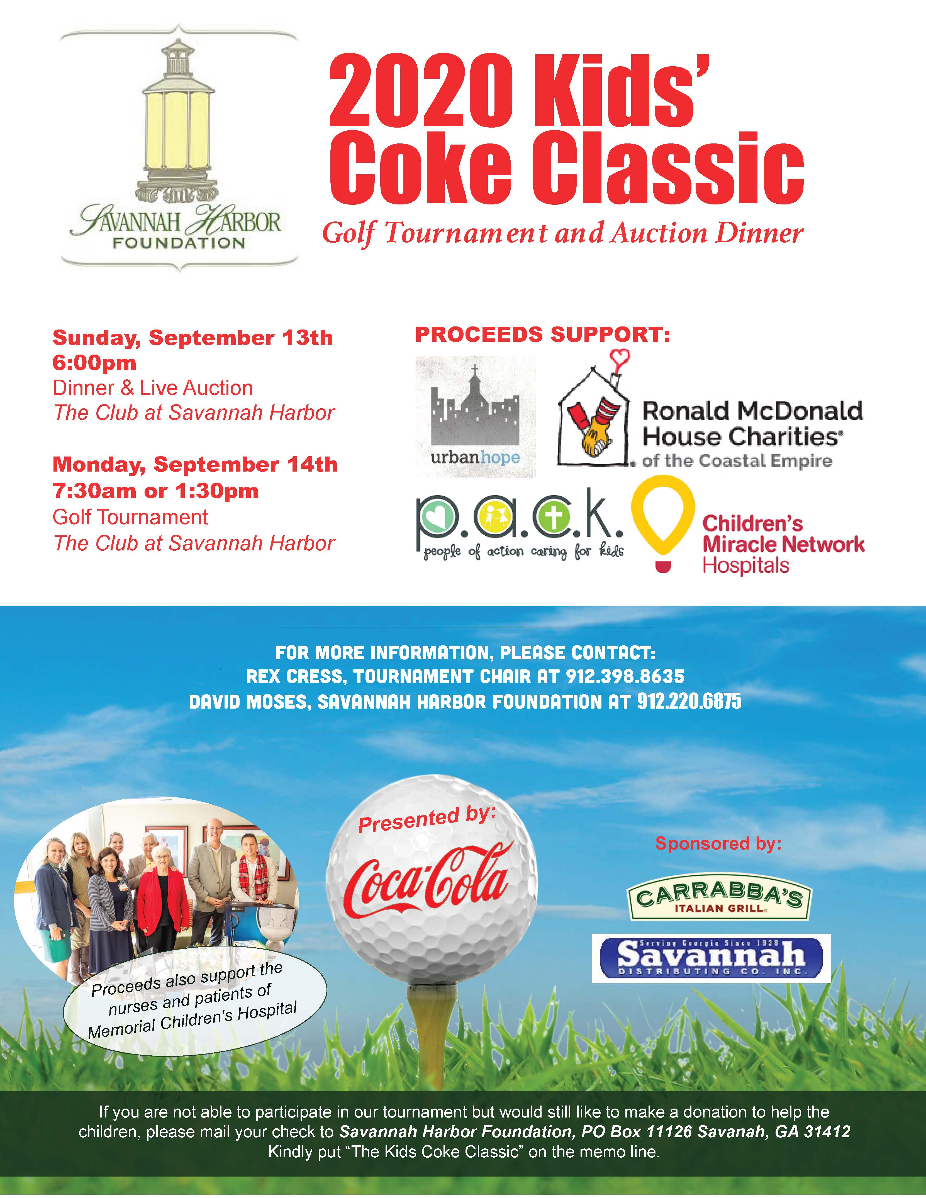
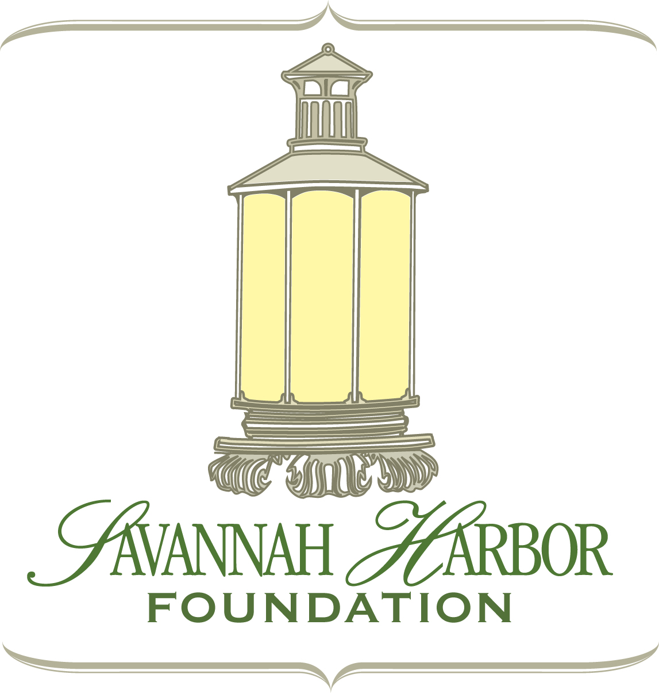
Nineteenth Annual
Kids’ Classic
Golf Tournament & Dinner
Dinner: 6 pm on Sunday, Sept. 13th

Golf: 7:30 am or 1:30 pm on Monday, Sept. 14th
The Club at Savannah Harbor

Dear Friends of the Kids Coke Classic:

I am excited to share the enclosed information with you about the upcoming Nineteenth Annual Kids’ Classic Golf Tournament presented by Coca-Cola of Savannah at The Club at Savannah Harbor on Monday, September 14th. Last year’s tournament was a huge success and the gross revenue exceeded $55,000! This year’s tournament will support multiple children’s charities in the Savannah area through the Savannah Harbor Foundation. This year’s recipients will include Urban Hope, Ronald McDonald House Charities of the Coastal Empire, P.A.C.K. and Children’s Miracle Network.

There are several team sponsorship options ranging from $600 to $1,000 per foursome. Details are outlined in the attached registration form. Your team registration will include cart, awards and prizes, lunch and beverages. The format of the tournament is four-person scramble with handicap. We are also seeking hole sponsors at $500 each. Your company name will be on signage at the hole and will be displayed prominently in the reception area. Putting green sponsors at $250 each will have their company’s name displayed on the putting green or practice tees. Please register today by completing the attached forms or visiting http://www.savannahharborfoundation.org.

You may also support the tournament by donating auction items or prizes (rounds of golf, dinners, vacations, merchandise, services, etc.). All donors and tournament participants are invited to attend a reception and live auction, catered meal, on Sunday, September 13, at 6:00 PM at The Club at Savannah Harbor.

If you are not able to participate in our tournament but would still like to make a donation to help the children, please mail your check to Savannah Harbor Foundation, PO Box 11126, Savannah, GA 31412. Kindly put “The Kids Coke Classic” on the memo line.

Thank you for your consideration!

Rex Cress - Tournament Chair
12 Belle Gate Court
Pooler, GA 31322
1.912.398.8635
rexcress@hargray.com

Dan Pavlin
President, Savannah Harbor Foundation
info@savannahharborfoundation.com

The Savannah Harbor Foundation, a 501(c)(3), makes a commitment to bettering our community and those who live within it. This mission is funded through community events and sponsorship in order to realize our vision of engaged and uplifted neighborhoods.

Nineteenth Annual Kids’ Classic Golf Tournament
Sunday, September 13 & Monday 14, 2020, at 7:30 am or 1:30 pm
at The Club at Savannah Harbor
Benefiting the Savannah Harbor Foundation & Charities in Savannah

YES! I would like to help children by supporting the Kid’s Classic Golf Tournament.
Company: ______________________________________________________
Address: _______________________________________________________
City: _____________________________ ST: _________ Zip: _____________
Phone: ____________________________ Fax: _________________________
Contact: _______________________________________________________
Email: ________________________________________________________

Sponsorship Levels:
- Presenting Sponsor - $10,000 (banner at dinner and tournament; opportunity for remarks at dinner; 2 teams of 4 players each; hole sponsor & scoreboard recognition)
❑ Annual Lantern Sponsor - $6,000 includes foursome and hole sponsor at the Kids Coke Classic Golf Tournament, Tickets to the Gourmet Seafood & Spirits Festival, Wheels in Savanah and other events; VIP Board Parade Seating, Inclusion on SavanahHarborFoundation.org, up to 4 complimentary passes ERS Races
❑ Gold Team - $1,000 (includes 4 players; highly visible hole sponsor & special recognition) at the event)
❑ Silver Team - $750 (includes 4 players; includes hole sponsor recognition)
❑ Bronze Team - $600 (includes 4 players)
❑ Hole Sponsor - $500
- Putting Green Sponsor - $250

PLEASE BRING DOOR PRIZES OR GIFTS FOR THE GIVE-AWAY BAGS FOR EACH PLAYER.
Payment:

❑ Check Enclosed (Payable to Savannah Harbor Foundation)
❑ Credit Card: MC VISA AMEX (circle one)
Acct #__________________________________ Exp. Date __________
Signature _________________________________ Date ____________

For more information, please contact Rex Cress, Tournament Chair, at 912.398.8635

Nineteenth Annual Kids’ Classic Golf Tournament
Sunday, September 13 & Monday 14, 2020, at 7:30 am or 1:30 pm
at The Club at Savannah Harbor
Benefiting the Savannah Harbor Foundation & Charities in Savannah

COMPANY: ____________________________________________________
TEAM NAME (if different from company name): _____________________
DATE: Monday, September 14, 2020
Preferred Tee Time for Monday, September 14: 7:30 AM OR 1:30 PM

Player 1 ____________________________________________ HDCP___________
Address _____________________________________________________________
City ________________________________________ ST _______ Zip ___________
Phone # __________________ Email ______________________________________
Club________________________________ Club Phone Number _________________

Player 2 ____________________________________________ HDCP___________
Address _____________________________________________________________
City ________________________________________ ST _______ Zip ___________
Phone # __________________ Email ______________________________________
Club________________________________ Club Phone Number _________________

Player 3 ____________________________________________ HDCP___________
Address _____________________________________________________________
City ________________________________________ ST _______ Zip ___________
Phone # __________________ Email ______________________________________
Club________________________________ Club Phone Number _________________

Player 4 ____________________________________________ HDCP___________
Address _____________________________________________________________
City ________________________________________ ST _______ Zip ___________
Phone # __________________ Email ______________________________________
Club________________________________ Club Phone Number _________________

** You may mail your entry form to Savannah Harbor Foundation, PO Box 11126, Savannah, GA 31412 or email to rexcress@hargray.com .

Gift-in-Kind Donation Form
The Kids’ Classic Golf Tournament 2020
September 13 & 14, 2020, at The Club at Savannah Harbor

Name of Donor: __________________________________________________

Contact Person: __________________________________________________

Address: _______________________________________________________

City: _______________________________ State: _______ Zip: ____________

Phone: __________________ Email: _________________________________

Description of Gift(s):_______________________________________________

______________________________________________________________

______________________________________________________________

Value of Gift: $ ________________________

Restrictions and Expiration Date of certificate (if applicable):____________________

______________________________________________________________

Tribute Option: (please check one)  In Memory of  In Honor of

Name of Person being Remembered/Honored:

______________________________________________________________

Donor Signature: __________________________________________________

The Savannah Harbor Foundation, a 501(c)(3), makes a commitment to bettering our community and those who live within it. This mission is funded through community events and sponsorship in order to realize our vision of engaged and uplifted neighborhoods.
We Thank Our Generous Supporters:


