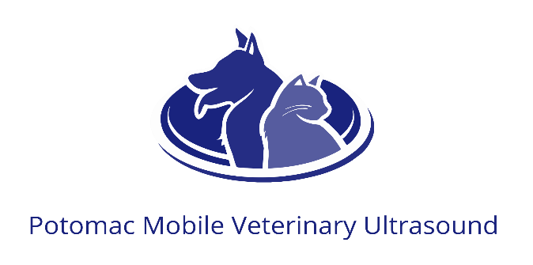
Date:
Clinic Name:
Doctor in Charge of Case:
Email Address for U/S report:
Type of Scan Requested (please circle): Abdomen/echo/double cavity/other

For abdomens only, please check one:
Report to be completed by Dr. Jarrett
Specialist overread
Patient First Name: Last name:
(Please circle): Canine / Feline
M MN F FS Age: Breed: Weight:
Reason for Ultrasound:
Current Medications:
Bloodwork findings:
Urinalysis findings: USG:
Coag times (if applicable) PT_____________ PTT_____________
Please email to: cj@potomacmvu.com or have ready at the time of the ultrasound. By submitting this form, this veterinary practice acknowledges agreement to payment terms set forth by Potomac Mobile Veterinary Ultrasound. I understand that payment is due immediately upon completion of the ultrasound, unless previous payment arrangements have been made in advance.

