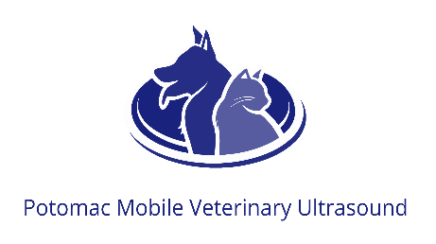
Ultrasound Procedure & Sedation Release
Date:__________
Patient & Client last name: ____________________________________
Ultrasound frequently requires shaving your pet (chest or abdomen or both)
Please initial: _______ I understand my pet will be shaved.
Ultrasound requires that your pet has been fasted for 8-12 hours
Please initial: _______ My pet was fasted. The last time (s)he ate was ______

Although ultrasound examinations are not painful, in many situations, sedation is extremely beneficial to help the patient relax, increase comfort, and allow for a more thorough examination that provides optimal diagnostic information. Your pet’s safety and comfort is of utmost importance to us. Although there are rare possible adverse effects to any drug, if sedation is utilized, your veterinarian will use medications that they deem suitable and safe for your pet.
Please Initial: _______ YES, I authorize sedation if necessary for my pet at an additional fee.
_______ NO, I do not authorize sedation for my pet. I understand that there may be a cancellation fee associated if the scan cannot be performed without sedation.

This section does not apply to echocardiograms:
During the ultrasound, your DVM may determine that sampling of masses or organs may be necessary to obtain samples for diagnosis. Pre-sampling labwork may be necessary and sedation will be required. Fine needle aspirates utilize very small needles and are generally very safe and have little risk, but there is a small risk of bleeding.
Please initial: _______ YES, I authorize sampling if deemed necessary
_______ NO, I do not authorize sampling, please call first. I am aware another appointment may be required for sampling if I am unreachable.

