KCSC Newsletter

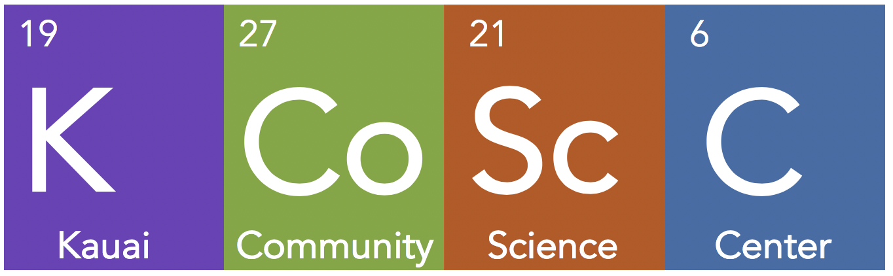
HIGHLIGHTS & LINKS
JULY
- Received 501c(3) Determination letter
- KCSC Website Live
- Presented to Kauai Area Complex Principals, Vice-Principals and Administrators.

AUGUST
- Started leasing an office in the West Kauai Technology & Visitor Center

SEPTEMBER
- Live on 
- Awarded County of Kauai, Office of Economic Development Grant for Students Sharing Science project.
- Attended ASTC Conference in Toronto, Canada.
- Students Sharing Science program listed in Root + STEM directory.

Welcome to Kauai Community Science Center’s inaugural KCSC Newsletter! We are happy to have news to share with you and look forward to your questions, suggestions and anything else you would like to share with us. We will share our history with you, let you know what’s coming up, where we are headed and how you can get involved.
We want the KCSC Newsletter to be a way for us to communicate with you and also an inspiration for you to communicate with us.
A Few Small Steps for Kauai Community Science Center, One Giant Leap for Kauai
2019 is the 50th anniversary of landing a man on the moon. In the spirit of that grand achievement, the “moonshot” for KCSC involves building an organization that is a community partner supporting P-20 education and the transformation to career-connected and project-based learning. KCSC will also grow science literacy and support building a resilient, vibrant and thriving community on Kauai. A community that is equipped and informed to be an active part of the solutions to the challenges and opportunities in the next 50 years and beyond.

KCSC Organizational Milestones to date
March 26, 2019 – Registered as a Domestic Nonprofit Organization by Hawaii DCCA
May 17, 2019 – Organizational Board Meeting
June 2019 – Met with representatives from Cornell Alliance for Science, Sciencenter, Ithaca, NY,Y, Connecticut Science Center, Boston Museum of Science while visiting the East Coast.
July 17, 2019 – Presented to Kauai Complex Principals, Vice-Principals & Administrators
July 24, 2019 – KCSC receives determination letter granting IRS tax exemption status
August 1, 2019– Begin lease of office at West Kauai Technology & Visitor Center
September 9, 2019 – Awarded County of Kauai OED grant for Students Sharing Science
September 24 – 25, 2019 – Attended ASTC Annual Conference in Toronto, Canada
October 2, 2019 – Presented to >100 students at WCMS during Career Day
CONTACT INFORMATION  For questions, suggestions or more information  contact Sarah Styan, sarah@kauaicsc.org  visit the KCSC website https://kauaicsc.org  or follow us on social media @kauaicsc  HAPPENING IN Q4  - KCSC participates in the WCMS Career Day, October 2nd.  - KCSC received a scholarship to attend the HANO Conference in Honolulu, October 11th.  - KCSC will present to Kauai Community College faculty and students, October 23rd.  - KCSC will participate in the Kauai Academies Career Fair, October 28th.  - KCSC will work with KEDB and other community partners to develop KCoRD, Kauai Community Resource Directory.  - KCSC will begin working with students and teachers at WCMS, Sciencenter, Ithaca, NY and professionals on Kauai for the the Students Sharing Science Project.  - Develop a KCSC Fundraising Campaign and build a Membership program. | What is The Big Idea?  Career Academies, Career-Connected Learning & Project-Based Learning  Kauai’s public education system is transforming right now. This transformation involves incorporating career academies, career-connected and project-based learning. Transforming education is no small task and Kauai’s educators need the support of the whole community to make this happen.  KCSC is a community partner supporting this transformation by connecting students and teachers with resources and professionals on Kauai and beyond. Every career has an element of science. Facilitating relationship building and project-based learning opportunities between students, teachers and professionals will result in student generated science-based content and student led activities. Students will be generating content and providing activities based on their interests, learning about careers and providing a community service.  Kauai Community Science Center promotes that science is part of our lives every day and you don’t have to be a scientist to use and enjoy science. Kauai and the World need a science literate community that is prepared to participate and be an active part of the solutions to the challenges we are facing as a global community. Science plays a role in these challenges and each one of us has a role to play using our talents and interests to ensure a vibrant and thriving future.  Below are some links to relevant organizations and a documentary film that provide more background on career academies, project-based learning and science centers around the world to get you started.  National Career Academies Coalition  This Organization is working with our high schools on Kauai to gain certification as Career Academy Schools. You may want to check out the examples from the Nashville, Tennessee School District and what career academies has done for the students and community there. https://www.ncacinc.com/nsop/academies  Most Likely to Succeed  A documentary film about High Tech High in San Diego, California. Educators on Kauai have visited this school and it is an example of what the future may look like on Kauai. This movie was inspirational to the development of the KCSC concept and is why KCSC wants to support this exciting transformation as a community partner. https://teddintersmith.com/mltsfilm/  Association of Science-Technology Centers, ASTC. An international association of science and technology centers. KCSC is a member of ASTC and was able to attend some of the annual conference this year in Toronto. https://www.astc.org/  Look for the next KCSC Newsletter in early 2020

