

**Set-aside for mid-tier companies still possible**

* By [Matthew Weigelt](http://fcw.com/forms/emailtoauthor.aspx?AuthorItem=%7B677B4E4C-11D9-4F02-8664-CA06358939E6%7D&ArticleItem=%7B0590E204-1027-4FCD-9795-C7306F5E84A1%7D)
* Feb 19, 2013

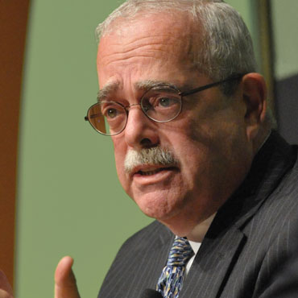

Rep. Gerald Connolly (D-Va) is renewing his effort to create special programs for midsized companies. (FCW photo)

The idea of a pilot set-aside program for middle-tier companies is not dead yet.

Krystal Brumfield, senior legislative tax counsel for the Senate Small Business and Entrepreneurship Committee, acknowledged that while the proposal did not make it into the final version of fiscal 2013 National Defense Authorization Act, "it's a new day, and a new Congress.

She spoke at a Feb. 14 Capitol Hill event hosted by [Mid-Tier Advocacy](http://midtier.org/), which describes itself as a "non-partisan organization made up of the country’s top veteran-owned, service disabled, hub-zone certified, minority-owned and woman-owned businesses."

On the other side of the Capitol, Rep. Gerry Connolly (D-Va.) worked in the previous Congress to require defense officials to examine the transition challenges that small businesses face when outgrowing the specific set-aside programs. He wants recommendations on helping these companies survive the next phase of their business when they face off against the major federal contractors with no help from their size status.

"Innovative, high-performing small businesses are becoming victims of their own success -- graduating from small business programs only to find themselves in the untenable position of facing off against multi-billion dollar firms," Connolly said Feb. 19.

Connolly said he expects these recommendations to inform legislation to establish a growth path that empowers successful small businesses to thrive when they achieve "advanced" or "mid-tier" status.

In 2011, Connolly introduced the Small Business Growth Act. It proposed a set-aside program that started with only the General Services Administration. GSA could award a contract through the set-aside program to a mid-tier company if officials believed a small business likely would not have received it. In addition, the mid-tier company was required to be mentoring a smaller company. Congress never passed the bill.

Language for a pilot program, based on Connolly's bill, was in the initial fiscal 2013 National Defense Authorization Act, which the House passed in May 2012. The provision was dropped, however, by the time the bill reached President Barack Obama and was signed into law on Jan. 2.

MTA, a group of industry executives comprised of mid-tier companies and small firms, has tried to drum up support in Congress for new legislation that would create a pilot program to give recent small-business grads and mid-tier companies a [stepping stone](http://fcw.com/articles/2011/10/24/home-page-acquisition-investing-in-midsize-companies.aspx) into the world of full-and-open competition.

Brumfield said the committee is interested in advocating for mid-tier companies, even as senators set the agenda for the next two years and new members join the committee. She noted that Sens. Heidi Heitkamp (D-N.D.) and William Cowan (D-Mass.), could bring more support to the effort, and said that senators in general understand the needs of companies just above the small-business threshold.

"There are some challenges that small business face, and there are some needs that are necessary [to address] in order for small business to continue to grow," she said.

*"Set-aside for mid-tier companies still possible"*

*Read:*

[*http://fcw.com/articles/2013/02/19/mid-tier-set-aside.aspx*](http://fcw.com/articles/2013/02/19/mid-tier-set-aside.aspx)

About the Author

Matthew Weigelt is a senior writer covering acquisition and procurement. Connect with him on Twitter: [@matthewweigelt](http://www.twitter.com/matthewweigelt).