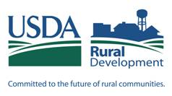
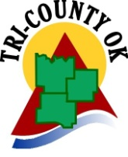
Tri-County Indian Nations Community Development Corporation
Self-Help Housing Program
Date: ______________
PRELIMINARY APPLICATION
$15 single/ $20 dual application fee (no personal checks)

APPLICANT________________________________ CO-APPLICANT__________________________________
(First, Middle, Last) (First, Middle, Last)

AGE________ Date of Birth __________ AGE________ Date of Birth_________
ADDRESS: ________________________________ CITY________________ STATE________ ZIP_________
PHONE NO. (HOME)_____/_____/_____________ (WORK)_____/_____/_______________ Best Time to Call_________
Are you or anyone in your household Disabled? _____ Are you a US Citizen? _____ Race _________________________
Do you have a CDIB card? _____ Marital Status __________ Do you rent or own your home?________________________
How did you find out about the Self-Help Program? __________________________________________________________
The above information is for data gathering purposes only and is strictly voluntary. It will not be considered in determining your eligibility.

NO. IN FAMILY: _____ CHILDREN’S AGES:_______________________ Do you have Child Care Expenses__________
INCOME SOURCE AND AMOUNT: (Include Food Stamps or Child Support, if applicable)___________________________________________
_____________________________________________________________________________________________________________________________
APPLICANT PLACE OF EMPLOYMENT: ______________________________ HOW LONG EMPLOYED: __________
CO-APPLICANT PLACE OF EMPLOYMENT: ____________________________ HOW LONG EMPLOYED: _________
TOTAL GROSS ANNUAL INCOME: ________________ DO YOU OWN PROPERTY?____________
ASSETS: ____________________________________________________________________________________________
CAN YOU FURNISH CREDIT REFERENCES UPON REQUEST?______________________________

I/WE HEREBY AUTHORIZE TRI-COUNTY INDIAN NATIONS COMMUNITY DEVELOPMENT CORPORATION

TO PROCESS A PRELIMINARY CREDIT CHECK.
SOC. SEC. #____________________________ SOC. SEC. #________________________________
Applicant Signature_______________________________ Co-Applicant Signature________________________________

DEBT INFORMATION (this does not include rent, utilities or insurance)
Payable to | Monthly payment amount | Approximate balance owed

Applications may be submitted to:
Tri-CountyOK
122 E. Main St.
Ada, OK 74820

FAX:(580) 310-9826 or e-mail to chill@tri-countyok.org (App will be processed when fee is received.)
Applications may also be delivered in person to 122 E. Main St, Ada, OK
For questions please call (580) 310-9300
MAKE YOUR DREAM HOME A REALITY WITH….

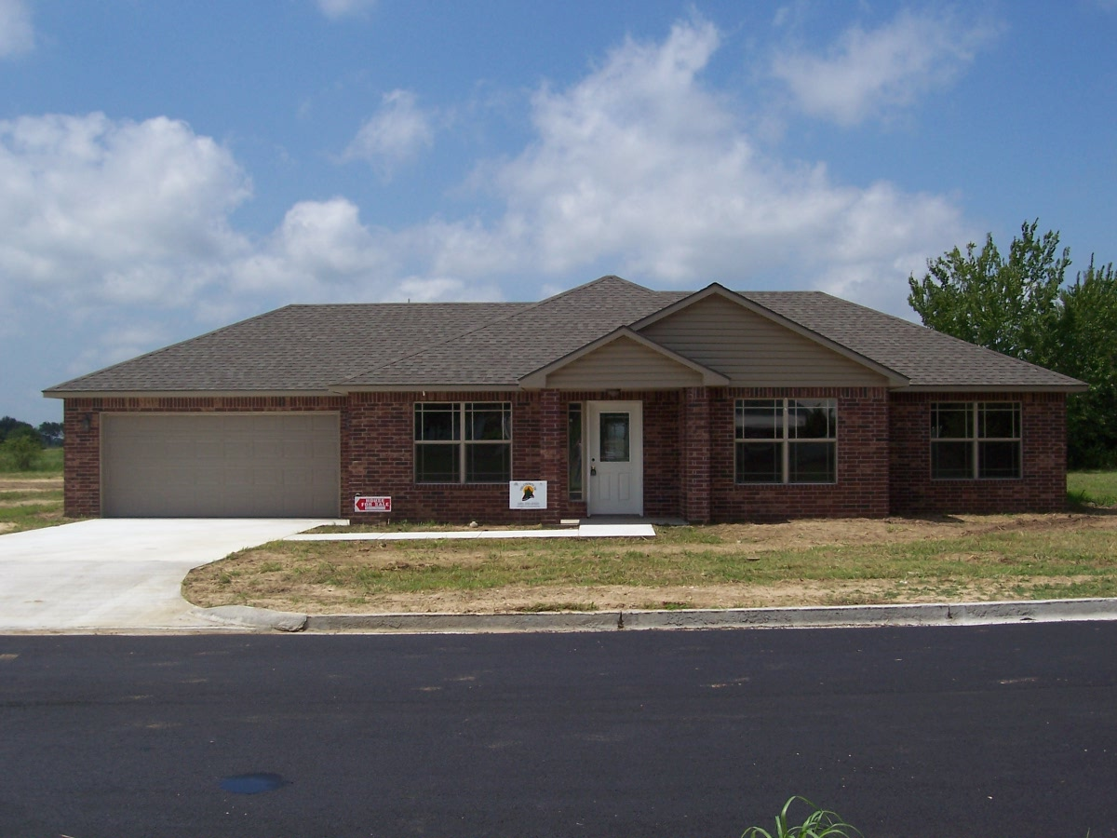

TRI-COUNTY SELF HELP HOUSING PROGRAM

A Non-Profit Organization
What is Tri County’s Self Help Housing Program?
This is a program where qualified individuals and families can build new homes. This program is offered to you by a combination of government financing, the coordination of Tri-County OK, and the family’s labor.

Qualifications
Be within income level guidelines
Have less than 41% income going to debt payments (including projected house payment)
Consistent work history or steady source of income
Have an acceptable credit record and score

*If you have had credit problems in the past, call us so we can visit. This may not hurt your chances of owning your own home.

Counties
Pontotoc
Coal
Johnston
Murray
Garvin

Income Limits

Varies depending on county and size of family. Call the office for more information.

Features and Facts
3 or 4 bedroom floor plans
Decoration choices
Brick exterior
Energy efficient construction
Composition roof
Central heating & A/C
Dishwasher , range and microwave
Attached garage
Paved driveway pad

Benefits
No down payment
Payments and Interest adjusted to income
Enjoy a home you helped build with instant equity
Provides secure and suitable housing
Improves family values
Allows families to graduate from renter status to homeownership
Promotes parent’s and children’s self esteem
Learn carpentry skills

Requirements (Self-Help)
Help paint
Help install interior trim and doors
Help insulate walls
Clean up after contractors
Complete a free session of Homebuyer Education class
Be a part of a home builders team
Help your team complete tasks at their homes and receive work credit

If you are interested and would like more information complete our preliminary application form and mail,
come by or contact TRI COUNTY and speak with Carolyn or Jennifer at:
122 E. Main Street Ada, OK 74820 (580)310-9300 www.facebook.com/tricountyok (800)722-0353 (TTY/TDD) 

