# Your Risk Tolerance

The Risk Profile is designed to determine your level of tolerance to, and acceptance of, investment risk. Investment risk is the chance that the actual value of, or return from, an investment may be less than its expected value or return. The following questions assess your willingness to accept investment risk, and your capacity to take risk relative to your financial situation, goals and objectives.

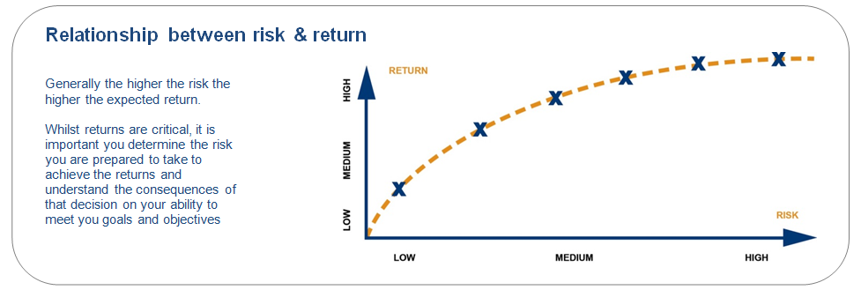

People have different risk profiles which can reflect variations in their current financial situation, their age and life stage, their goals and objectives (and the time in which they wish to achieve them), their financial experience and knowledge, as well as personal values and beliefs. For example, some investors find it easy to ignore movements in the market and to focus on their long-term investment goals. However, others become anxious when their investments decrease in value, even by a small amount. This means we need to understand your willingness to take on risk, and also your capacity to handle the risks associated with an investment; for example, you may need a less volatile investment for a short term goal to ensure you have the money available at the time you need it.

By more clearly determining your risk profile, we are able to provide you with advice that is tailored and appropriate for your individual circumstance.

## Risk & return profile questionnaire

The following questions will help me determine your risk profile.

*Please note that C1 = Client 1, C2 = Client 2, J = Joint, E = SMSF.* Select only one response that best matches your experience/reaction.

**Q1. Which of the following best describes your current situation?**

|  |  |  |  |  |
| --- | --- | --- | --- | --- |
|  | | | | |
| **C1** | **C2** | **J** | **S** |  |
|  |  |  |  | **I have few financial commitments and looking to build wealth for the future.** |
|  |  |  |  | **I have financial commitments, such as a mortgage or young family, but want to optimise my finances to build wealth.** |
|  |  |  |  | **My finances are under control and I want to build further wealth for the future.** |
|  |  |  |  | **I am preparing for retirement and looking at strategies to optimise my retirement income and wealth.** |
|  |  |  |  | **I have retired and depend on my investments to maintain lifestyle.** |

**Q2. How familiar are you with investing?**

|  |  |  |  |  |
| --- | --- | --- | --- | --- |
| **C1** | **C2** | **J** | **S** |  |
|  |  |  |  | **I am an experienced investor. I understand financial markets and take an active interest in the share market.** |
|  |  |  |  | **I have a good understanding. I know how super and shares work and where my money is invested.** |
|  |  |  |  | **I have very little experience. I might know the balance of my super fund.** |
|  |  |  |  | **I have no experience with investing.** |

**Q3. Which statement below best describes your approach to investing?**

|  |  |  |  |  |
| --- | --- | --- | --- | --- |
| **C1** | **C2** | **J** | **S** |  |
|  |  |  |  | **I prefer stable investments, like term deposits, and willing to accept lower returns to reduce the levels of fluctuation.** |
|  |  |  |  | **While I prefer stable investments, I am comfortable if a small portion of my investments are in assets with higher levels of fluctuation, like shares, to achieve higher growth and protect against inflation.** |
|  |  |  |  | **I accept that my investments will go up and down in value, but I would like to maintain some stable investments to smooth returns over time.** |
|  |  |  |  | **I expect to see the value of my portfolio going up and down, and I am comfortable investing most of my portfolio in assets with higher levels of fluctuation to achieve higher growth.** |

**Q4. When making decisions about your investments, do you think more about possible losses or possible gains?**

|  |  |  |  |  |
| --- | --- | --- | --- | --- |
| **C1** | **C2** | **J** | **S** |  |
|  |  |  |  | **I am always concerned about possible losses to my investments.** |
|  |  |  |  | **I am a little concerned about possible losses to my investments.** |
|  |  |  |  | **I mostly think about possible gains to my investments.** |
|  |  |  |  | **I always think about possible gains to my investments.** |

**Q5. If your investment portfolio increased over time and you felt confident of meeting your financial goals, what would you do?**

|  |  |  |  |  |
| --- | --- | --- | --- | --- |
| **C1** | **C2** | **J** | **S** |  |
|  |  |  |  | **Take more risk within my portfolio, with the hope of achieving more of my goals, even if this has a chance of jeopardise some of my goals.** |
|  |  |  |  | **Continue to maintain my investment strategy.** |
|  |  |  |  | **I would sell down some of my investments to reduce the chance of jeopardising my goals, even if this means accepting a lower return.** |
|  |  |  |  | **Sell down most of my investments into safer investments to ensure my goals are met, even if this means a lower return.** |

**Q6. If your investment portfolio fell in value over time and you were behind in meeting your goals, what would you do?**

|  |  |  |  |  |
| --- | --- | --- | --- | --- |
| **C1** | **C2** | **J** | **S** |  |
|  |  |  |  | **Increase my exposure to more volatile investments, like shares, to seek higher returns and pursue my goals.** |
|  |  |  |  | **Continue to maintain my investment strategy to ride out the negative returns.** |
|  |  |  |  | **Reduce the exposure to more volatile investments, like shares, to minimise any further losses, even if this means I wouldn’t be able to meet all of my goals.** |
|  |  |  |  | **Sell all my investments to avoid any further losses, even if it means my goals will not be met.** |

**Q7. Assume you established a $300,000 investment portfolio 12 months ago. What would you do if it fell 20% to $240,000 due to market fluctuations?**

|  |  |  |  |  |
| --- | --- | --- | --- | --- |
| **C1** | **C2** | **J** | **S** |  |
|  |  |  |  | **Immediately transfer all my investments into stable investments, like cash and term deposits, to protect against further losses.** |
|  |  |  |  | **Transfer some of my investments into stable investments to reduce my exposure to volatile investments, like shares.** |
|  |  |  |  | **Maintain my portfolio and wait for the investment markets to recover.** |
|  |  |  |  | **Look for a way to buy more volatile assets to benefit from the market recovery.** |

**Q.8 Assume your investment portfolio drops in value due to market fluctuations. How long would you wait for it to return to its previous balance before moving to a more stable investment?**

|  |  |  |  |  |
| --- | --- | --- | --- | --- |
| **C1** | **C2** | **J** | **S** |  |
|  |  |  |  | **I would move to a more stable investment immediately. I won’t accept any fall in my portfolio.** |
|  |  |  |  | **I would wait up to 12 months.** |
|  |  |  |  | **I would wait up to 2 years.** |
|  |  |  |  | **I would wait up to 5 years.** |
|  |  |  |  | **I would wait at least 7 years.** |

**Risk Profile Scoring**

|  |  |  |  |  |  |  |  |  |
| --- | --- | --- | --- | --- | --- | --- | --- | --- |
|  | **Q1** | **Q2** | **Q3** | **Q4** | **Q5** | **Q6** | **Q7** | **Q8** |
| **Option 1** | 0 | 640 | 100 | 0 | 1000 | 1200 | 0 | 0 |
| **Option 2** | 0 | 480 | 300 | 200 | 600 | 840 | 400 | 240 |
| **Option 3** | 0 | 160 | 600 | 400 | 200 | 600 | 600 | 480 |
| **Option 4** | 0 | 0 | 1000 | 900 | 0 | 120 | 800 | 960 |
| **Option 5** | 0 | N/A | N/A | N/A | N/A | N/A | N/A | 1200 |

|  |  |
| --- | --- |
| **Score** | **Profile** |
| **120 - 1135** | **Defensive** |
| **1136 – 2020** | **Conservative** |
| **2021 – 3183** | **Moderate** |
| **3184 – 4380** | **Balanced** |
| **4381 – 5748** | **Growth** |
| **5749 – 6740** | **High Growth** |

## Your risk / return profile

Your risk profile is generally limited by both your personal willingness to accept risk, and your financial capacity to take risk. Your capacity to take risk is usually dictated by factors such as your investment timeframe, and reliance on funds. For example, where you plan to retire in 3 years, and you will be reliant on the sum of your funds being invested to generate an income for you in retirement, your capacity to take risk will be lower than an investor who is 10 years from retirement, or who will have funds surplus to their requirements in retirement. As a result, an appropriate risk profile may be more conservative than your personal willingness to take risk. Likewise, where your financial capacity to take risk exceeds your personal willingness to accept risk, an appropriate risk profile will generally align with your more conservative willingness to accept risk.

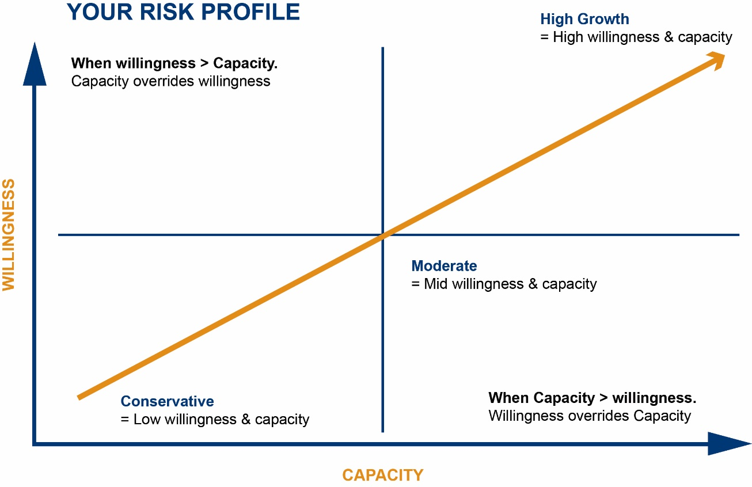

## Your risk tolerance

Understanding your investment risk tolerance is vital to portfolio construction and developing an appropriate asset allocation for you.

|  |  |  |  |
| --- | --- | --- | --- |
| **Tolerance** | **Low Medium High** | | |
| **Detail** | Low risk investors are generally uncomfortable with fluctuating investments. Seeking to protect most or all of their capital, they sacrifice higher returns to achieve capital protection. Portfolios mainly consist of income assets, with little exposure to growth assets. | Medium risk investors are generally comfortable with significant ups and downs in their investment values – they understand this is required for long term gains. To achieve their goals, funds are spread across the asset classes, with growth assets of 30% to 60% proving comfortable. | High risk investors are comfortable with the volatility that comes with a long-term, growth-focussed investment portfolio. This type of portfolio may consist of 80% to 100% growth assets. These portfolios generally suit longer timeframes due to the risk and resulting volatility. |

**Please indicate where you believe you fall on the following risk tolerance spectrum:**

**Tolerance**

|  |  |  |  |  |  |  |
| --- | --- | --- | --- | --- | --- | --- |
|  | **Low Medium High** | | | | | |
| **Client 1** |  |  |  |  |  |  |
| **Client 2** |  |  |  |  |  |  |
| **Joint** |  |  |  |  |  |  |

## Count’s risk profiles

|  |  |  |
| --- | --- | --- |
| **Defensive**  Suitable for Investors with low risk tolerance and/or short investment timeframe   * Minimum time frame: 2 years * Volatility: Low * Returns: Low |  | **Conservative**  Suitable for Investors with low risk tolerance and/or short to medium investment timeframe   * Minimum time frame: 3 years * Volatility: Low - Moderate * Returns: Low - Moderate |
|  |  |  |
| **Moderate**  Suitable for Investors with a moderate risk tolerance and/or medium investment timeframe   * Minimum time frame: 5 years * Volatility: Low - Moderate * Returns: Low - Moderate |  | **Balanced**  Suitable for Investors with a moderate risk tolerance and/or long investment timeframe   * Minimum time frame: 6 years * Volatility: Moderate - High * Returns: Moderate - High |
|  |  |  |
| **Growth**  Suitable for Investors with moderate to high risk tolerance and/or long investment timeframe   * Minimum time frame: 8 years * Volatility: High * Returns: High |  | **High Growth**  Suitable for Investors with a high risk tolerance and/or long investment timeframe   * Minimum time frame: 10 years * Volatility: High * Returns: High |

## Historical asset class returns

The graph below demonstrates the cumulative impact of investing in different asset classes.

The addition of extra asset classes to an investment can enhance returns and reduce risk as not all asset classes have the same risk return profile. Some assets perform strongly in periods of growth, whilst others perform better when the economy is slowing. This is known as correlation, which effectively measures how assets perform in relation to one another. Having multiple assets in a portfolio can smoothen the ride for investors as they are not subject to risks related to the single asset. The following graph shows the growth of $10,000 of various asset classes over the past decades (Jan 1996 to Dec 2015) and illustrates the ‘smoother’ returns that can be achieved with a ‘Diversified’ portfolio.

