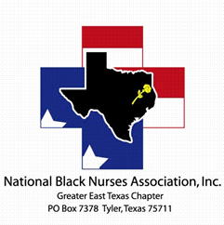

Greater East Texas Black Nurses Association, Inc.

Scholarship Requirements

1. Must be a GETBNA Member
2. Actively enrolled in nursing school
3. GPA 2.5
4. Attend three or more monthly meetings
5. Participate in three-chapter activities prior to applying for scholarship
6. Submit the following documents
   1. Official transcript
   2. Letter of acceptance and active enrollment
   3. One-page essay stating why you chose to pursue the nursing profession.
   4. Two Letters of Recommendation
   5. Proof of 3 or more community service hours

**Scholarships are awarded once a year during the Annual Awards & Recognition Dinner.**

**Applications are accepted between May 1st thru June 30th. All documents must be received by the deadline date.**

**Each applicant will be notified via telephone or email.**