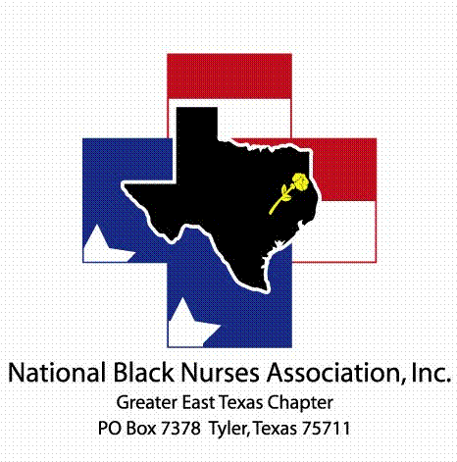
Greater East Texas Black Nurse Association, Inc.
PO Box 7378 … Tyler, TX … 75711

Application for Scholarship

Name ________________________________________________________________________________ _____
First Middle Last

Telephone Number: _____________________________ Email: _______________________________________

Current Address: ____________________________________________________________________________

Permanent Address: (if different from current)__________________________________________________________

NBNA Member: ( ) YES ( ) NO NBNA Chapter Affiliation: ______________________________

Social Security Number (only last four digits): XXX-XX- _______ Date of Birth: __________________________

Place of Employment: ______________________________________ Hrly Wage or Annual: $ ____________

Spouse Employer: __________________________________________ Hrly Wage or Annual: $ ____________

Head of Household: ( ) YES ( ) NO Others You Support:

Name Relationship Age Employer/School/ Other

Do you currently hold a nursing license? ( ) YES ( ) NO Type: ( ) RN ( ) LVN/LPN

If yes, License number and state: _______________________________________________________________

Anticipated Source of Income such as scholarship, student loan, grant, Veterans benefit, other:

Current or Proposed School of Nursing:__________________________________________________________

Address: ___________________________________________________________________________________

School of Nursing Contact Name and Telephone Number: ___________________________________________

Current Degree Plan: _________________________________ Expected Graduation Date: _______________

Community Service/Activities: ____________________________________________________________________________________________________________________________________________________________________________________

I affirm that all information provided is true. Any false statements will forfeit the award.

Signature: __________________________________________ Date: _________________________________

Required Attachments: Official transcript from school(s). Letter of acceptance and active enrollment in nursing program. Two letters of recommendation; One-page essay stating why you chose to pursue the nursing profession. Proof of community service participation.
Applications are accepted between May 1st thru June 30th

