
Business Continuity Policy

Policy approved/reviewed by: | Director
Date reviewed: | 21/01/26
Next review date: | 21/01/27 (annually)

Contents
- Introduction
- Scope of Policy
- Key Principles and Aims
- Plan Remit
- Preparing staff for a critical incident
- Preparing pupils for a critical incident
- Circumstances
- Business Continuity Plan- Key Checklist
- Activation decision and plan
- Responsibilities
- Incident Management
- Business Continuity
- Recovery and Resumption
- Training and Awareness
- Monitoring and Review

1.Introduction
Stace Provision is committed to ensuring, as far as reasonably practicable, the continuity of its educational and support services during periods of disruption. This Business Continuity Policy sets out the framework for maintaining critical functions, safeguarding pupils and staff, and minimising the impact of unexpected incidents.
A critical incident is a sudden crisis or emergency involving the provision, either during or outside normal operating hours, where the effectiveness of the response is likely to have a significant impact on the wider community.
Parents and carers trust Stace Provision to keep their children safe, and staff work hard to ensure that the provision is a secure and supportive environment. However, education providers can find themselves facing a crisis with little or no warning. This may include a natural disaster such as a fire or flood, a serious accident resulting in the injury or death of a pupil or member of staff, or a violent incident that threatens the safety of pupils and staff.
Although serious incidents are rare, when they do occur they can have a long-term impact on the educational community. Staff are often at the forefront of any incident that occurs on or near the premises and must be prepared to act quickly to ensure the safety and welfare of pupils and themselves. Effective crisis management can save lives, prevent incidents from escalating, protect pupils, staff, witnesses, and property, reduce the risk of litigation, safeguard the reputation of the provision, and support any subsequent investigations.
Business continuity refers to the ability of Stace Provision to continue delivering essential services at an acceptable level following a disruptive incident.
Disruptions may include (but are not limited to):
- Loss of premises or restricted access
- Staff absence or shortages
- IT or data loss
- Utilities failure (power, water, heating)
- Severe weather
- Public health incidents
- Safeguarding or serious incident impacting operations

2.Scope of Policy
This policy applies to:
- All staff, contractors, and volunteers working for or on behalf of Stace Provision
- All sites used by Stace Provision, including off-site and community-based provision
- All activities delivered by Stace Provision, including education, mentoring, and support services

3.Key Principles and Aims
Stace Provision’s approach to business continuity is based on the following principles:
- Safeguarding first: The safety and welfare of pupils and staff is paramount
- Proportionality: Responses will be appropriate to the size and nature of the incident
- Flexibility: Alternative delivery models will be used where necessary
- Clear communication: Timely, accurate information will be shared with stakeholders
- Learning and improvement: Incidents will be reviewed to strengthen future resilience
The aim of the Business Continuity Management Plan is to ensure that pupils and staff at Stace Provision are safeguarded and appropriately prepared in the event of disruption, that confidence in the provision is maintained, and that normal educational and support activities are restored as quickly as reasonably practicable.
The plan enables Stace Provision to respond in a clear, proportionate, and flexible manner by:
- Responding effectively to disruptive incidents (incident management)
- Maintaining the delivery of critical activities during periods of disruption (business continuity)
- Supporting a safe and timely return to normal operations (recovery and resumption)
4.Plan Remit
The following core functions of Stace Provision are covered by this Business Continuity Plan:
- Educational delivery and planned activities
- Administration and record keeping
- Food provision, where applicable
- Out-of-hours or extended provision activities
- Educational visits, trips, and journeys
- IT systems and data storage
- Communication systems and contact arrangements
This plan does not attempt to provide a definitive or exhaustive list of actions to be taken during every possible incident that may affect the continuity of services. However, by having a clear and proportionate plan in place, Stace Provision is better prepared to protect pupils and staff, minimise disruption, and recover in an efficient and effective manner.

5.Preparing staff for a critical incident
To ensure that serious and critical incidents are managed effectively and appropriately, Stace Provision recognises the importance of preparation and training. All staff will be made familiar with the contents of the incident response plan and understand their specific roles and responsibilities in the event of an incident.
Planned incident response exercises will be carried out at least once each academic year. These may include, where appropriate, lockdown procedures, site access checks, and evacuation exercises. An annual incident planning schedule will be in place to support the practice of a range of potential scenarios.
All arrangements will be clearly communicated to staff and will form part of the staff induction process.

6.Preparing pupils for a critical incident
Stace Provision ensures that themes such as loss, bereavement, personal safety, risk awareness, and managing change are addressed in an age-appropriate and sensitive way through the curriculum. A clear safety policy is in place, and key information is shared with all pupils as part of their induction. These topics are discussed openly and treated as part of normal life experiences, helping pupils to build resilience and feel better prepared should a difficult or distressing incident occur.
The Business Continuity Management Plan is also communicated, in an appropriate manner, to pupils and parents so that everyone is prepared in the event of disruption or emergency. Pupils are supported to understand how to respond safely during an incident, with practical exercises and drills used where appropriate.
This approach includes:
- Familiarising pupils with incident procedures and reassuring them that such plans are precautionary and unlikely to be required
- Periodically reinforcing awareness of emergency signals or instructions to reduce anxiety during an incident
- Encouraging pupils to remain calm, quiet, and follow staff guidance, ensuring drills are conducted seriously but without causing fear
- Ensuring pupils understand that, in a lockdown situation, they should move to the nearest identified safe space
- Reassuring pupils that Stace Provision is a safe environment and that staff are trained to respond effectively should an incident occur
7.Circumstances
The following are examples of incidents where critical incident planning may need to be implemented. This list is not exhaustive but reflects situations that could significantly disrupt the operation of Stace Provision or pose a risk to the safety and welfare of pupils and staff:
- Loss of key staff or essential skills, including higher-than-normal staff absence due to illness, severe weather, or transport disruption
- Failure or loss of critical systems, such as ICT outages, power failure, or theft of equipment
- Loss of access to, or damage to, premises, including fire, flood, or an external emergency resulting in restricted site access
- Deliberate acts of violence or threats of violence, including the use or threat of weapons, civil disturbance, or terrorism
- Situations requiring pupils and staff to remain on site for extended periods, such as during a lockdown
- Significant IT or data loss, system failure, or theft of data-holding equipment
- A missing pupil or member of staff, absconding, abduction, or hostage situation
- A fatality or serious medical incident affecting an individual or large numbers of pupils or staff, including public health emergencies or pandemics
- Threats of terrorist activity, including bomb threats or hoaxes
- The death of a pupil or member of staff as a result of natural causes, accident, or criminal action
- Transport-related incidents involving pupils or staff, including serious injury or death during journeys, trips, or educational visits

8.Business Continuity Plan – Key Checklist
Stace Provision maintains a clear and proportionate escalation checklist to support the effective management of incidents and emergencies. This includes up-to-date contact information and practical guidance for responding to a range of situations, including communication with external agencies, media interest where relevant, and ICT-related issues.
- Is there a clearly identified incident management lead or team in place?
- Are roles and responsibilities defined and understood by relevant staff?
- Has the emergency response plan been agreed and communicated to staff?
- Are robust procedures in place to ensure contact details are maintained and regularly updated for:
  - Parents and carers
  - Staff
  - Pupils
  - Proprietor/Directors
  - Other relevant parties (e.g. commissioning bodies, supply staff, external professionals)
- Are IT systems backed up regularly, with backups stored securely off-site where appropriate?
- Is an up-to-date asset register maintained, with a copy stored securely off-site or electronically?
- Are appropriate arrangements in place for the secure storage of sensitive records (e.g. fire-resistant storage or secure digital systems)?
- Is a site plan available showing the location of gas, electricity, and water shut-off points?
- Are details of pupils and staff on educational visits, off-site activities, or work experience known to relevant staff at all times?
- Are procedures in place for adverse weather conditions, including flooding where applicable?
- Have risk assessments been completed and appropriate control measures implemented to reduce identified risks?
- Have reasonable precautions been taken to reduce the risk of arson or deliberate damage?
- Are suitable arrangements in place to manage emergencies occurring outside of normal operating hours?
- Is there an off-site evacuation or alternative location contingency plan?
- Are arrangements in place to access additional support, including counselling or emotional wellbeing support, for pupils, staff, and parents/carers where required?

9.Activation Decision and Plan
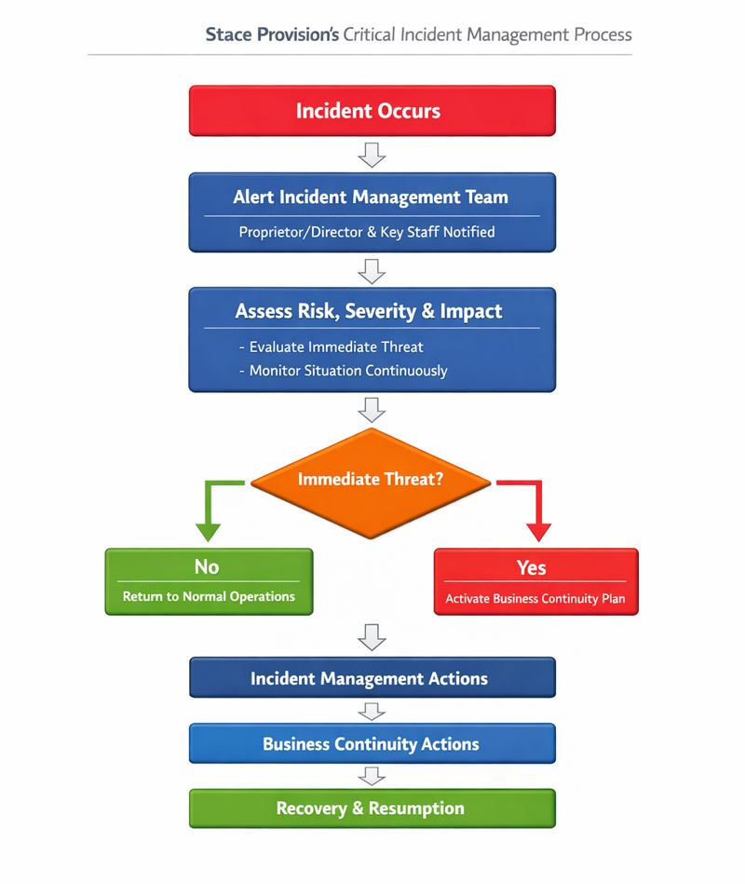

10.Responsibilities
The responsibility for managing any actions during a critical incident lies with the most senior member of staff present, typically the Director. Their responsibilities include:
- Acting as the senior accountable lead for Business Continuity Management
- Ensuring Stace Provision has the capacity and resources to respond effectively to incidents
- Determining the overall response and recovery strategy
- Developing, reviewing, and maintaining the Business Continuity Plan
- Establishing continuity arrangements and strategies, such as alternative locations or temporary staffing solutions
- Engaging the community and relevant stakeholders in continuity planning, where appropriate
- Testing and exercising the plan to ensure readiness
- Conducting debriefs after incidents, tests, or exercises to identify lessons learned and opportunities for improvement
- Training staff on Business Continuity procedures and promoting a culture of resilience within the provision
- Leading the initial and ongoing response to any incident
- Declaring when an incident is taking place and activating the Business Continuity Plan
- Notifying relevant stakeholders of the incident, plan activation, and ongoing response actions
- Providing clear direction and leadership for the Stace Provision community
- Coordinating response and communication actions as outlined in the plan
- Prioritising the recovery of key activities disrupted by the incident
- Managing the deployment of resources effectively
- Safeguarding the welfare of pupils
- Supporting staff welfare and addressing any employment-related issues arising during the incident

Response and Recovery:
The Response and Recovery phase ensures that incidents are managed effectively, key decisions are logged, and continuity is restored as quickly and safely as possible. Responsibilities for this phase include:
- Accurately record all decisions and actions taken during the incident
- Collate information for dissemination, including press statements where appropriate
- Coordinate communication with key stakeholders
- Maintain site security and safety
- Liaise with the Incident Management Team regarding any issues related to the site’s physical infrastructure
- Act as lead contact for contractors involved in incident response
- Ensure the resilience of ICT systems and coordinate with ICT support or external providers
- Develop proportionate risk responses
- Lead and report on the recovery process
- Identify lessons learned and incorporate them into future plan development
- Monitor, evaluate, and ensure the Business Continuity Plan remains fit for purpose

Staff Responsibilities:
- Follow instructions issued during an incident
- Act in accordance with safeguarding and health & safety requirements
- Report concerns or risks promptly

Designated Safeguarding Lead (DSL) Responsibilities:
- Ensure safeguarding procedures continue during disruption
- Advise on risk to pupils and necessary control measures

11.Incident Management

Purpose of the Incident Management Phase
The incident management phase is the initial response stage immediately after an incident occurs, where the focus is on safeguarding people, assessing the situation, and coordinating the immediate response. Its purpose is to:
- Protect the safety and welfare of pupils, staff, visitors, and the wider community
- Safeguard vital assets such as equipment, data, and reputation
- Ensure urgent and accurate communication takes place
- Support the Business Continuity phase to enable recovery
Note: This list is not exhaustive; much of what individuals do will be instinctive, but staff should refer to this checklist to ensure all aspects are considered.

Incident Management Actions
- Conduct a quick initial assessment: survey the scene, assess scale, severity, duration, and impact, and share information as appropriate
- Contact emergency services if required
- Evacuate the building if necessary, or move pupils to a safe indoor location if it is safer; consider recovery of vital assets to maintain critical activities, if safe to do so
- Ensure all pupils, staff, and visitors assemble at the designated Assembly Point
- Confirm that all pupils, staff, contractors, and visitors are accounted for
- Ensure appropriate access for emergency services vehicles
- Establish a contact point for all supporting personnel
- Use the Stace Provision Incident Management Team to undertake specific emergency response roles
- Maintain a log of key decisions and actions throughout the incident
- Record details of any individuals injured or affected by the incident
- Assess the ongoing impact and agree next steps
- Log any items lost or damaged during the incident, if appropriate
- Arrange press contact if necessary
- Identify key priorities for the remainder of the day and take relevant action
- Keep staff informed of their roles and responsibilities
- Keep parents/carers informed as appropriate, giving extra consideration for those immediately affected
- Ensure directors are updated according to the circumstances of the incident
- Communicate interim arrangements for the delivery of critical activities
- Log any expenditure incurred as a result of the incident
- Seek advice and inform insurance providers where relevant
12.Business Continuity

Purpose of the Business Continuity Phase
The purpose of the Business Continuity phase is to ensure that critical activities are maintained or resumed as quickly as possible during a disruption. This may involve activating one or more pre-identified business continuity strategies to enable alternative ways of working.
During an incident, it is unlikely that all resources will be available. As a result, some non-critical activities may need to be temporarily suspended to prioritise essential functions.

Business Continuity Actions
- Identify any additional stakeholders who need to be involved in the continuity response
- Evaluate the impact of the incident on critical activities
- Plan how essential activities will be maintained using pre-identified or new continuity strategies
- Log all decisions and actions, including activities not undertaken, with a rationale for decision-making
- Record all financial expenditure incurred as a result of the incident
- Allocate specific roles and responsibilities as necessary
- Secure resources to enable critical activities to continue or be recovered
- Deliver appropriate communications to staff, pupils, parents/carers, and other stakeholders

Business Continuity Strategies
- Use temporary staff where required (e.g., cover supervisors, supply teachers, office staff)
- Multi-skill and cross-train staff to cover different roles; include deputies, job shadowing, succession planning, and handovers for known absences (e.g., maternity leave)
- Adapt ways of working to manage reduced workforce, such as:
  - Larger class groups within safe ratios
  - Use of teaching assistants or learning support staff
  - Virtual learning or independent study materials
  - Team activities and sports to manage larger pupil numbers
- Suspend non-critical activities to focus on priorities
- Manage staff-related considerations, including attendance policies, job description flexibility, and contractual requirements

Arrangements for Loss of Premises or Utilities
- Pre-agreed alternative premises in the community (e.g., local halls or church rooms)
- Remote learning opportunities where feasible
- Localise the incident by isolating the affected area or using alternative sites
- Review off-site activities (trips, swimming, physical activities) and prioritise essential events

Arrangements for Loss of Technology, Data, Telephony, or Power
- Daily backups of key data stored off-site
- Revert to paper-based systems if needed (e.g., registers, whiteboards)
- Flexible lesson plans to adapt to resource limitations
- Use of emergency lighting and other essential infrastructure

Indicative Recovery Timescales for Disruptions
Stace Provision recognises that recovery times will vary depending on the nature, scale, and complexity of an incident. The timescales below are indicative and realistic, based on current capacity and resources, and are intended to guide decision-making and communication during a disruption. Safeguarding considerations will always take priority over speed of recovery.

Type of Disruption | Indicative Recovery Timescale
Short-term staff absence (1–2 staff) | Within 24 hours
Significant staff absence (multiple staff / illness outbreak) | 24–72 hours
Loss of key staff (DSL / senior staff) | 24–48 hours
Loss of premises (fire, flood, unsafe building) | 48 hours – 5 working days
Restricted access to premises | 24–72 hours
IT system failure / loss of access to data | 24–48 hours
Utilities failure (power, water, heating) | 24–72 hours
Severe weather | 24–72 hours
Public health incident | 48 hours – ongoing
Safeguarding or serious incident | Immediate response; recovery ongoing

13.Recovery and Resumption

Purpose of the Recovery and Resumption Phase
The purpose of the Recovery and Resumption phase is to restore normal working practices as quickly and safely as possible. In some cases, where the impact of the incident is prolonged, operations may need to continue under temporary or alternative arrangements, such as using a different location or modified working practices.

Recovery and Resumption Actions
- Plan Recovery Actions
  - Agree and plan the steps required to restore normal operations efficiently.
- Support Staff and Pupils
  - Address any ongoing or long-term support needs, including emotional wellbeing, counselling, or practical assistance.
- Communicate Resumption
  - Once recovery actions are complete, inform staff, pupils, and stakeholders that the provision has returned to “business as usual.”
- Debrief and Report
  - Conduct a debrief with staff (and where appropriate, pupils) to review how the incident was managed.
  - Document lessons learned, opportunities for improvement, and recommendations for future responses.
- Review and Update the Plan
  - Update the Business Continuity Plan based on lessons learned and feedback from the incident to strengthen future preparedness.

14.Training and Awareness
- Staff will be made aware of this policy as part of induction
- Business continuity arrangements will be discussed periodically
- Relevant training will be provided where appropriate

15.Monitoring and Review
This policy will be:
- Reviewed annually
- Reviewed following any significant incident
- Updated to reflect changes in provision, staffing, or risk
Lessons learned from disruptions will inform future planning

