MAJOR CHANGES FOR PRESCRIPTION DRUG PLANS
I wanted to personally reach out to let you know about a major change that unfortunately impacts on how we can assist you with your Medicare Prescription Drug Plan (Part D) this year. Here is what is going on: https://www.youtube.com/watch?v=C3bfwCfWYVw
Due to new rules and decisions made last minute by ALL insurance companies/Medicare, agents and brokers are NO LONGER PERMITTED to assist with or submit Part D Rx. Enrollment applications on behalf of clients. We don’t fully understand the reasoning behind this change, but have listed some insight information below for you.
I want to sincerely apologize for this last-minute notification, as it was not our decision and took effect suddenly. We truly value being able to guide you through every part of your Medicare coverage, and it’s disappointing that this part has been taken out of our hands. NOW, don’t panic, if you run into any issues, give us a call 863-588-1587 Sue or 863-588-1582 Lynne
Here is what 2026 plans look like: https://www.youtube.com/watch?v=MLN3mjcvHWM
Do not confuse your PDP(rx) plan with your Medicare Advantage or Medicare Supplement as they are 3 different distinct Individual Products. If you are in a Medicare Advantage Program, you do not want to follow any of these instructions as this will terminate your plan.
INSTRUCTIONS: HERE IS THE FIRST THING YOU NEED TO DO EVERY YEAR:
- create a Medicare.gov account by clicking on Log In on the upper right side of the webpage follow the Instructions from the video and list below: https://www.medicare.gov/plan-compare/#/?year=2026&lang=en This is the site that you will need to use each year and YES every year between 10/15 to 12/7 you MUST/SHOULD review your plan as the Insurance companies, WILL CHANGE the monthly premium, deductibles, copays, Tiers of Meds, formulary list of drugs that are covered/not covered, etc.
- Once you create your account, you can log in and then you will be at your Medicare home page
- Click on the open all options box on the right hand side
- Then find health & drug plans
- It should auto populate with your current drug plan, there are times it won’t, not to worry. It could pull in medications that you were taking and you need to remove them, scroll down to edit your drug list
- Then click the find plans now button, choose the year, your zip code and then Medicare drug plan (Part D) find plans.
- The next thing that will show up is your current plan for the next year with all the changes.
- You will notice other options that you could enroll in to. However, what they don’t tell you about is how you can trick the system by getting some of your drugs from either by presenting a www.GoodRx.com coupon or use Mark Cuban’s mail order program www.costplusdrugs.com (doctor’s instructions are listed below).
- Please keep in mind that some carriers apply their $615 deductible to all tiers, while others only apply it to Tiers 3-5. This is where we pride ourselves on, giving you the options and recommendations that are right for you based on your drug list and looking for other options to save you money like using a www.GoodRx.com coupon or Mark Cuban’s new mail order program www.costplusdrugs.com
While we can no longer complete your Part D enrollments moving forward, we want to make this as easy as possible for you. Below at the very bottom are the insurance carrier phone numbers and website links to contact them directly and complete your enrollment. REMEMBER: Always make sure ALL your prescriptions you take and might have to take are on their Drug Formulary Listing each and every year. You must do all your changes 10/15 until 12/7 of each year regardless of what changes for you because insurance carriers change the monthly premium, the Tiering of Drugs, a List of what drugs will be on their formulary, as this could IMPACT you significantly if you don’t complete this exercise annually.
PLEASE NOTE – Rx Monthly Premiums: It is better if you have your premium deducted from your Social Security check (if you are collecting). If you forget to make one payment and don’t catch it in the 30-day lapse period, they will cancel your plan and you will have to wait until the next year to enroll in a drug plan. So, technically you will be WITHOUT a drug plan and then you will have a PENALTY for your LIFETIME for not having a drug plan for those months. https://www.medicare.gov/basics/costs/medicare-costs/avoid-penalties
If you are currently remaining with the insurance carrier, you may want to call their customer service number on the back of your ID card (or below) and have them deduct your premium from your Social Security if this is not already being done. It will take them about 2 months to set this up, so please make sure you make this call in the first week of January.
We can still assist you or anyone else in the 50 states with your Medicare Supplement (Medigap) or Medicare Advantage plans — including reviewing coverage, exploring new options, and ensuring your medical needs are met at the best possible value. If you know someone Turning 65, they are confused about a plan that they are on or prices have gone up, please refer them over our way so we can get them educated and within the best plans possible for them.
Again, please note that there are certain drugs that you may obtain CHEAPER through a www.GoodRx.com coupon at the Pharmacy or Mail Order Via Mark Cuban’s Cost Plus Drug Plan . https://www.costplusdrugs.com/medications/ for much less than you would pay under your RX insurance Medicare Part D plan, so you want to run some of your drugs through these sites first and then run your drugs that aren’t available cheaper under on your Rx Plan
SIGN UP: https://www.costplusdrugs.com/create-account/
Look up your Drug: https://www.costplusdrugs.com/medications/
How to Order Instructions: https://www.youtube.com/watch?v=1e8ZjqImGp8
FORM YOU GIVE TO YOUR DOCTOR TO COMPLETE OR INFO FOR ELECTRONIC FILLING https://www.costplusdrugs.com/contact-your-doctor/
Why Cost Plus Drugs (Transparency): https://www.youtube.com/watch?v=RT46ThdJYjY
Interview with Jon Stewart https://www.youtube.com/watch?v=ayhRmnFlSkE

Thank you so much for your understanding and for allowing us to serve you. We are still here for you and any questions you may have give us a call.
Warm regards,
Lynne Clausen and Sue Smigelsky
Retirement & Medicare Specialist
📞 863-588-1582 or 863-588-1587
📧 lynne@insadvocates.com or Sue@InsAdvocates.com
🌐 www.insadvocates.com

👉 Information where to Find/Quote/Enroll into Plans
📞 Phone 💻 Website
Wellcare  844-954-0123 | https://www.wellcare.com/en/explore-plans/prescription-drug-plans  They have a broader formulary list of drugs than Humana. If you currently have Wellcare, you can contact their Customer Service Department if you have questions, want to make payment process, etc at 888-550-5252
Humana  800-457-4708 | https://www.humana.com/medicare/part-d-drug-plans
AARP  UnitedHealthcare  855-972-6166 | https://www.uhc.com/medicare/shop/prescription-drug-plans.html
Silverscript  866-235-5112 | https://www.aetna.com/medicare/compare-plans-enroll/part-d-prescription-drug-plans.html
HealthSpring (Cigna -rebranding the company name)  877/642-2812 | https://www.healthspring.com/medicare/shop-plans/part-d
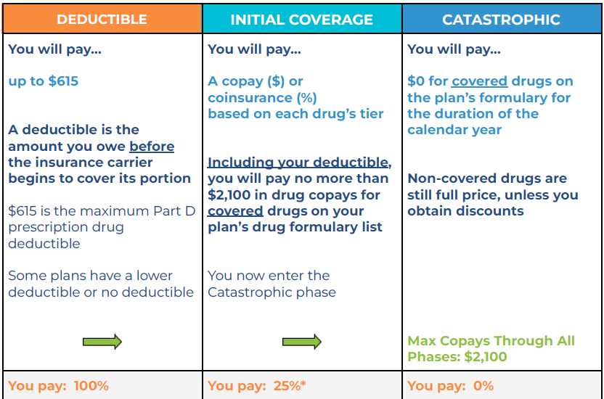

Reasoning for the Change
It’s a big, frustrating shift -- Here’s the heart of what’s going on and why brokers are getting squeezed out of prescription drug plan (PDP) market/compensation
Insurance companies are feeling the financial strain they are facing with the removal of the $8,000 donut hole, increased coverage for certain diabetic medications at lower costs, and other cost-related adjustments in the Medicare system. Either way, we always want to help and make sure this is a smooth transition for you. Also, the www.Medicare.gov account should auto populate your drugs from your pharmacy and drug plan you are currently on to help speed up the process. Again, you must create your own personal account in order to have this work smoothly https://www.medicare.gov/plan-compare/#/?year=2026&lang=en
Please know that even though these companies may be limiting our role, we’re still here for you — to answer your questions, review your options, and continue to be your trusted Medicare resource as always!

1. PDPs Have Become Low-Margin, High-Cost for Carriers
Stand-alone drug plans don’t bring in much revenue for insurance companies anymore.
But CMS keeps raising compliance requirements, oversight expectations, and administrative rules — and carriers eat those costs. The easiest place for them to cut? Brokers/Agents and theircommissions.

2. CMS Is Pushing Toward Simplification
There’s a quiet but very real push to:
- Consolidate plans
- Reduce marketing
- Move people toward MAPD (Medicare Advantage with drug coverage) instead of PDPs
- Strip away anything seen as “unnecessary administrative spending”
From CMS’s perspective, paying agents for PDPs is “nonessential” compared to hospital/medical coverage — even though we both know brokers are the ones who prevent medication disasters.

3. Huge Growth in $0 Premium MAPDs
Because MAPDs can bundle drugs, dental, vision, OTC, and more, they’re more profitable for carriers — and they compensate brokers/agents. PDPs, meanwhile, lose enrollments every year, making them even less attractive for insurers to support financially.

4. The Government Assumes Beneficiaries Can Self-Enroll
CMS believes:
- Medicare.gov’s Plan Finder is “sufficient”
- SHIP volunteers can fill the gap
- People can evaluate their drug costs alone
Of course, you and I know that’s unrealistic — especially for seniors with multiple prescriptions, changing formularies, and high drug prices. But here’s the truth that no one says out loud: PDPs are no longer profitable, and CMS doesn’t see agents as essential to the drug-plan part of Medicare — even though the public needs us now more than ever.

