
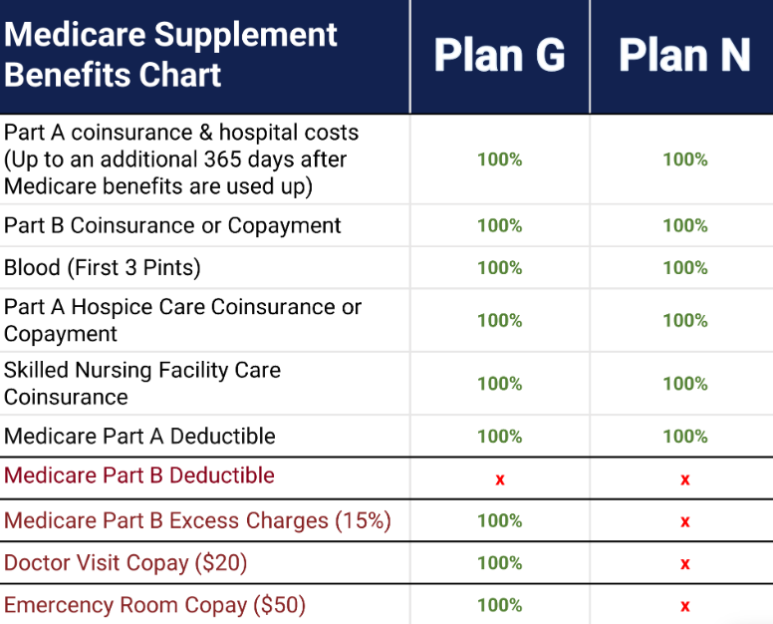
2027 YEAR
- Plan G & N Deductible is $292-310 for the 2027
- Plan N has your usual Deductible of $292 for the year, a $20 copay for doctors, ER Copay of $50 and possible Excess Charge, but again this is rare.
- Generally the premium savings from Plan N to Plan G is about $50/mo x12 =$600.00 savings for the year
- States that DON’T have Medicare Part B Excess Charges: CT, MA, MN, NY(5%), OH, PA, RI & VT
- States that have Excess Charges could be up to 15% if you don’t use a doc that accepts Medicare Assignment, most do.
If you have Plan N then you will want to be sure to always ask your doctor, especially if it’s a specialist… “Do you accept Medicare Assignment?” (they are accepting the Medicare Payment in FULL)
- States where you can change your MedSup at anytime CT, NY & VT (no health questions/Underwriting)
- Some you can change on your Birthday or other periods: CT, ME, MA, MS, NY, RI
- Birthday Rule: CA, ID, IL, MS, NV, OR, KY, UT, MD, WA
- You can change your Medsup at any time, but most states require you to answer medical questions/underwriting to change your MedSup any time after 6 months after your 65th Birthday unless you are switching from an employer plan. You could be denied coverage or charged a higher premium based on your medical history, so you might want to stay with your original MedSup if this happens.

