
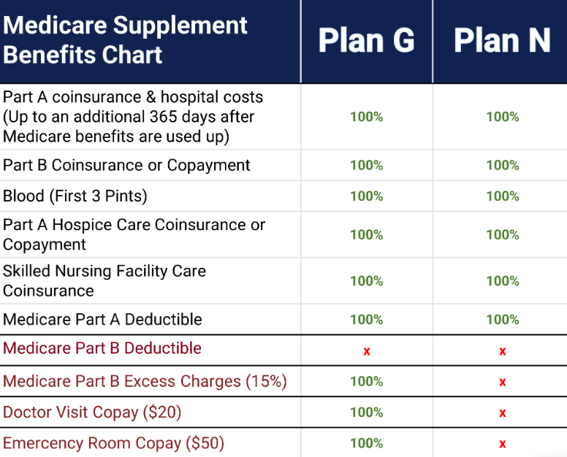
2026 YEAR
- Plan G & N Deductible is $288 for the 2026
- Plan N has your usual Deductible of $288 for the year, a $20 copay for doctors, ER Copay of $50 and possible Excess Charge, but again this is very rare and you can even ask your current doc if he charges excess charges.
- Generally the premium savings from Plan N to Plan G is about $50/mo x12 =$600.00 savings for the year
- States that DON’T have Medicare Part B Excess Charges: CT, MA, MN, NY(5%), OH, PA, RI & VT
- States that have Excess Charges could be up to 15% if you don’t use a doc that accepts Medicare Assignment, most do.
If you have Plan N then you will want to be sure to always ask your doctor, especially if it’s a specialist… “Do you accept Medicare Assignment?” (they are accepting the Medicare Payment in FULL)
- States where you can change your MedSup at anytime CT, NY & VT (no health questions/Underwriting)
- Some you can change on your Birthday or other periods: CT, ME, MA, MS, NY, RI
- Birthday Rule: CA, ID, IL, MS, NV, OR, KY, UT, MD, WA
- You can change your Medsup at any time, but most states require you to answer medical questions/underwriting to change your MedSup any time after 6 months after your 65th Birthday unless you are switching from an employer plan. You could be denied coverage or charged a higher premium based on your medical history, so you might want to stay with your original MedSup if this happens.

MEDICARE EXCESS CHARGES (WHAT ARE THEY AND CAN YOU AVOID)
Medicare excess charges are fees that healthcare providers can charge up to 15% above the Medicare-approved amount for Part B services. These charges only occur when a provider does not accept Medicare assignment, which means they are not accepting the Medicare-approved amount as full payment. To avoid them, you can find a doctor who accepts assignment, use a tool like the one on medicare.gov to verify their status, or have a (like F or G) that covers excess charges. LQQK up my doctor to see if he accepts Medicare Assignment enter your address, find your doctor, click on the FILTER button “Medicare-Approved Payment

What they are
- An extra fee: A Part B excess charge is an additional cost that can be up to 15% more than what Medicare has approved for a service, such as an office visit or outpatient procedure.
- Not all doctors charge them: Most providers accept Medicare assignment, meaning they accept the Medicare-approved amount as full payment and do not charge excess charges. It is uncommon for doctors to charge Medicare excess charges because over 96% of providers accept Medicare assignment, meaning they agree to the Medicare-approved amount as full payment. Less than 4% of physicians have opted out of Medicare entirely, and those who are non-participating providers may charge up to 15% over the Medicare-approved amount. However, some states have made it illegal for providers to charge excess charges (see below where they don’t apply)
- Responsibility: If you are not covered by a Medigap plan, you are responsible for paying these charges in addition to your regular 20% Part B coinsurance.
How to avoid them
- Find a doctor who accepts assignment: You can verify this by using the online search tool on medicare.gov to find participating providers. A green check mark indicates they accept assignment and will not bill excess charges.
- Check with the provider: Before your appointment, ask the healthcare provider or their office if they accept Medicare assignment.
- Review the Advance Beneficiary Notice (ABN): If a provider plans to charge you more than the Medicare-approved amount for a service, they must provide you with an ABN before the service is provided.
- Consider a Medigap plan: Certain Medicare Supplement (Medigap) plans, specifically Plans F and G, cover Part B excess charges.
Where they don't apply
- Some states, including Connecticut, Massachusetts, Minnesota, New York, Ohio, Pennsylvania, Rhode Island, and Vermont, do not allow excess charges.
- Providers who have "opted out" of Medicare entirely can charge any amount for services, but Medicare will not pay for any of those services.

