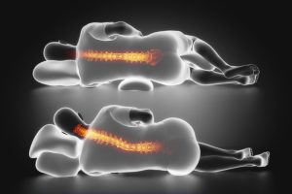
Pilllow

\\

Pillow should not push head up so your spine is curved
Top person= GOOD
Bottom person= BAD

