
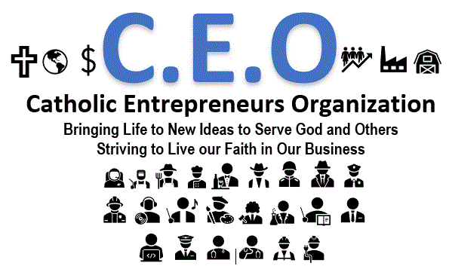
https://www.linkedin.com/groups/12267915/

All Catholics are invited to join the Catholic Entrepreneurs Organization. The organization is dedicated to helping Catholic entrepreneurs, managers, and employees to be faithful as they serve their customers, colleagues, and community. The group will encourage professional development, profitable operations, mentorship, ethics, and networking. Please join the organization via LinkedIn or email billschretter@j24charity.org. Membership is free. Event schedule is being developed and will be published soon.

