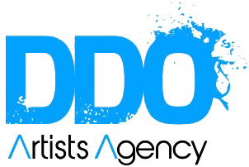**KATHRYN ALEXANDER**

**SAG/AFTRA**

**TELEVISION**

MacGyver Co-Star CBS

Homicide Hunter Co-Star Jupiter Entertainment

Murder Calls Co- Star Jupiter Entertainment

**FILM**

Pie Lead Dir. Hugo Acevedo

Another Life Supporting Dir. Dean Jones

Aloha (2023 River Run Film Festival) Lead Dir. Burgess Jenkins

Flex Lead Dir. Max Schmidt

Making Him Famous Supporting Cornelius Mueller Prods

Pastime Supporting Pastime Productions

The Arbors Supporting Dir. Clayton Whitmer

The Harem of Harry Javier Supporting UNCSA Productions

Gloria-The Dear Hunter Supporting Silent Flight Production

**MUSIC VIDEO**

Luke Combs Going Going Gone Lead TA Films

**INDUSTRIAL/ COMMERCIAL**

*Full list given upon request.

**TRAINING**

LA 4 Day Scene Study Intensive Howard Fine Studio Howard Fine

Audition For Film and TV (ongoing) Howard Fine Studio Howard Fine

Voice and Speech Online Howard Fine Studio David Coury

Alexander Technique Howard Fine Studio Jennifer Schultz/Nick George

Scene Study Kawaoka Studios (LA) Devin Kawaoka

Acting for Film and Television (Advanced) The Actors Group NC Burgess Jenkins

Audition Intensive Mornell Studios Sara Mornell

**Special Skills & Interests:** Horseback Riding (western), Yoga (200RYT), Spanish conversational, Beginning Italian, RP British accent, Midwest Accent, Southern Accent. Former financial planner, Mom