Media Contact
Michele Brown
mbrown@housingalaskans.com
(907) 223-4661
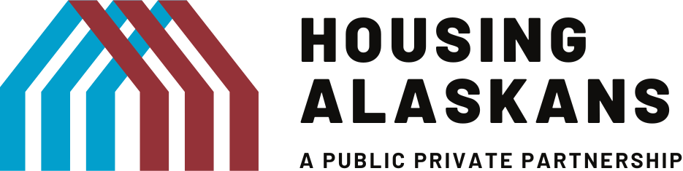

FOR IMMEDIATE RELEASE
March 31, 2026

Housing Alaskans Public Private Partnership (HAPPP) Announces an Infusion of Funding to Accelerate Stalled Housing Projects Across the State – Bridging the Gap Between Vision and Construction.

ANCHORAGE, AK – Alaska is facing a housing crisis. Across the state, workforce shortages are deepening, businesses are turning away growth opportunities, and communities are being forced to cut essential services – all because there simply are not enough homes.

Today, we are taking action to address that.

HAPPP is soliciting applications to fund projects that are ready to break ground, are scheduled for completion in 2026-2027, or that will expedite and accelerate housing projects in the Western Alaska storm-impacted communities. The solicitation is powered by $1.5M funding from the Wells Fargo Foundation, Northrim Bank, the Federal Home Loan Bank Des Moines, and the Denali Commission.

The grants will provide critical “top-off” capital to housing projects across Alaska that are ready to build but stall out before they cross the finish line. These are projects that already have public and private investment committed, but escalating costs in the time it takes to seek the final funding needed keeps moving the goalpost. HAPPP fills that gap.

“Alaska faces some of the most complex housing challenges in the United States, from high construction costs to remote logistics. Alaska needs shovels in the ground. HAPPP funding is designed to do exactly that by streamlining project development and maximizing the impact of public and private investment.”
— Shauna Hegna, Chair, Board of Directors

HAPPP’s grants are designed for speed. By building on the project reviews already completed by other public and private funders, HAPPP eliminates redundant paperwork and reduces bureaucratic friction — getting developers the resources they need faster.

HAPPP’s grants are designed to complement, leverage, and augment traditional grant programs. By coordinating and applying new sources of public and private funding to almost shovel-ready housing projects, every dollar of HAPPP funding unlocks multiple dollars of committed capital already waiting on the sidelines.

This is HAPPP’s fourth grant offering for top-off funding. Since 2023, HAPPP has helped 11 housing projects in nine communities cross the finish line, opening the doors of 145 new housing units for Alaskans. Communities served to date are Juneau, Kodiak, Nikolai, Nome, Palmer, Seward, Sitka, Soldotna, and Wasilla.

“These grants will help accelerate housing development across Alaska and address the statewide housing shortage. Tackling the housing crisis is critical to strong communities and a prosperous future, and it will take all of us working together to build more homes,” said Mike Huston, President and CEO of Northrim Bank and a board member of HAPPP.

“The Denali Commission is committed to being a partner in addressing the housing shortage in Alaska. We welcome the shovel-ready approach and thank HAPPP for its enthusiasm, hard work, and leadership in this area,” said Julie Kitka, Federal Co-Chair, Denali Commission.

“The Member Impact Fund is designed to help our members, Wells Fargo Bank and Northrim Bank, champion organizations like Housing Alaskans Public Private Partnership that make a real difference in their communities. By partnering with our members, we’re able to multiply resources and support their vital work as they continue to strengthen opportunities for the people they serve,” said Kris Williams, President and CEO of Federal Home Loan Bank of Des Moines.

HAPPP and its funding partners are actively working to identify and fund shovel-ready projects immediately. Developers and project sponsors with pending housing developments are encouraged to reach out to learn how HAPPP’s top-off funding can help their projects move forward. The application packet be found here: Housing Alaskans: A Public-Private Partnership

About Housing Alaskans Public Private Partnership
HAPPP addresses Alaska’s housing crisis through creative funding solutions which coordinate public and private resources to boost new and rehabilitated housing production, incent developers, and alleviate barriers to housing development. The Alaska Community Foundation fiscally sponsors HAPPP and will administer the grants.

