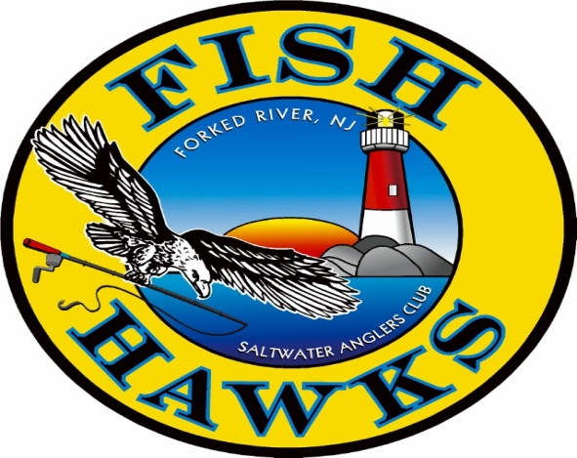NEW MEMBER APPLICATION
P. O. Box 700
Forked River, N. J. 08731

Must be at least 18 years of age to join. Yearly Dues are $40.00
NAME: (First) ____________________ (MI) _____ (Last) _____________________________
STREET ADDRESS: ____________________________________________________________
CITY: ____________________________ STATE _________ Zip Code _________
PHONE # ____________________________ CELL # ________________________
E-MAIL ADDRESS: _________________________________________ DOB: ______________
OCCUPATION (LIST ALL) ____________________________ BOAT NAME: __________________
NEW MEMBERS PLEASE COMPLETE BELOW
MANDATORY REQUIREMENT FOR ALL NEW MEMBERS. YOU MUST SIGN UP AND PARTICIPATE IN AT LEAST ONE OF THE COMMITTEES LISTED BELOW:
___ Banquet | ___ Flea Market | ___ Newsletter Editor | ___ Speaker Program
___ Club Gear | ___ Good & Welfare | ___ Picnic | ___ Youth Fishing Seminar
___ Newsletter Ads | ___ JCAA Interface | ___ Political Advocate | ___ Webmaster
___ Fishing Contests/Tour. | ___ Membership/Roster | ___ Rod & Reel | ___ 50/50 Fair Share
___ Fishing Trips
____ I wish to receive the monthly newsletter at the above listed email address.
____ Please continue to send the monthly newsletter to my mailing address, for and additional cost of $10.
-------------------------------------------------------------------------------------------------------------
SPONSOR: Print Name Clearly _________________________________________
If approved, I agree to abide by the By-Laws of this Club and participate in club activities.
Applicant’s Signature: _________________________________________________ Date: ____________________
Attached: $10.00 Administration Fee
$40.00 Current year dues and additional $10 for hard copy (mailed Newsletter).
Payment Received: ____________________________ (Treasurer) Amt. $________ Check # _____ Cash _____

