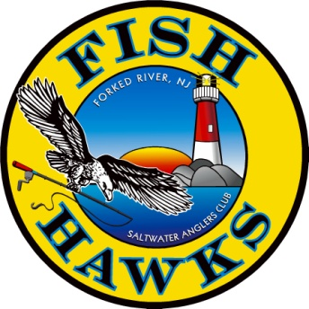 FISH HAWKS SALTWATER ANGLERS CLUB
P.O. Box 700Forked River, NJ 08731http://www.fishhawksnj.com/
HAWK SQUAWKS NEWSLETTER ADVERTISERS
Not only will your ad appear in our monthly newsletter, but will also appear on our web site under "Advertisers". If you have a web site address on the ad, it will be linked to your website. Your Ad will run each year from September to August of the following year and depending on when the Ad is summitted, it may be Pro-Rated.
We are ranked number 2 on Yahoo!, MSN, and Google search engines.
Please print website address _______________________________________________________

The Fish Hawks, founded in 1977, is one of the largest fishing clubs in New Jersey and we appreciate your interest in supporting our club by advertising in our Newsletter. Renewal payment needs to be received within 30 days from receipt of this form or the AD will be removed from the newsletter. Please check the appropriate box to either receive a HARD COPY ______ or an EMAIL ______ of the Newsletter.
Company name: ________________________________________________
Address: ______________________________________________________
Phone: ________________________________________________________
Contact Name: __________________________________________________
Fish Hawks Member Name: ______________________________________
Rates: Business Card size ad $60.00 for the year_________________
1 Line (1/5 Page) Ad $120.00 for the year ______________________
2 Lines (2/5 of Page) Ad $240.00 for the year______________________
3 Lines (3/5 of Page) Ad $360.00 for the year______________________
Full Page Ad $480.00 for the year______________________
Please submit two business cards with application. If you wish to have an ad other than your business card, please submit either a camera-ready digital image or a PDF. Ads can be changed each year on the renewal date. If you wish to make a change during the year, there will be a service charge minimum of $20 for those changes. Email files to: kjr1104@comcast.net For Questions call Ken 609-575-7477
(Official Use Only) Check Received Date:__________________________

