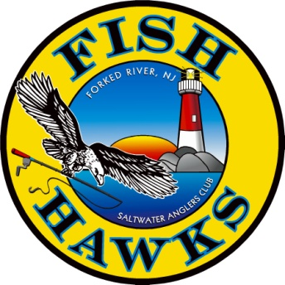 FISH HAWKS SALTWATER ANGLERS CLUB
P.O. Box 700Forked River, NJ 08731http://www.fishhawksnj.com/
HAWK SQUAWKS NEWSLETTER ADVERTISERS
Not only will your ad appear in our monthly newsletter, but will also appear on our web site under "Advertisers". If you have a web site address on the ad, it will be linked to your website. Your Ad will run each year from September to August of the following year.
Email Address where the Newsletter is sent:_____________________________________________________

Your Ad will now run from September 1st 2023 to August 31st 2024, 12 months in total. You currently have a ___ line Ad for $_____, which is due by July 15th 2023. Again, this renewal payment needs to be received by JULY 15, 2023. If no payment is received by JULY 15th, your AD will be removed from the newsletter. Please check the appropriate box to either receive a HARD COPY ______ or an EMAIL ______ of the Newsletter.

If you elect to receive the Newsletter via email, please provide in the space above, the email address that the newsletter should be sent to.
Company name: ________________________________________________
Address: ______________________________________________________
Phone: ________________________________________________________
Contact Name: __________________________________________________
Fish Hawks Member Name: ______________________________________
Rates: Business Card size ad $60.00 for the year_________________
1 Line (1/5 Page) Ad $120.00 for the year ______________________
2 Lines (2/5 of Page) Ad $240.00 for the year______________________
3 Lines (3/5 of Page) Ad $360.00 for the year______________________
Full Page Ad $480.00 for the year_______________________________
Please submit two business cards with application. If you wish to have an ad other than your business card, please submit either a camera-ready digital image or a PDF. Ads can be changed each year on the renewal date. If you wish to make a change during the year, there will be a service charge minimum of $20 for those changes. Email files to: kjr1104@comcast.net For Questions call Ken 609-575-7477
KJR 4/18/2023 Check Received Date:__________________________

