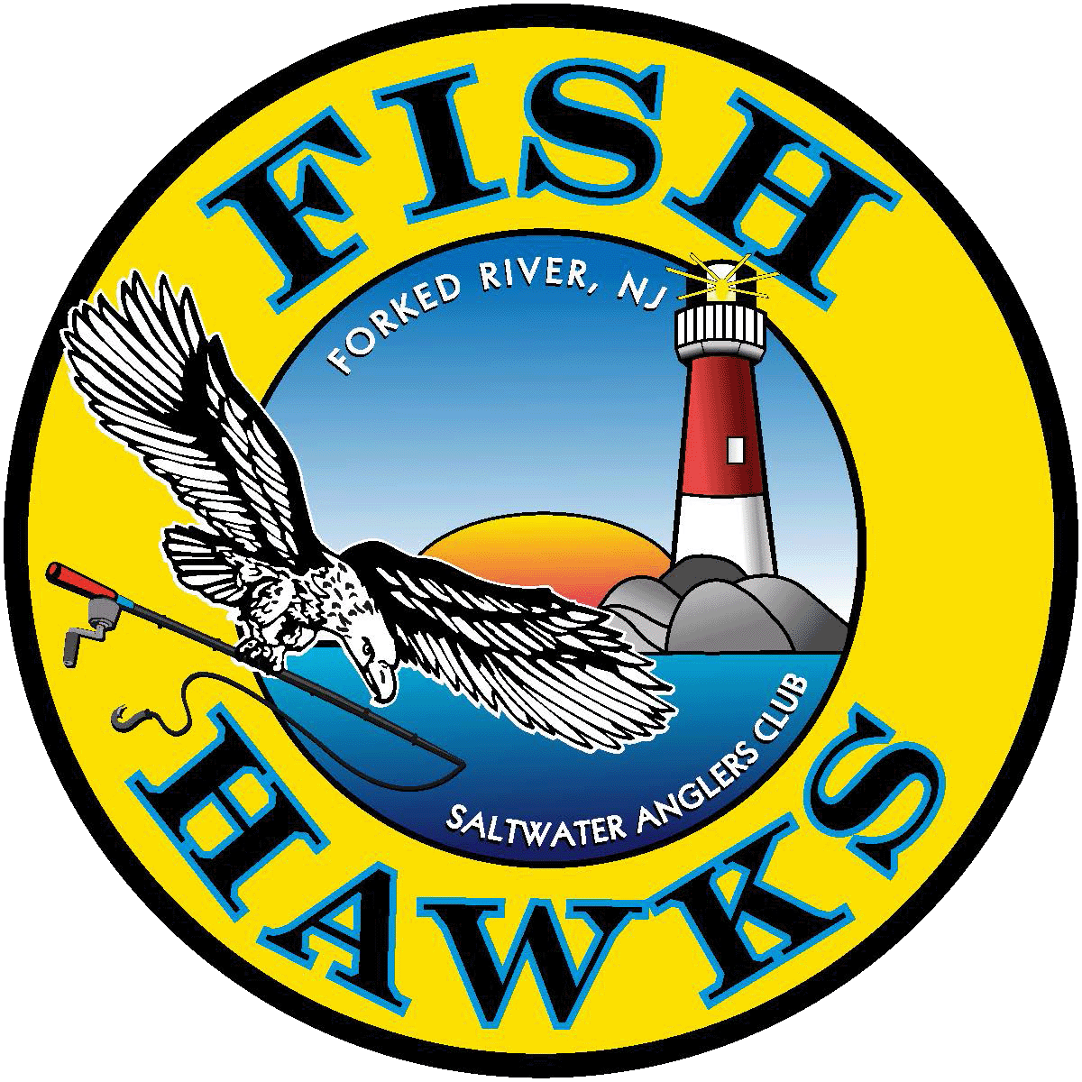
Fish Hawks Salt Water Anglers Club
PO Box 700
Forked River, NJ 08731
ANNUAL RENEWAL FORM
Renewal Amounts:
$40.00 – Monthly Newsletter via email
$50 – Monthly Newsletter hard copy mailed to your address

MEMBER NAME: (First,M,Last)_____________________________________________
STREET ADDRESS:________________________________________________________
CITY:_______________________________STATE:____________ZIP:_______________
PHONE#:____________________________CELL PHONE #________________________
EMAIL ADDRESS:_______________________________________DOB:______________
Applicant’s Signature :_________________________________Date________________
Check One:
- Email Newsletter: By selecting the email version of the monthly newsletter you will NOT receive a hard copy in the mail. You will have the ability to print attached forms i.e., Banquet, Picnic, etc. You must sign up for the entire year and include your email address above.
- Hard Copy Newsletter: By selecting hard copy version you will pay an additional $10 in your annual dues ($40 + $10) to receive the monthly newsletter in the mail. You must sign up for the entire year.
Amount Enclosed: $____________________

(Office Use Only)
Payment Received:
Date:___________ Amount: $_____________Check #_____________Cash__________

Rev. 8/21-PBye

