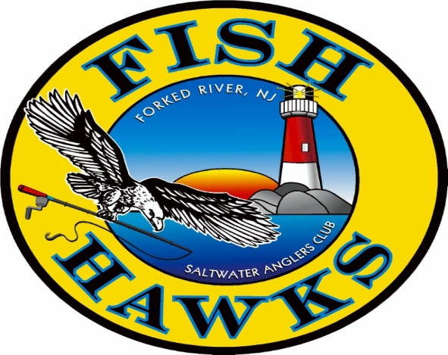

Fish Hawks Saltwater Anglers Club
P.O Box 700
Forked River, N.J. 08731

Forked River, N. J. 08731

NEW MEMBER APPLICATION Must be 18 Years of age to Join
Yearly Dues are: $40.00 current year dues & $10.00 administration fee total: $50.00 or additional $25 for hard copy mailed Newsletter total: $75.00.
NAME:(First) ____________________ (MI) _____ (Last) ______________________________
STREET ADDRESS: _____________________________________________________________
CITY: ____________________________ STATE _________ Zip Code ____________________
PHONE #____________________________ CELL # _______________________________
E-MAIL ADDRESS: *print clearly* ____________________________________________________ DOB:_______________________
OCCUPATION (LIST ALL) ____________________________ BOAT NAME: _________________
NEW MEMBERS PLEASE COMPLETE BELOW
MANDATORY REQUIREMENT FOR ALL NEW MEMBERS. YOU MUST SIGN UP AND PARTICIPATE IN AT LEAST ONE OF THE COMMITTEES LISTED BELOW:
___ Banquet | ___ Flea Market | ___ Newsletter Editor | ___ Speaker Program
___ Club Gear | ___ Good & Welfare | ___ Picnic | ___ Youth Fishing Seminar
___ Newsletter Ads | ___ JCAA Interface | ___ Political Advocate | ___ Webmaster
___ Fishing Contests/Tour. | ___ Membership/Roster | ___ Rod & Reel | ___ 50/50 Fair Share
___ Fishing Trips
____ I wish to receive the monthly newsletter at the above listed email address.
____ Please send the monthly newsletter to my mailing address, for an additional cost of $25.
SPONSOR: Print Name Clearly _________________________________________
If approved, I agree to abide by the By-Laws of this Club and participate in club activities.
Applicant’s Signature: _________________________________________________ Date: ___________________
Attached: $40.00 current year dues & $10.00 administration fee total: $50.00 or additional $25 for hard copy mailed Newsletter total: $75.00.
Payment Received: ____________________________ (Treasurer) Amt. $__________ Check # __________ Cash_________
Accepted for Membership:___________________________ (BOD Member) Date______/_______/_______

