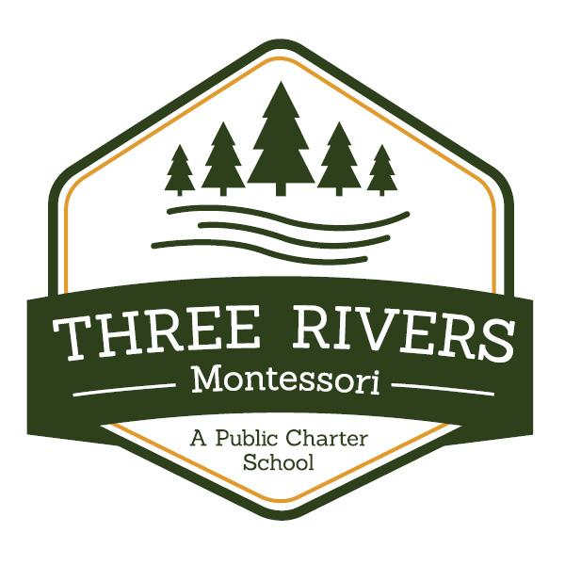
Three Rivers Montessori Charter School
District 4266-07
17267 Yale Street NW
Elk River, MN 55330
763-595-1213
Three Rivers Montessori Charter School
School Social Worker
School Mission: Empowering students to reach their full potential through authentic Montessori learning.

Description: Three Rivers Montessori is seeking a School Social Worker for the 2021-2022 school year. The School Social Worker will report to the School Director and Special Education Director. The Social Worker will work directly with students, teachers, and parents to provide individual and group counseling, as well as link families to long term counseling solutions and external support organizations. The Social Worker will provide support to all school stakeholders to help the school achieve its mission. This is a full-time position at Three Rivers Montessori.

Major responsibilities:

Provide social work services as detailed in students’ IEPs by:

- Maintaining a caseload of students receiving regular, ongoing clinical services. This includes providing direct service minutes that align to the goals and services outlined in the student’s IEP and completing weekly progress notes to maintain compliance.
- Collaborating with the IEP team to create and update the Individualized Educational Plan (IEP) and Functional Behavioral Assessment (FBA)/Behavior Intervention Plan (BIP) (if applicable) for each student served.
- Attending and participating in the IEP meetings of students on the social work caseload.
- Conducting Social Work Assessments and participating in Eligibility Determination meetings.
- Therapeutic group facilitation
Support Child Study Team by:
- Conducting regular assessments of current and emerging student and family needs
- Setting goals with students and tracking progress towards those goals
- Collaborating and working directly with other social workers as well as other student support staff (Speech Therapist, Occupational Therapist, Special Education Teachers)
Support the implementation of restorative practices at the school by:
- Leading restorative conversations between students and students/teachers as needed
- Leading professional development for teachers around restorative practices
- Leading lunch reflection
- Supporting teachers one-on-one in developing their skills in having restorative conversations with students
- Assisting the Principal, Assistant Principal, and teachers when discipline issues arise.
Build relationships with community organizations to support students and families by:
- Developing and maintaining partnerships with external agencies.
- Referring individuals and families to external resources and services and when necessary referring cases of suspected child abuse to the State Central Registry.
- Monitoring and facilitating the delivery of external resources and services.
- Leading and/or supporting workshops to educate families, staff, and/or students on specific issues.
Other Responsibilities:
- Provide crisis intervention as needed.
- Participate actively in department meetings, faculty meetings, and other meetings.
- Support home visits.
- Support grade-level and school-wide activities, including chaperoning trips.

Qualifications:
The ideal Social Worker candidate is licensed (MSW, LISW, LICSW, LGSW), has a deep passion for social justice and equity, and has experience working in a similar elementary or middle school setting as well as someone with specific experience treating and working with childhood trauma. We prefer candidates with experience in implementing research based practices and curriculum. We are seeking someone who is warm, positive, intensely organized, and approaches their work with a tremendous attention to detail.
Industry
Special Education

Employment Type
1.0 FTE – Competitive Salary and Benefits
Start Date:
2021-2022 School Year

Application Procedure
Please send resume and cover letter to admin@threeriversmontessori.org

Visit threeriversmontessori.org for more information.
Posted: 7/7/21

Three Rivers Montessori Charter School is an Equal Opportunity Employer and strongly supports a diverse and inclusive workplace.

