CHELSEA WRITERS’ WORKSHOP

April 19, 2025

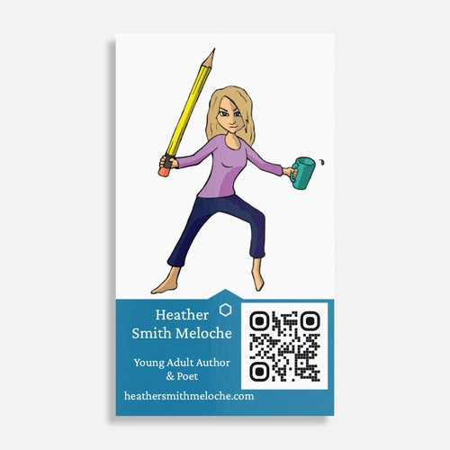

## **INTRODUCTION**

* 1. discuss my writing journey
  2. my accomplishments
  3. where I am on the journey now

## **CONTESTS**

* 1. Benefits
     1. Exposure to people in the market
        1. how I got my second agent, who sold my novel
     2. Helps you evaluate your progress
        1. If you place, you’re doing pretty well = think about submitting bigger
  2. Where to find contests
     1. Duotrope -- <https://duotrope.com>
     2. Facebook Submissions pages
        1. Call for Submissions -- <https://www.facebook.com/groups/156020074604805>
        2. Call for Submissions (Poetry/Art/Fiction) -- <https://www.facebook.com/groups/479272113505741>
  3. My judging of contests
     1. Before publication
        1. School Reflections contests – local
     2. After publication
        1. More broadly – Teen writing contests
           1. Barnes & Noble
           2. Ann Arbor Public Library
           3. Get Inked Teen Writing Conference
     3. What I got out of it
        1. I write for teens, so connecting with them is always a joy
        2. Helps me gauge what they are into, what they are interested in
        3. Always reminds me how brilliant and amazing they are
        4. Helps me look at work objectively – what do I want to see in a piece of writing and how can that translate into my own writing to make it better

## **WRITER’S RESISTANCE, WRITER’S BLOCK, & IMPOSTER SYNDROME**

* 1. Sympathetic vs. Parasympathetic nervous system = automatic responses
     1. SNS = fight or flight = “the arousing system”
     2. PSNS = calms the body = “the calming system”
     3. 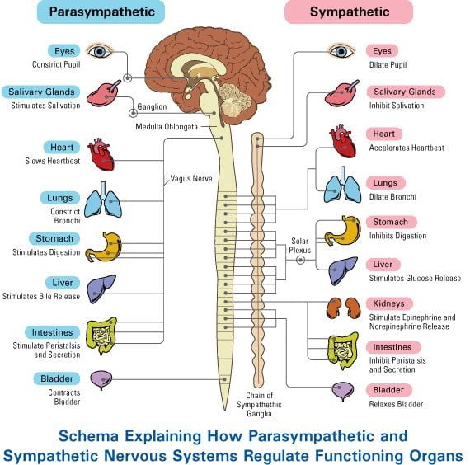
        1. amygdala freaks out and sends a message to hypothalamus to release adrenaline and cortisol
        2. 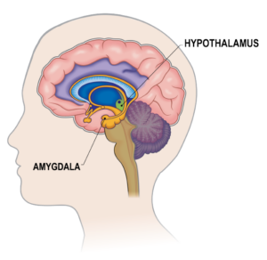
  2. 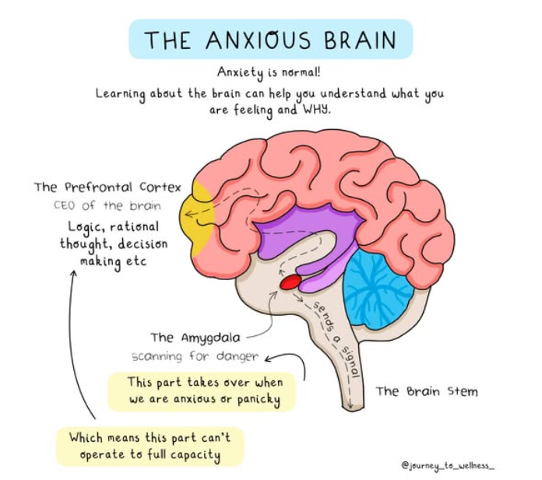

If you get bad feedback on a piece of writing, this becomes part of the cycle. You freak out every time and throw yourself into fight or flight. Prolonged exposure to cortisol creates anxiety, depression, vacillation and this creates the writer’s block, imposter syndrome, and writer’s resistance we all know and hate.

* 1. Solutions:
     1. Webinars and classes = connection and community so take them often and never stop learning craft and industry – I love Lisa Hall-Wilson’s Deep POV class! <https://lisahallwilson.com/resource-hub/>
     2. Critique groups and writer friends – have dinner, coffee, Zoom meet-ups – my friends keep me sane and talk me off the ledge when I am freaking out and want to quit
     3. Read struggles from other writers – a great blog “Writers in the Storm” offers some great posts on what to do when you are stuck, among a slew of fabulous information about craft and industry
     4. Ways to decompress and clear your mind
        1. meditation
        2. exercise/walking/running
        3. Take breaks or stay away from anything that distracts or makes you more anxious
           1. The news
           2. Social Media
        4. Take a course on writer’s resistance (Monica Hayes) or meditation for writers to get into flow (Heather Demetrios)

## **ONLINE (and not online) WRITING RESOURCES**

* 1. One Stop for Writers by Angela Ackerman and Becca Puglisi
     1. Sign up for their blog – Writers Helping Writers -- <https://writershelpingwriters.net/>
     2. I outline my books, create a “book bible” with characters, backstory, wounds, flaws, goals, secrets, fears, lies – and responses and consequences of all of those
     3. They also have hard copies of their awesome pull-down lists for flaws, fears, goals, etc. (show some to the group)
  2. Writer’s University and Laurie Schnebly – See the list at the end of handout of upcoming classes and link to Writer’s U with other writers’ classes
  3. Duotrope
     1. fabulous resource with contests and submission opportunities for every genre.
     2. Keep track of your submissions so you know what your progress is
  4. QueryTracker
     1. I use this for my novels
     2. Give me a personalized list of agents and publishers I’ve submitted to or want to submit to
     3. Keeps track of my rejections and requests for more
  5. #MSWL – Manuscript Wish List -- https://www.manuscriptwishlist.com/
     1. Tells me what agents and editors want
     2. Keeps me updated on current trends

**Sources:**

1. <https://sites.psu.edu/intropsychf19grp8/2019/09/18/sympathetic-and-parasympathetic-systems/>
2. <https://we.care/en/fight-flight-freeze-and-the-autonomic-nervous-system/>
3. <https://www.facebook.com/journeytowellnessnz/posts/if-you-are-someone-who-experiences-anxiety-and-worry-and-you-dont-know-the-neuro/5011993742221146/>
4. <https://diymfa.com/writing/5-stages-of-writers-block/>

## Writers University -- https://writeruniv.com/

## Laurie Schnebley’s latest workshops:

online: **FROM PLOT TO FINISH**  
(April 7-18) [writeruniv.com/classes/onemaster-class-from-plot-to-finish/](https://writeruniv.com/classes/onemaster-class-from-plot-to-finish/" \t "_blank)  
       For anyone who’s taken Plotting Via Motivation online or in person at some point, this group gets you plotting a brand new or already-begun book (using your completed 14-point worksheet) from start to finish. No need to prepare a new story idea, character bios, goal charts or anything else...because you’ll see how to plot an entire book, and actually have it ready to type, by the end of this hands-on workshop.  
  
Zoom for FCRW: **BOFFO BEGINNINGS/FAB F**and **SHOWING EMOTION**  
(April 12, 10:45am-1pm Eastern) [firstcoastromancewriters.com/workshops/](https://firstcoastromancewriters.com/workshops/)  
       Making readers love what you’ve written by giving them what they want most.  
  
Zoom for VIRW: **BOF B/FABULOUS FINALES**and **THAT FATAL FLAW**  
(April 12, 1-3pm Pacific) [vancouverislandromanceauthors.com/meetings](https://www.vancouverislandromanceauthors.com/meetings)  
       Your opening, closing, and what your characters will overcome along the way.  
  
live in Tacoma: **SPRING RETREAT**  
(April 28-May 1) [booklaurie@yahoo.com](mailto:booklaurie@yahoo.com)  
       See the letter above. :)  
  
online: **REVISION HEL--NO, HEAVEN**  
(May 5-16) [groups.io/g/Revision](https://groups.io/g/Revision" \t "_blank)  
       Most writers are uncomfortably familiar with the experience of getting stuck in Revision Hell. But the chance to re(en)vision any concept that's attracted attention can be a wonderful opportunity. This class covers the psychological and practical aspects of editing your work: when to do it, why (and why not) to do it, how to make the process easier, and--most important of all--how to know when you're finished.  
  
blog: **ALL THE FUN, A LOT LESS WORK**  
(May 26) writers in the storm blogspot  
       Why are secondary characters so entertaining? And yet so often overlooked?  
  
online: **THOSE SECONDARY CHARACTERS**  
(June 2-13) [groups.io/g/Secondary](https://groups.io/g/Secondary)  
       Think about the award nominations when your book is made into a movie. Who’ll be nominated as Best Supporting rather than Best Actor / Actress? They don’t carry the entire weight of the story, but it’d be considerably less effective without these characters. Here’s how to make them into people who do their job in a way readers will appreciate, without taking over the book for themselves...at least, not until the potential sequel.  
  
Zoom for Virginia Romance Writers: **PERFECT PITCH**  
(June 7, 10am Eastern) [virginiaromancewriters.com/event/june-meeting/](https://virginiaromancewriters.com/event/june-meeting/)  
       Pitching your work to an editor, agent, publicist, reader? Here’s what to do.  
  
live in Cleveland/Oberlin: **SUMMER RETREAT**  
(June 25-28) [booklaurie@yahoo.com](mailto:booklaurie@yahoo.com)  
       Plot, character, brainstorming, individual work with me--ask for details.  
  
online: **CHALLENGING RELATIONSHIPS**  
(August 4-15) S in C Guppies dot wild apricot dot org *(Guppy members only)*  
       While it’s easy to create conflict between characters whose kingdoms are at war, relationships in everyday life can be equally full of challenges...even when everyone in the situation is a fundamentally decent person. But the same types of interpersonal conflict that often trouble writers and the people in their lives--plus the same solutions recommended by counselors--can work equally well (and often better) for the fictional characters facing such turmoil.  
  
online: **YOUR PLOT / CHARACTER / STORY BRAID**  
(Sept. 1-26) [writeruniv.com/classes/braid](https://writeruniv.com/classes/braid/)  
       Weaving the different strands and levels of your story is trickier than making a simple braid, but the idea is the same: you need to give equal attention to every separate element that’s part of the finished creation. Whether you’re braiding the conflict & resolution of a fantasy, thriller, romance, mystery, women’s fiction or any other journey of discovery, learn how to deliver the balance your readers expect.  
online: **BUILDING YOUR BRAID**  
(Oct. 6-17) [writeruniv.com/classes/building-braid](https://writeruniv.com/classes/building-braid/)  
       Once you’ve outlined the elements of your braid in the just-finished (or a previous) September class, this hands-on master class takes you through the steps of assembling it from beginning to end. Each day’s assignment will keep you going, accomplishing more actual writing than in any usual two-week period, with individual feedback during every segment of the process.  
  
live in Atlanta and/or Raleigh: **FALL RETREAT**  
(sometime/s in October) [booklaurie@yahoo.com](mailto:booklaurie@yahoo.com)  
       Plot, character, brainstorming, individual work with me--ask for details.  
  
online: **BOFFO BEGINNINGS & FAB FINALES**  
(Nov. 3-14) [groups.io/g/BoffoFab/](https://groups.io/g/BoffoFab/)  
       How can you make sure your book will draw readers in from the very first paragraph, through the next several pages, continuing into further chapters until they realize they’ve been reading so fast and so deep they can’t put this story down? How can you leave them, after reaching The End, so wonderfully satisfied with the book they just finished that they’re already vowing to read whatever else you’ve written and are going to write next? That’s what this class is about.  
  
live in Phoenix: **THE DOUBLE D’S**  
(Saturday, Jan. 17, 12-2) [booklaurie@yahoo.com](mailto:booklaurie@yahoo.com)  
       Dynamic Dialogue & Delicious Description: use one to improve the other.  
  
online in Feb: **NOT SURE YET, AWAITING IDEAS**  
  
online: **PLOTTING VIA MOTIVATION**  
(March 3-28) [writeruniv.com/classes/plotting-via-motivation/](http://writeruniv.com/classes/plotting-via-motivation/)  
       Here’s what writers have said about the course in previous years: “I never thought I could plot my entire book from start to finish, but here it is. This is AWESOME.” / “This month has truly changed the way I think about writing. I wish I’d taken Plotting Via Motivation before giving up on my earlier novels.” / “Now that I look back in the notebook where I wrote all my homework, I realize I’ve got my book right here.”