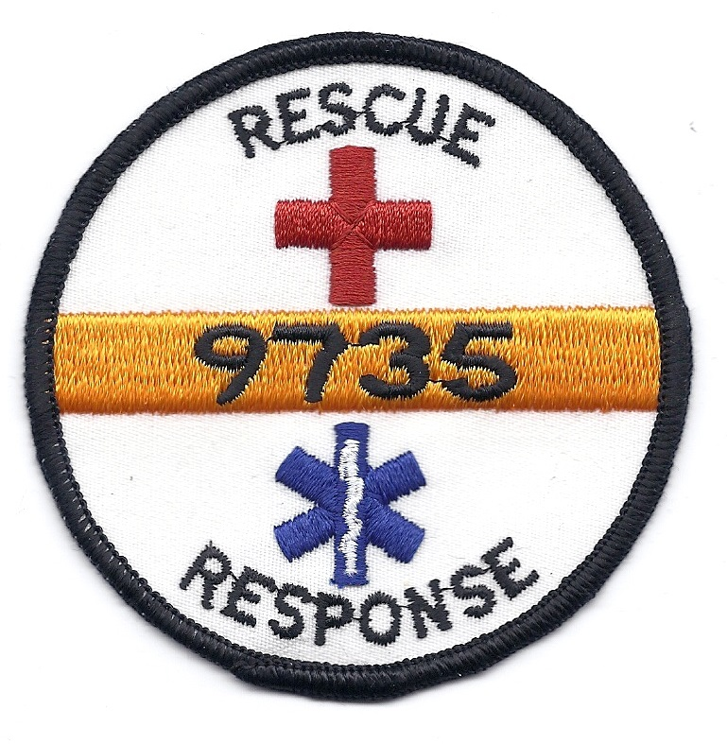
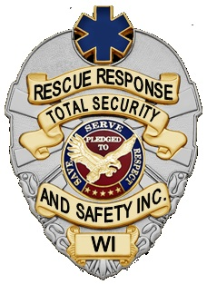
Application for Volunteers

Today’s Date:

Personal Information
Name: _____________________________________________________________
Address: _________________________ City: _______________ State: _____ Zip: ________
Home Phone: (_____) __________________ Work Phone: (____) ________________________
Cell Phone: __________________________ Email: ____________________________________
Date of Birth ____/____/________ SSN (for background check) ____________________________

Why are you interested in volunteering? Personal interest Educational Community Service Hours
Court ordered other __________________________________________________________________
Age ____over 18 ____under 18
Have you ever worked or do you currently work for Rescue Response? Yes No
Have you ever received services from Rescue Response? Yes No
Do you have a valid driver’s license? Yes No
Do you have a car available for use while volunteering? Yes No

Experience and Education
Are you currently certified in First Aid? Yes No (Expiration: ____/______)
Are you currently certified in CPR? Yes No (Expiration: ____/______)
Are you currently certified in AED? Yes No (Expiration: ____/______)
First Responder? Yes No (Expiration: ____/______)
EMT or above? Yes No (License #: ______________ State: _____________)
Other (nursing, MD, …) __________________________________________________________________

You’re Interests at Rescue Response
How did you learn about Rescue Response? Event/ Station Website I was treated at an event
Current Volunteer (who)? ___________________________________________
Other please specify _________________________________________________________

How long can you commit to volunteering? One time occasionally 3-6 months
6 months or more other ____________________________________________________

What days are you available? Mondays Tuesdays Wednesdays Thursdays Fridays
Saturdays Sundays

What times are you available? Mornings Afternoons Evenings
Rescue Response considers applicants for volunteering without regard to sex, race, age, religion, national origin, veteran or marital status, or any other legally protected status. We provide reasonable accommodation to qualified individuals with disabilities when it would not be an undue hardship. If you need a reasonable accommodation in the pre-placement process, please contact the Volunteer Manager.

AUTHORIZATION AND AGREEMENT BY APPLICANT
- I certify that the facts set for in this volunteer application are true and complete to the best of my knowledge. I understand that any false statement, omission or misrepresentation in my application or placement interview may result in the rejection of my application or discharge from the volunteer program.
- I consent to having Rescue Response and Total Security and Safety Inc. complete a criminal background check prior to volunteering.
- I agree to complete a drug screening and TB screening requirements if needed relevant to the position for which I am applying.

_______________________________________________________ ________________________
Signature of Applicant Date
_______________________________________________________ ________________________
Parent/Guardian Signature (required if less than 18 years of age) Date

DRUG AND ALCOHOL TESTING CONSENT
Rescue Response recognizes the costs to society and to individuals from drug and alcohol use. The Agency maintains a firm commitment to strive to provide reliable service to its clients and a safe and healthy work environment for its volunteers. While the vast majority of volunteers are not involved with alcohol abuse or illegal drugs, those who are can have an adverse impact on the workplace, as well as their own job performance. To meet our obligations, and to comply with our obligation under the Drug Free Workplace Act of 1988, the following policy has been adopted and will be enforced:

- The Agency prohibits the unlawful use, sale, possession, manufacture, distribution, or being under the influence of alcohol, drugs or any controlled substance, on Agency property, in the presence of Agency clients, while on duty, during rest periods and break periods, while operating an Agency vehicle or attending an Agency-sponsored event.

- Volunteers who violate this prohibition will be subject to disciplinary action, up to and including termination. Nothing in this policy restricts the Agency’s right to terminate a volunteer at any time, with or without notice, for any reason not expressly prohibited by law.

- The agency retains the right to require any volunteer to report for drug and/or alcohol testing for reasonable suspicion or following an accident in which there is injury to persons or damage to property.

- Volunteers must abide by the terms of this statement and must notify the employer of any criminal drug conviction within five days of the conviction if workplace conduct is involved.

- New interns/volunteers may be required to report for drug testing after a placement offer has been made but before reporting for the assignment.

I have read and understand the Drug Free Workplace Compliance Statement. I agree to comply with the Rescue Response Drug and Alcohol Policy. I understand that any offer of placement with the Agency may be contingent upon the successful completion of drug testing before beginning assignment, and I consent to testing according to Rescue Response policy.

_______________________________________________________ ________________________
Signature of Applicant Date
_______________________________________________________ ________________________
Parent/Guardian Signature (required if less than 18 years of age) Date

