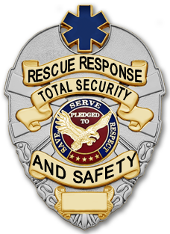
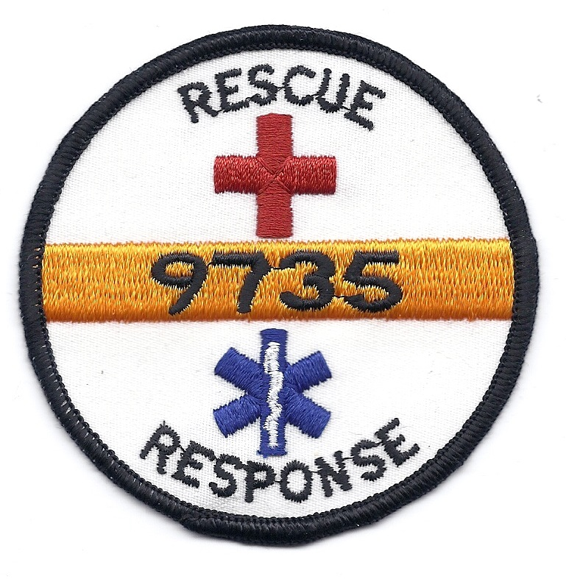
Total Security and Safety Inc. and Rescue Response
FIRST AID & EMERGENCY CARE
Station Request/Agreement

Event Information
Requesting Organization:
Mailing address:
Name of Event:
Event Location:
Contact name:
Phone:
Email address:
Event Details
 | Date | Expected Attendance | # of stations | Event Hours  From: To: |  | Station operation hours requested  From: To: |  | Rapid Response Team Requested* | Lost child center | Serve as event lost and found
Day 1
Day 2
Day 3
Day 4
Day 5
Day 6
Day 7
Day 8
Day 9
Day 10
First aid and Emergency Care Station Details
The requesting Organization shall agree to provide suitable location(s) for stations. Please check the additional following items that will be provided by the requesting organization or sponsors:

Tent with side or room tables/chairs lights (after dark) Ice

Running water Electricity Site Map Event radio(s)

Security/Law Enforcement Internet Access Staff meals/drinks parking
Event tickets for volunteer families Other: _______________________________

Other activities (during your event) that need Special First Aid Attention
Date: | Event: | Location: | Start: | End:

First Aid and Emergency Care Agreement
Rescue Response will provide:  - Volunteers that will provide first aid up to their level of training.  - Duty Chief or Team Leader on site to oversee operations.  - Fully equipped station including AED (when available). | Rapid Response Team includes:  - 2 person bike team (one Medic and one security officer or 2 medics/Responders) with supplies and AED (when available).  - Team will patrol event grounds. | What Rescue Response will not provide:  - Transport, if a patient needs to be moved, we will contact 911.  - Level of volunteers (above basic first aid).  - Completely free care. Patients may receive bills for care provided by agencies other than Rescue Response. | Your responsibility:  - Provide a safe environment.  - If you want advanced EMS services also at your event, you will need to arrange for it.  - Recognize Rescue Response as providing support for your event.
If you agree to all of the information and have provided the requested information, please sign the document below and return to Total Security and Safety Inc. via email or mail.

Print Name of contact person for requesting agency

Signature of contact person from requesting agency Date

Date: / /

I check this box as endorsement of my agreement in lieu of my signature.

- Additional fee may apply for Rapid Response Team.

The purpose of Total Security and Safety Inc./Rescue Response first aid and Emergency Care stations is to provide immediate coverage for those events where there is a higher than usual risk of accidental injury. It is not intended to replace or delay advanced medical care.
Please e-mail or mail application to: Total Security and Safety Inc.
Attn: Rescue Response
1432 Old Knapp Rd.
Oshkosh, WI 54902
or e-mail: chief@totalsecurityandsafety.net

Approval (Total Security and Safety Use Only)
Approved by (printed): |  |  |  | Signature:
Date Approved: |  | Event #: |  |  |  | Duty Chief Assigned:
Fee per hour: | Total hours (rounded to ½ hour): |  | Rapid Response Team |  | Other Services fees: |  | Total Due:
$ | $ |  | $ |  | $ |  | $

Instructions: Submit competed form (with event map in digital form if possible). Any request submitted without signature from contact person will be provided a quote before signing. Once signed and fees established, we will approve your request if possible and you will receive a signed copy of this agreement. Once signed by both parties, this becomes confirmation of our station(s) at the event listed on the form (no agreement is in place until both entities sign the agreement). Any questions please contact our office.

Total Security and Safety Inc. and Rescue Response may offer a multi-year deal to events or organizations to allow for planning events in the future and guarantee a set price structure and services upon request of individual originations or events. Please contact our office for more information.
Payment is required within 15 days of event end. For multi-year pricing agreement contact our office.

