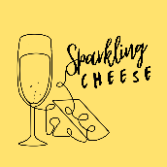
Welcome to the 2025 Christmas Order Form! To avoid disappointment please complete and return this to me by no later than Thursday 20th November. Any orders after this date cannot be guaranteed
Name:

Contact Details:

Preferred Delivery Date and Address:

Please select from the following products – all prices exclude P&P
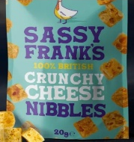
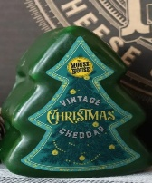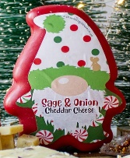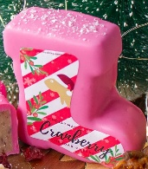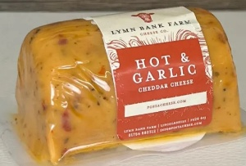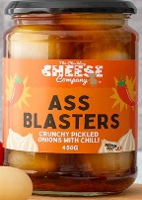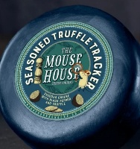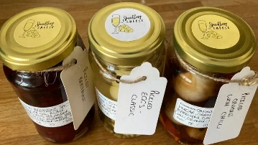
Cheese Truckles 200g: £5.00 each, 2 for £9.50, 3 for £13.50, 4 for £17.50 or 5 for £21 | Quantity
Apricot & Ginger
Ale & Mustard
Black as Coal
Black Pepper
Caramelised Onion
Chili
Chorizo
Christmas Pudding
Cranberry and Chili
Cream Tea
Double Gloucester & Chive
Flaming Heart Extra Hot Chili
Garlic & Chive
Gin & Tonic
Gingerbread
Italian Pizza/Margherita
Lemon Cheesecake
Orange & Whiskey
Pickled Onion
Pigs In Blanket
Red Leicester
Rum & Pineapple
Sage & Onion
Seasoned Truffle
Smoked
Smokey Salami
Sunday Roast
Tikka Masala
Vintage

Cheese Barrels 145g : £2.50 each or 4 for £9.50 | Quantity
Apple Smoked
Black Pepper
Caramelised Onion
Cranberry
Garden Herb
Garlic
Ginger
Hot & Garlic
Hot & Spicy
Limoncello
Regular
Smoked
Strong
Smoked
Regular

Pickles and Things! Pickled Onions £4.50 each or mix and match, 3 for £12, Chuckling Cheese or Crooked Jars of Chutneys / Chili Jams £4 each or 3 for £10.50 | Quantity
Ass Blasters Pickled Onions (450g)
Bangin Balsamic Pickled Onions (450g)
Glorious Garlic Pickled Onions (450g)
Pickle My Fancy Pickle My Fancy (450g)
Ring Stingers Pickled Onions (450g)
Caramelised Onion Chutney (285g)
Punchy Pickle (285g)
Real Ale Chutney (285g)
Tomato & Garlic Chutney (285g)
Tangy Apple Chutney (285g)
Sweet Chilli Jam (285g)
Habenero Chilli Jam (200g)
Reaper Chili Jam (200g)
Spring Veg Chilli (200g)

Sparkling Cheese Pickles and Things Continued : As Priced | Quantity
Honey and Walnut (Small 150g) £2.75
Honey and Walnut (Large 300g) £4.50
Pickled Eggs – Original or Chilli (350g) £3.00
Pickled Beetroot (350g) – £3.00
Pickled Red Cabbage (350g) – £3.00
Pickled Radishes – (Small 150g) £2.00, (Large 300g) £3.50

Snacks £1.50 each, 2 for £2.50, 3 for £4 or 4 for £5 | Quantity
Sassy Franks Cheese Bites (20g)
Munchie Mouse Bites (20g Original or Chilli)
Pork Scratchings (Original or Various Flavours, 50g)
Please select from BBQ, Black Pepper, Garlic, Habanero, Salt & Vinegar, Truffle or Worcestershire

Other Requests: Please enter any other requests here, such as Speciality Cheeses, Taster Boxes, Hampers, Pre Prepared Cheese and Charcuterie Boards and I will get back to you with the best price! Also list here any allergens or dietary requirements

